
Crescent Girls’ School
Secondary 4 Express
Elementary Mathematics
Transformation (Translation)

- Find the coordinates of the images of the quadrilateral A(1,1), B(2,6), C(6,4) and D(5,2) under the translation T₁ represented by $\left(\begin{matrix}4 \\ −3\end{matrix}\right)$. What would be the image of the new quadrilateral if it underwent another translation T₂ represented by $\left(\begin{matrix}2 \\ 6\end{matrix}\right)$?
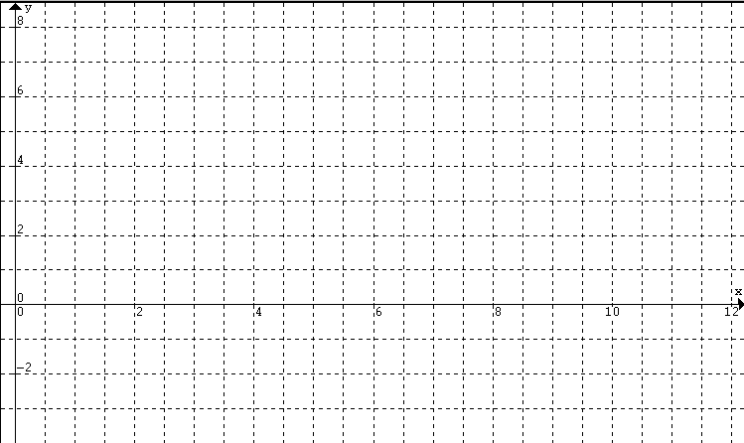

- T₁ is the translation $\left(\begin{matrix}2 \\ 3\end{matrix}\right)$and T₂ is a translation that will move the point (1,2) to (-2,5).
- Find the image of the point A(7,4) under T₁.
- Find the translation vector represented by T_{2.}
- What is the image of the point B(8,-4) under T₂?

- Under a translation T₁, the image of the point(5,-1) is (2,3). Under a translation T₂, the image of the point (-2,5) is (4,-5). Find the image of the point (7,6) under the following translation.
a) T₁ b) T₂ c) T₁T₂
d) T₂T₁ e) T₁²

TRANSLATION

Translation represented by a column vector $\left(\begin{matrix}a \\ b\end{matrix}\right)$:
$$T:(x,y)→(x+a,y+b)$$

Under the transformations (reflection, rotation and translation), the figures are transformed into congruent figures (i.e. distances, angles, areas, shapes and sizes are preserved).

