
Crescent Girls’ School
Secondary 4 Express
Elementary Mathematics
Transformation (Rotation)

1. Construct the image of the figure under a clockwise rotation of 90⁰ about the point O.
A
B
C
O

- The line PQ is rotated in a plane so that P’ is the image of P and Q’, the image of Q, lies on the line segment P’R.
- Mark the point Q’
- Construct and label X, the centre of rotation.
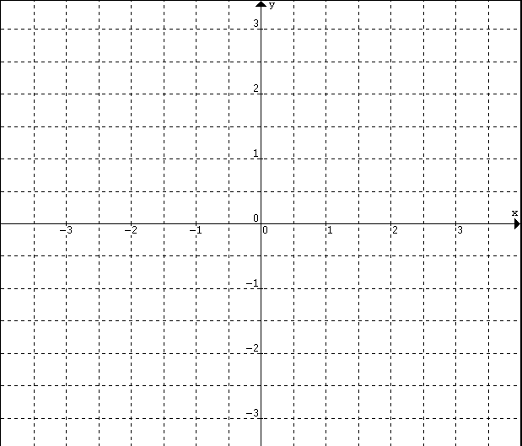
P’
P
Q
R
3. Draw, in each case, the image of each figure under rotation about the origin O with the given angle of rotation.
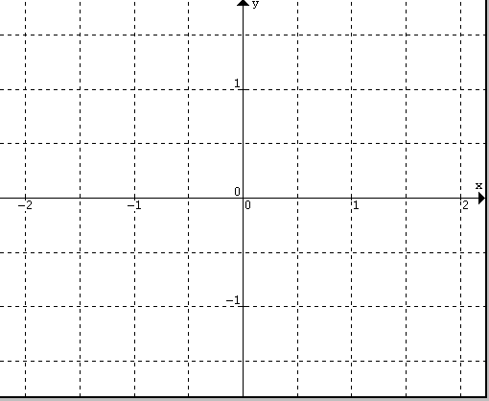
H
K
J
I
K
J
I
H
Through 180⁰
Through 90⁰ clockwise

- A and B rotates anticlockwise 90⁰ about the centre (origin) to form A’ and B’.

A
B
- Write down the coordinates of A and B.

- Write down the coordinates of A’ and B’.

- Write down your observation.

- A and B rotates clockwise 90⁰ about the centre (origin) to form A’ and B’.

A
B
- Write down the coordinates of A and B.

- Write down the coordinates of A’ and B’.

- Write down your observation.

- A and B rotates 180⁰ about the centre (origin) to form A’ and B’.

A
B
- Write down the coordinates of A and B.

- Write down the coordinates of A’ and B’.

- Write down your observation.

ROTATION

i) Rotation through 90⁰, anticlockwise about (0,0):

$R:\left(x,y\right)→\left(−y,x\right)$

ii) Rotation through 270⁰, anticlockwise (or 90⁰ clockwise) about (0,0):

$R:\left(x,y\right)→\left(y,−x\right)$

iii) Rotation through 180⁰, anticlockwise about (0,0):

$R:\left(x,y\right)→\left(−x,−y\right)$

