
Crescent Girls’ School
Secondary 4 Express
Elementary Mathematics
Transformation (Reflection)

1. Construct the image of the figure under the reflection in the line XY.
X
Y
A
B
C

- Draw the reflection of $Δ\text{ABC}$using the line m.
A
B
C
X
Y
m

Does point B moves? If not, what is the name of this point?

- Draw the reflection of the figure using y-axis as the mirror line.
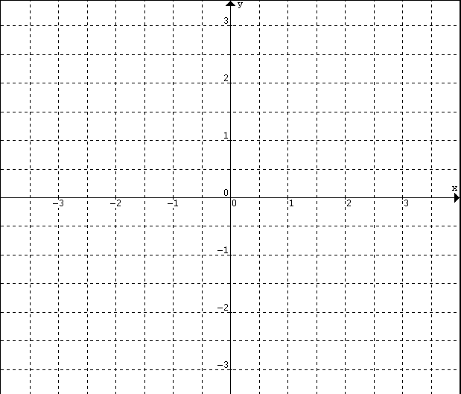
A
B
A

- State the coordinates of points A and B.

- State the coordinates of points A¹ and B¹.

- Describe your observation.

- Draw the reflection of the figure using x-axis as the mirror line.
B
A

- State the coordinates of points A and B.

- State the coordinates of points A¹ and B¹.

- Describe your observation.
- Draw the reflection of the figure using y = x as the mirror line.
A
B

- State the coordinates of points A and B.

- State the coordinates of points A¹and B¹.

- Describe your observation.

- Draw the reflection of the figure using y = -x as the mirror line.
A
B

- State the coordinates of points A and B.

- State the coordinates of points A¹ and B¹.

- Describe your observation.
- Write down the equation of the mirror line.
A
C¹
C
B
B¹
A¹

- Write down the equation of the mirror line.

REFLECTION
- Reflection in the x-axis:
$$M:(x,y)→(x,−y)$$
- Reflection in the y-axis:
$M:(x,y)→(−x,y)$
- Reflection in the line y = x:
$M:(x,y)→(y,x)$
- Reflection in the line y = - x:
$$M:(x,y)→(−y,−x)$$

