
Crescent Girls’ School
Secondary 4 Express
Elementary Mathematics
Transformation (Enlargement)

- Given the following figure and with X as the centre of enlargement, enlarge each figure by the factor given.

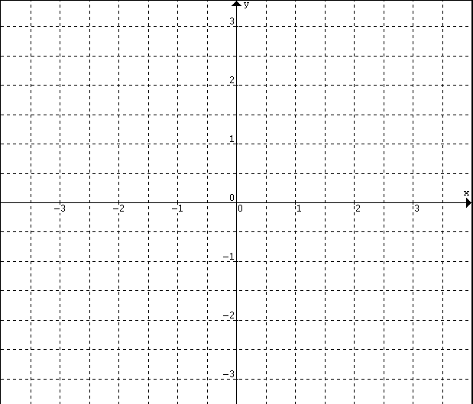
x
Enlarge by factor 2
x
Enlarge by factor $\frac{1}{2}$

Enlarge by factor -2
Enlarge by factor $−\frac{1}{2}$
x
x

- Find the centre of enlargement and scale factor for each of the following enlargements which map ABC onto A'B'C'.
C
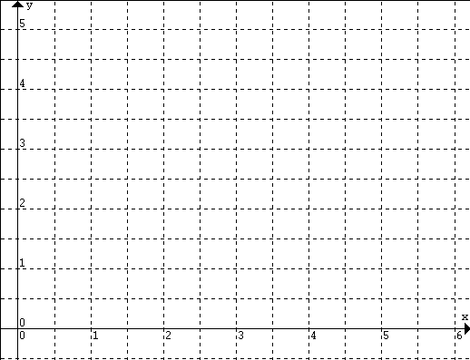
A
B
C
B'
C'
A'
C'
A
A'
B
B'
C
C
C'
C'
A
A
A'
A'
B
B
B'
B'

- Given the following figure and with (0,0) as the centre of enlargement, enlarge each figure by the factor given.
Enlarge by factor 2
Enlarge by factor -$\frac{1}{2}$

A
C
C
B
A
B
Write down the coordinates of A, B and C. | Write down the coordinates of A, B and C.
Write down the cooridnates of A', B' and C' | Write down the cooridnates of A', B' and C'
Write down your observation. | Write down your observation.

- Figure below shows $Δ\text{AB}C$is enlarged to $Δ\text{APQ}$with the centre of enlargement at A and factor k. Prove that $\frac{\text{Area of }Δ\text{APQ}}{\text{Area of }Δ\text{ABC}}=k^{2}$.
A
kx
y
x
B
Q
P
ky

C

- The coordinates of $Δ\text{ABC}$are A(1,1), B(7,1) and C(5,6). $Δ\text{ABC}$is mapped onto $Δ\text{APR}$by an enlargement of scale factor 3. Find
- the coordinates of centre of enlargement,
- the area of $Δ\text{APR}$.

ENLARGEMENT

Enlargement with factor k and the origin as centre:
$$E:(x,y)→(\text{kx},\text{ky})$$

The figure is transformed into a similar figure
(i.e. angle and shape are preserved, the area is increased by k² times).

