
Crescent Girls’ School
Additional Mathematics

Worksheet: Sets
Name:_______________________________ ( ) Class:_______________

- Given that $n(ξ)=\text{80}$, where $ξ$ is the universal set, n(A)=45 and n(B)=30, find (i) the largest possible value of $n(A∪B)'$
(ii) the largest possible value of $n(A'∩B)$
Illustrate each of your answers on a Venn diagram. [CHIJ(SN)/2002/P2]

- If $ξ=${all pizzas} and sets T, M and H are defined by
T={pizzas with tomatoes}
M={pizzas with mushrooms}
H={pizzas with ham}

(a) Express the following statements in set notations.
- All pizzas with tomatoes have either mushrooms or ham.
- Some pizzas with ham have no mushrooms

(b) Describe in words what pizzas belong to the set
(i) $(T∪M)'∩H$
(ii) $T∩H∩M'$

(c) Given that T is a subset of M and $T∩H∩M≠φ$, illustrate the sets T, M, and H using a Venn diagram [CHIJ(TP)/2002/P1]

- (a) Given that $ξ=\left\{1,2,3,4,\text{.}\text{.}\text{.},t\right\}$where t is a positive integer. P and Q are two subsets of $ξ$ where P={x:x is a prime number} and
Q={x: the unit digit of x is 7}
  - If t=50, list all the elements of the set Q.
  - If $n\left(P∩Q\right)=5$, list all the elements of the set P∩Q and find the largest possible value of t.
(b) Given that $n\left(ξ\right)=\text{23}$, $n\left(A∩B\right)=x$, n(A)=y, n(B)=2y and $n(A'∩B')=7$. Show that 3y=16+x and hence deduce the least possible value of y. [Cedar/2002/P1]

- (a) Three sets A, B and C satisfy the following conditions.
A={$\left(x,y\right):x,y∈ℜ,x+2y=k,$where k is a constant}
B={$(x,y):x,y∈ℜ,x+\text{my}=2,$where m is a constant}
C={$(x,y):x,y∈ℜ,x^{2}+\text{xy}+8=0$}
- If $A∩B=φ,$ write down the value of m and a possible value for k.
- If $n\left(A∩C\right)=2,$ find the range of values of k.

(b) Three sets P, Q and R satisfy the conditions:
$P⊂Q$ and $n(P∪R)=n(P)+n(R)\text{.}$
- Simplify $P∩Q'\text{.}$
- Find $n(P∩R)\text{.}$
[NYHG/2002/P2]

5. (a) Given that $ξ$ is the set of people, L the set of leaders, N the set of entrepreneurs, S the set
of scholars and F the set of financial analysts. Express the following logic statements in set notation.
- All scholars are leaders or entrepreneurs.
- Some entrepreneurs are scholars.
- Financial analysts who do not lead are not scholars.

(b) At an airplane service center 60 planes were inspected. Assume that 33 planes needed new tires and 44 planes needed new brakes.
- What is the least number of planes that could have needed both tires and brakes?
- What is the greatest number of planes that could have needed both?
- What is the greatest number of planes that could have needed neither?

(c ) Express in set notation, as simply as possible, the subset in the Venn diagram.
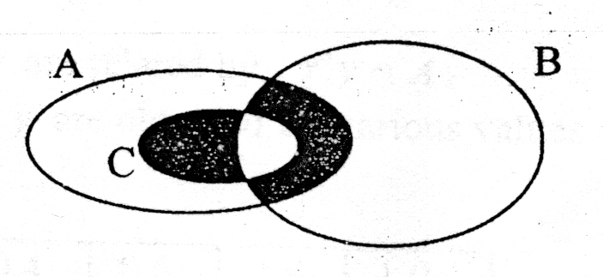

[CHS/2002/P2]

6. Given that $ξ$={pupils in a school}, B={boys}, H={Hockey players}, F={Football players},
(a) make a statement explaining the meaning of
(i) $H⊂B'$ (ii) $F∩H≠φ$
(b) express in set language the statement “All pupils either play football or hockey”.
[MGS/2002/P1]

7. (a) Given that B is the set of people who can play badminton, S is the set of people who can swim and C is the set of people who can play chess.
- Express in set language the statement ‘not all who can play badminton can swim’.
- Describe in words the meaning of $B'∩S'∩C≠φ$
(b) In a group of 450 pupils, 300 study Geography (G) and 200 study History (H). With the help of Venn diagrams, find
- the least value of $n\left(G∩H\right)$
- the greatest value of $n\left(G∪H\right)'\text{.}$ [ACS(I)/2002/P1]
8. (a) A, B and C are three sets such that $E=A∪B∪C$, where E is the universal set. The Venn diagram below represents the number of elements in each subset. Given that $n(A)=n(B'∩C)$and $n(A')=n(A∪B')$, find the value of x and of y.
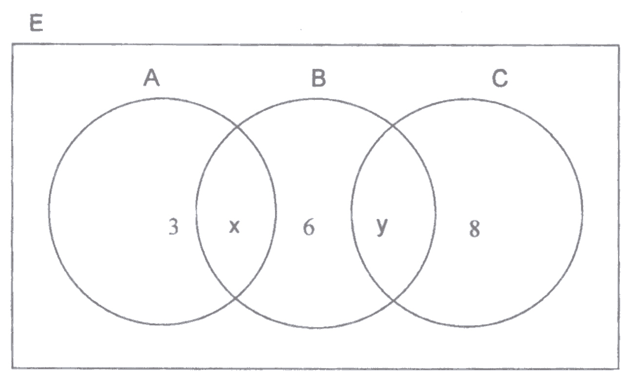

(b) It is given that E={boys in class}
F={boys who play football}
R={boys who play rugby}
Express in set notation, the statement “the number of boys who play only rugby is the same as the number of boys who play neither football nor rugby.” [FMSS/2002/P1]

9. (a) Two sets A and B are such that $n(A)=\text{19}$and $n(B)=\text{12}$. If $n(ξ)=\text{28},$ find
- the smallest possible value of $n(A∩B')$,
- the largest possible value of $n(A'∩B)\text{.}$

(b) (i) Copy the Venn diagram and shade the region that represents the set $P'∪(Q∩R')\text{.}$

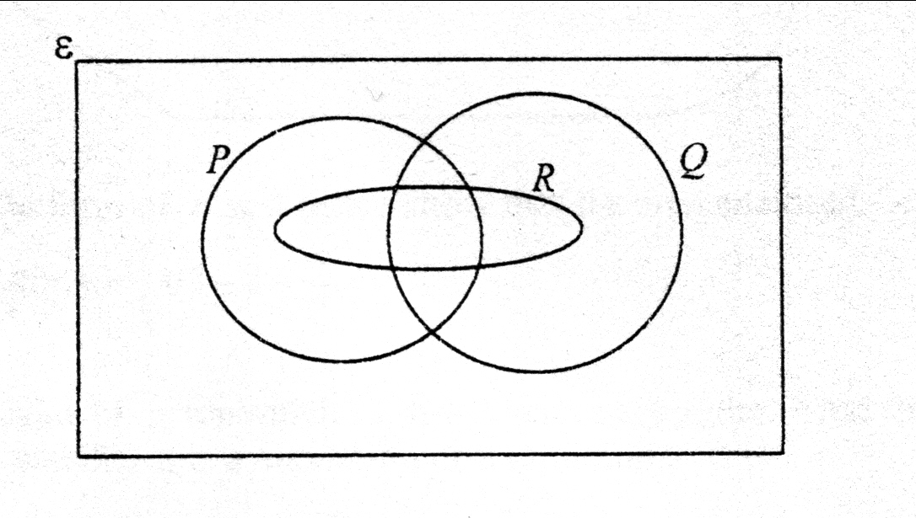

(ii) There are 20 pupils taking Geography. All those who take History also take Mathematics. 17 pupils take Mathematics but Geography. Nobody takes both History and Geography together. The number of pupils taking both Geography and Mathematics is twice the number of those taking History. The number of pupils who took Geography only is three times the number of those taking History.

Draw a Venn diagram to represent the above information, and find the number of pupils taking Mathematics but not History. [VS/2002/P1]

10. (a) The Venn diagram below represents three sets, A, B and C. Express as simply as possible, the coordinates in set notations which would lead to this diagram.

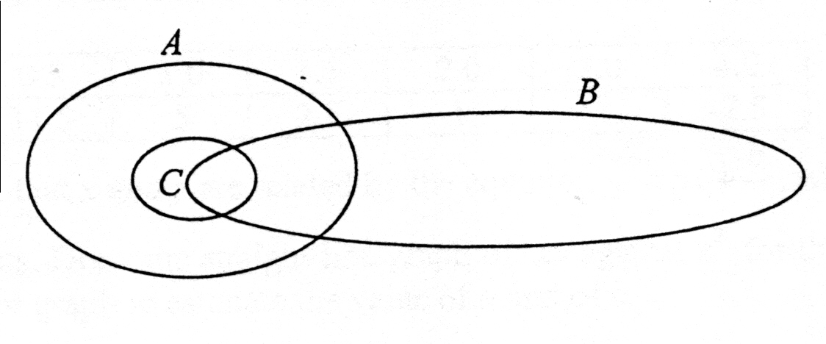

(b) If $n(ξ)=\text{50}$ and P and Q are two sets for which $n(P)=\text{30}$ and $n(Q')=\text{26},$ find, with the aid of Venn diagrams, the largest possible value of $n(P'∩Q')\text{.}$ [RGS/2002/P1]

11. In a recent survey on World Cup, 120 adults took part in voting for their favourite teams. Brazil, England and Germany topped the votes. 80 voted for Brazil and 30 voted for England. Of those who voted for Brazil, 20 voted for England but not Germany while 12 voted for Brazil supported Germany as well. There were 32 votes for Germany only, 5 gave support to Germany and England only while 2 voted for Argentina.
- Complete the Venn diagram given.
- How many adults voted for Germany?
- How many adults do not support Brazil
nor Germany?
[RGS/2002/P2]
12. A, B and C are three sets. The number of elements in some of the subsets are shown in the Venn diagram and $n(ξ)=\text{70}$.

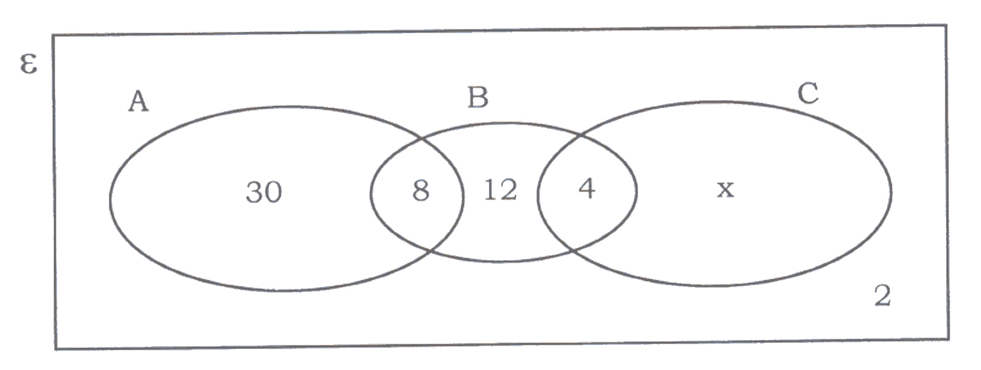
Find
(i) n(C)
(ii) n(B∪C’)
(iii) n(A’∩B’)
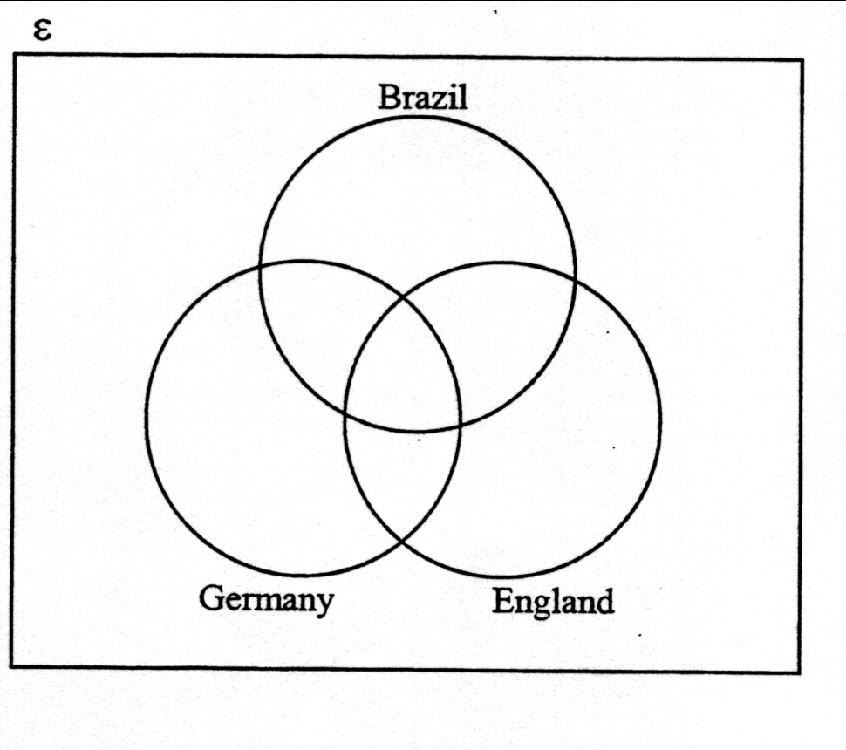
[SJI/2002/P1]
Answers.
- (i) 35; (ii) 30
- (a) (i) $T⊆(M∪H)$ (ii) $H∩M'≠φ$ (b) (i) Pizzas with ham but without mushrooms or tomatoes. (b)(ii) Pizzas with tomatoes and ham but without mushrooms
3. (a)(i) $Q=\left\{7,\text{17},\text{27},\text{37},\text{47}\right\}$ (ii) P∩Q={7,17,37,47,67}; t=96 (b)y=6
4. (a)(i) m=2; k: any values except 2 (ii) k<-8 or k>8 (b)(i) {} (ii) 0
5. (a) (i) $S⊆\left(L∪N\right)$ (ii) $N∩S≠φ$ (iii) $\left(F∩L'\right)⊆S'$ (b)(i) 17 (ii) 33 (iii)16 (c) $\left(B'∩C\right)∪\left(A∩B∩C'\right)$
6. (a) (i) The hockey players are all girls/not boys. (ii) there are some who play both football and hockey. (b) $H∪F=ξ$
7. (a)(i) $B∩S'≠φ$. (ii) Not all who can play chess can swim or play badminton
(b)(i) 50 (ii)150
8. (a) x=5; y=2 (b) $n(R)−n(R∩F)=n\left[\left(R∪F\right)'\right]$ or $n(R∩F')=n(R'∩F')$
9. (ai) 7 (ii) 9 (b)(ii) 21
10. (a) $B∩C⊆B∩A$ and $B∩C⊂A$; $C⊂A$ or $C∩A=C$or , , $B∩C∩A≠φ$, $A∩B≠φ$ (b) 20
11. (i) (ii) 49 (iii) 3
5
48
8
20
32
1
x = 4
(80)

12. (i) 18 (ii) 20 (iii) 62

