
Crescent Girls’ School
Mathematics D

Worksheet: Vectors in 2 Dimensions
Name:_______________________________ ( ) Class:_______________

- (a) In the diagram, O is the origin. If $\vec{\text{OA}}=\left(\begin{matrix}4 \\ 4\end{matrix}\right)=a\text{ and }\vec{\text{OB}}=\left(\begin{matrix}−4 \\ 0\end{matrix}\right)=b$, mark and label clearly on the diagram
  - the point P such that $\vec{\text{OP}}=\frac{1}{2}a−b$,
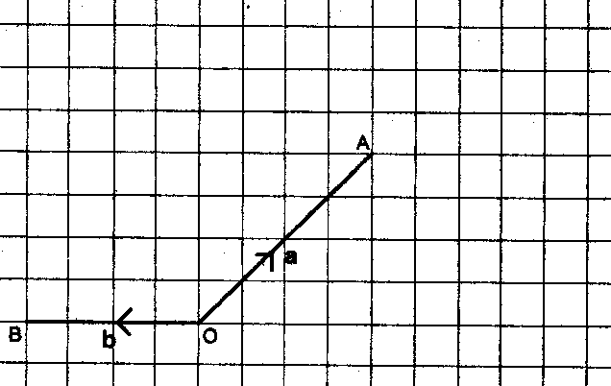
  - the point Q such that $\vec{\text{OQ}}=\frac{3}{4}b+a$.

It is given that $\vec{\text{AR}}$ is the vector $\left(\begin{matrix}5 \\ 2\end{matrix}\right)$
    - Express $\vec{\text{PR}}$ as a column vector,
    - Find $\vec{\left|\text{PR}\right|}$. [BMSS/2001/P1]

- (a) Given that $p=\left(\begin{matrix}3 \\ 4\end{matrix}\right),q=\left(\begin{matrix}−2 \\ 6\end{matrix}\right)$,
  - Express 3p – ½q as a column vector
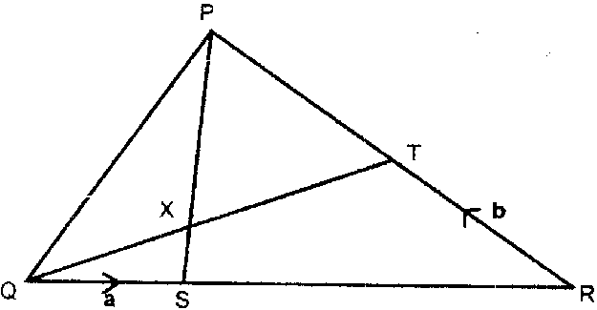
  - Find | q |.

(b) In the diagram, QR = 4 QS and AP = 5 SX. T is the midpoint of PR and PA intersect QT at X. Given that $\vec{\text{QS}}=a\text{ and }\vec{\text{RT}}=b$,
- Express the following vectors, as simply as possible, in terms of a and/or b
(a) $\vec{\text{SR}}$
(b) $\vec{\text{SP}}$
(c) $\vec{\text{SX}}$
- Show that $\vec{\text{QX}}=\frac{2}{5}(4a+b)$
- Express $\vec{\text{QT}}$as simply as possible in terms of a and/or b
- Calculate the value of $\frac{\text{QX}}{\text{QT}}$
- Calculate $\frac{\text{area PQX}}{\text{area PXT}}$ [BMSS/2001/P2]

- $$p=\left(\begin{matrix}−6 \\ 5\end{matrix}\right),q=\left(\begin{matrix}1 \\ 7\end{matrix}\right),\text{r }=\left(\begin{matrix}4 \\ m\end{matrix}\right)$$
    - Express q – 2p as a column vector
    - Find $\left|p+q\right|$.
    - Given that p is parallel to r, find m. [Catholic/2001/P1]

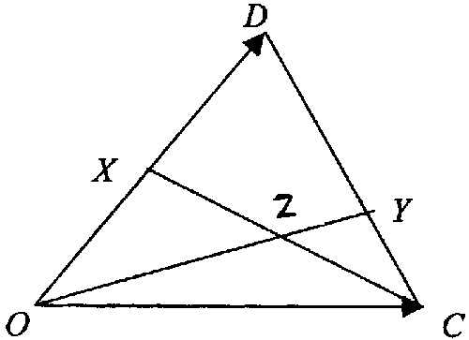
- In the diagram above, X is the midpoint of OD. Y lies on CD such that CY = $\frac{1}{3}$CD. $\vec{\text{OC}}=c\text{ and }\vec{\text{OD}}=d$.
    - Express $\vec{\text{CD}},\vec{\text{CY}}\text{, }\vec{\text{OY}}\text{ and }\vec{\text{CX}}$ in terms of c and d.
    - Given that $\vec{\text{CZ}}=h\vec{\text{CX}},\text{ express }\vec{\text{OZ}}$ in terms of c, d and h.
    - If $\vec{\text{OZ}}=k\vec{\text{OY}}$, find the value of h and k.
    - Calculate the numerical value of
    - OZ : ZY
    - $$\frac{\text{area of }Δ\text{OCZ}}{\text{area of }Δ\text{OZX}}$$
    - $\frac{\text{area of }Δ\text{CZY}}{\text{area of }Δ\text{OZX}}$ [Catholic/2001/P2]

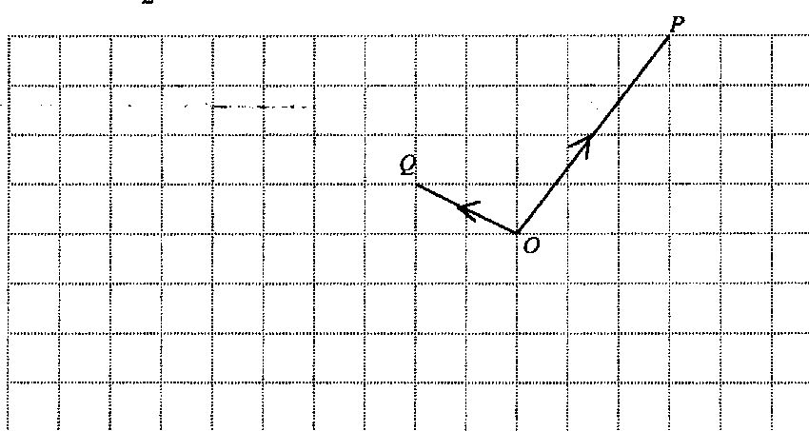
- (a) The diagram shows 3 points, O, P, Q. If $\vec{\text{OA}}=a\text{ and }\vec{\text{OB}}=b$, mark and label on the diagram the point R where by $\vec{\text{OR}}=2b−\frac{1}{2}a$.
(b) It is given that S is the point (3, 4) and T is the point (8, 1).
  - Find $\left|\vec{\text{ST}}\right|\text{.}$
  - If $\vec{\text{CD}}=\frac{1}{3}\vec{\text{ST}}$ and D is the point (7, 2), find the coordinates of the point C.
  - If $\vec{\text{XY}}=\left(\begin{matrix}−\text{20} \\ k\end{matrix}\right)$ and $\vec{\text{XY}}\text{ is parallel to }\vec{\text{ST}}$, find the value of k. [Cedar/2001/P1]

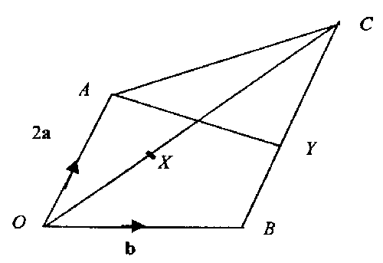
- In the diagram, $\vec{\text{OA}}=2a\text{ and }\vec{\text{OB}}=b$, BC is parallel to OA and BC = $\frac{3}{2}$OA. X is a point on OC such that OX = $\frac{2}{3}$XC. Y is the midpoint of BC.
(a) Express the following in terms of a and b
(i) $\vec{\text{AB}}$ (ii) $\vec{\text{OC}}$ (iii) $\vec{\text{OX}}$ (iv) $\vec{\text{AX}}$
(b) Show that B lies on AX produced.
- AY produced meet OB produced at Z. Given that $\vec{\text{AZ}}=h\vec{\text{AY}}$, express $\vec{\text{AZ}}$ in terms of a, b and h.
(d) Given also that $\vec{\text{OZ}}=k\vec{\text{OB}}$, form an equation involving a, b, h and k. Hence find the value of h and k.
(e) Find the numerical value of (i) $\frac{\text{area of ΔOAX}}{\text{area of ΔOAB}}$
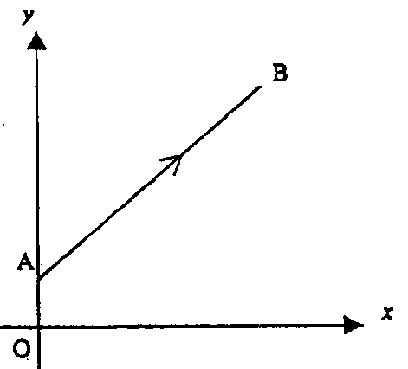
(ii) $\frac{\text{area of ΔOAB}}{\text{area of ΔABC}}$ [Cedar/2001/P2]
- On the diagram, A is the point (0, 1) and B is the point (3, 5).
    - The point C lies on AB produced. Given that $\vec{\text{AC}}=2\vec{\text{AB}}$, express $\vec{\text{OC}}$ as a column vector.
    - The point D is the reflection of B in the y-axis. Express $\vec{\text{AD}}$ as a column vector.
    - AB is rotated in a clockwise direction about A so that B is mapped onto E, where E is a point on the negative y-axis. Express $\vec{\text{OE}}$ as a column vector.
    - The point B is translated by $\left(\begin{matrix}−3 \\ −\text{10}\end{matrix}\right)$ to point F. Express $\vec{\text{OF}}$ as a column vector.
    - The line AG is an enlargement of the line AB with centre on enlargement at A and scale factor of –1. Express $\vec{\text{OG}}$ as a column vector. [MGS/2001/P1]
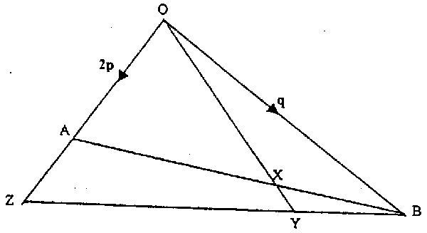
- In the diagram $\vec{\text{OA}}=2p,\vec{\text{OB}}=q,\vec{\text{OA}}=2\vec{\text{AZ}}\text{ and }\vec{\text{BZ}}=4\vec{\text{BY}}$. The lines OY and AB intersect at X.
(a) Express the following as simply as possible in terms p and/or q
(i) $\vec{\text{OZ}}$
(ii) $\vec{\text{BZ}}$
(iii) $\vec{\text{AB}}$
(iv) $\vec{\text{OY}}$
(b) (i) Given that $\vec{\text{AX}}=h\vec{\text{AB}}$, express $\vec{\text{AX}}$ in terms of p, q and h.
  - Hence show that $\vec{\text{OX}}=2(1−h)p+hq$.
- Given also that $\vec{\text{OX}}=k\vec{\text{OY}}$, form an equation involving p, q, h and k and use it to find the numerical values of h and k.
- Write down the numerical value of XY : OY.
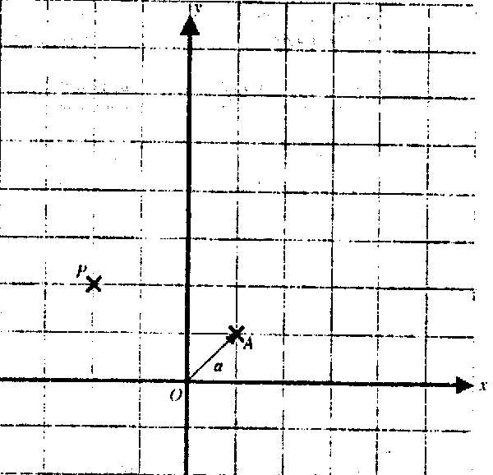
(e) Given that the area of ΔOAB is 15 cm², calculate the area of ΔOBX. [MGS/2001/P2]

- In the diagram, O is the origin and the points A, P and vector a where a = $\left(\begin{matrix}1 \\ 1\end{matrix}\right)$ are as shown.
(a) (i) If $\vec{\text{AQ}}+2a=\vec{\text{AP}}$, mark and label the point Q on the grids provided.
(ii) Express $\vec{\text{OQ}}$ as a column vector.
(b) If PQAB is a trapezium such that PQ : AB = 1 : 2 and PQ is parallel to BA.
- Mark and label the position of point B clearly on the grids.
- Find, leaving your answers in surds, the magnitude of $\vec{\text{PB}}$. [RGS/2001/P1]

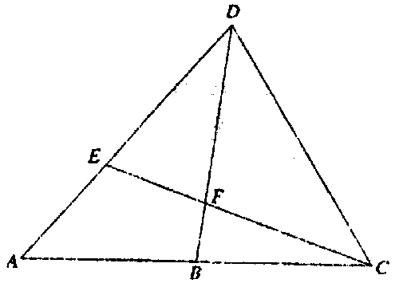
- In the figure, A is a point on DE produced such that DE : DA = 3 : 5. B is the midpoint of AC. It is given that $\vec{\text{CA}}=m\text{ and }\vec{\text{CD}}=n$.
(a) Express, in terms of m and n
(i) $\vec{\text{AD}}$ (ii) $\vec{\text{ED}}$ (iii) $\vec{\text{BD}}$
(b) If EC and BD meet at F such that 5EF = 3 FC, show that $\vec{\text{DF}}=\frac{3}{8}(m−\text{2n})$
(c) Find the numerical value of (i) $\frac{\text{area of }Δ\text{CDF}}{\text{area of }Δ\text{DEF}}$
(ii) $\frac{\text{area of }Δ\text{CDF}}{\text{area of }Δ\text{AEC}}$ [RGS/2001/P2]

- The diagram shows $\vec{\text{OA}}=a\text{ and }\vec{\text{OB}}=b$. Each square on the grid is of length 1 unit.
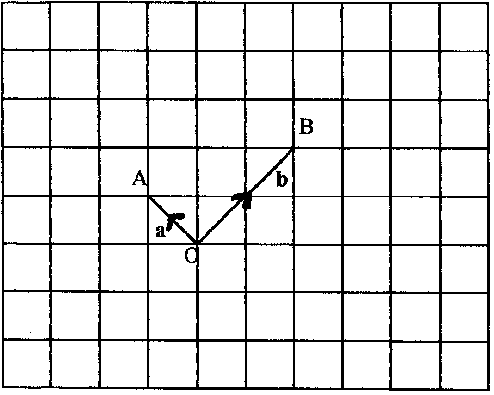
    - Mark the point Y such that $\vec{\text{OY}}=2b−a$.
    - Find the magnitude of $\vec{\text{BY}}$, leaving your answer to the nearest whole number.
    - Construct on the grid above, 2 position of the point K such that $\left|\vec{\text{BK}}\right|=3\left|\vec{\text{AK}}\right|$.
[SJI/2001/P1]
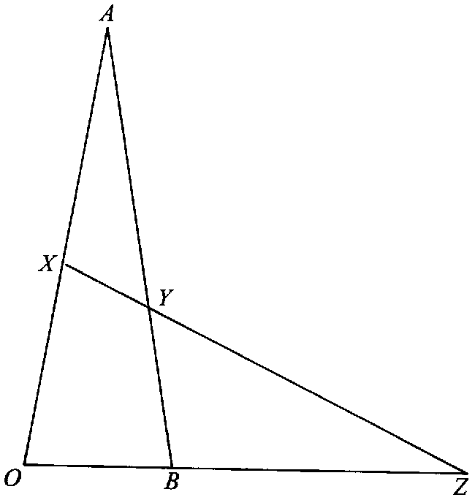
- In the diagram, $\vec{\text{OA}}=\text{10}a\text{ and }\vec{\text{OB}}=\text{10}b$. X is the midpoint of $\vec{\text{OA}}$. Y lies on AB such that $\vec{\text{AY}}=\frac{3}{2}\vec{\text{YB}}$. Z lies on $\vec{\text{OB}}$ produced such that $\vec{\text{BZ}}=2\vec{\text{OB}}$.
Express the following vectors in terms of a and b
(i) $\vec{\text{OX}}$
(ii) $\vec{\text{AY}}$
(iii) $\vec{\text{XY}}$
(iv) $\vec{\text{XZ}}$
(v) P is a point on OZ produced such that $\vec{\text{OP}}=k$b and $\vec{\text{AP}}$ is parallel to $\vec{\text{XY}}$. Show by vector method that k = 60.
(vi) Given that the area of ΔAXY = 6 cm²,
Find (a) the area of ΔOXY
(b) the area of ΔOYB
(c) $\frac{\text{areaof}Δ\text{YBZ}}{\text{areaof}Δ\text{OAP}}$ [SJI/2001/P2]
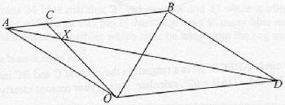
- OABD is a parallelogram and O is the origin. A is the point (–7, 3) and $\vec{\text{AB}}=\left(\begin{matrix}4 \\ \text{12}\end{matrix}\right)$. If $\vec{\text{AC}}=\frac{1}{4}\vec{\text{AB}}$, find (i) the position vector of C
(ii) $\left|\vec{\text{OD}}\right|$
(iii) the value of (a) $\frac{\text{areaof}Δ\text{OAC}}{\text{areaof}Δ\text{OBC}}$
(b) $\frac{\text{areaof}Δ\text{OXD}}{\text{areaof}Δ\text{AXC}}$ [SCGS/2001/P2]
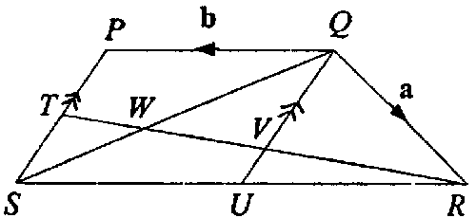
- In the figure, PQRS is a trapezium where $\vec{\text{QR}}=$ a, $\vec{\text{QP}}=$ b and $\vec{\text{RS}}=$2b. PS is parallel to QU. T, V and U are midpoints of PS, RT and SR respectively. The line RT intersects QS and QU at the points W and V respectively.
(a) Express as simply as possible in terms of a and b, (i) $\vec{\text{QU}}$
(ii) $\vec{\text{QS}}$
(iii) $\vec{\text{RT}}$
(b) Given that $\frac{\text{WT}}{\text{RT}}=h$, find $\vec{\text{PW}}$ in terms of h, a and b.
(c) Given that $\frac{\text{WS}}{\text{QS}}=k$, find $\vec{\text{PW}}$ in terms of k, a and b.
(d) Hence find the value of h and of k
(e) If the area of ΔSWT is 16 cm², find the area of ΔQWV. [VS/2001/P2]

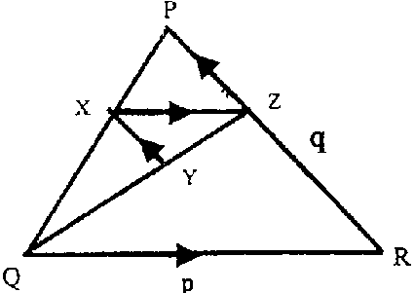
- In the figure, $\vec{\text{QR}}=p\text{ and }\vec{\text{RP}}=q\text{.}$ PZ : PR = 2 :3, XZ is parallel to QR and RP is parallel to YX. Find in terms of p and/or q, the vector (a) $\vec{\text{QZ}}$
(b) $\vec{\text{ZX}}$
(c) $\vec{\text{RY}}$
(d) $\vec{\text{YX}}$ [Xinmin/2001/P1]

- In ΔOAB, $\vec{\text{OA}}=a\text{ and }\vec{\text{OB}}=b$ and M is the midpoint of AB.
  - Express $\vec{\text{AB}}$ and $\vec{\text{OM}}$in terms of a and b
  - N is a point on OB such that $\vec{\text{NM}}=\frac{1}{2}$a, name the shape of the quadrilateral.
  - Given that $\left|\vec{\text{OA}}\right|=\text{10},\left|\vec{\text{OB}}\right|=\text{15}$ and ∠AOB= 62º, calculate
  - the values of d if a = $\left(\begin{matrix}−6 \\ d\end{matrix}\right)$
  - the length of AB. [Xinmin/2001/P2]
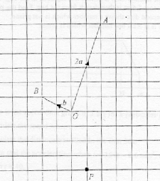
- On the grid shown, $\vec{\text{OA}}=2a\text{ and }\vec{\text{OB}}=b$. The point P is also shown.
  - Find the ratio OA : OB
  - Mark clearly on the grid, the point C such that $\vec{\text{CA}}=2$(a – b)
  - Given that D is a point such that $\vec{\text{OD}}=h$a and $\vec{\text{DP}}=k$b, mark and label clearly the point D on the grid. [RI/2001/P1]

Answers
- (b) $\left(\begin{matrix}3 \\ 4\end{matrix}\right)$ (c) 5 units
- (a)(i) $\left(\begin{matrix}\text{10} \\ 9\end{matrix}\right)$ (ii) 6.32 units (b)(i) 3a; 3a + 2b; $\frac{1}{5}$(3a + 2b) (ii)$\frac{2}{5}(4a+b)$ (iii) 4a + b (iv)(v) $\frac{2}{5};\frac{2}{3}$
- (a) $\left(\begin{matrix}\text{13} \\ −3\end{matrix}\right)$ (b) 13 (c) –3$\frac{1}{3}$
- (a) d – c; $\frac{1}{3}(d−c);\frac{1}{3}(2c+d);\frac{1}{2}d−c$ (b) $(1−h)c+\frac{h}{2}d$ (c) h = 0.5, k = 0.75
(d) 3 : 1; 1; $\frac{1}{3}$
- (b)(i) √34 units (ii) C(5$\frac{1}{3}$, 3) (iii) k = 12
- (a)(i) b – 2a (ii) 3a + b (iii) $\frac{2}{5}(3a+b)$ (iv) $\frac{2}{5}(−2a+b)$ (c) hb – ½ha (d) (½h – 2)a = (h – k)b;
h= 4, k = 4 (e)(i) $\frac{2}{5}$ (ii) $\frac{2}{3}$
- (a) $\left(\begin{matrix}6 \\ 9\end{matrix}\right) (b)\left(\begin{matrix}\text{-3} \\ 4\end{matrix}\right) (c)\left(\begin{matrix}0 \\ \text{-4}\end{matrix}\right) (d)\left(\begin{matrix}0 \\ \text{-5}\end{matrix}\right) (e)\left(\begin{matrix}\text{-3} \\ \text{-3}\end{matrix}\right)$
- (a)(i) 3p (ii) 3p – q (iii) q – 2p (iv) $\frac{3}{4}(p+q)$ (b)(i) h(q – 2p) (ii) (2 – 2h)p + hq
(c) $h=\frac{2}{3},k=\frac{8}{9}$ (d) 1 : 9 (e) 5 cm²
- (a)(ii)$\left(\begin{matrix}−4 \\ 0\end{matrix}\right)(b)(\text{ii})\sqrt{\text{58}}\text{units}$
- (a)(i) $\vec{\text{AD}}=n−m$ (ii) $\vec{\text{ED}}=\frac{3}{5}(n=m)$ (iii) $\vec{\text{BD}}=n−\frac{1}{2}m$ (c)(i) $\frac{5}{3}$ (ii) $\frac{\text{15}}{\text{16}}$
- (b) 3 units
- (i) 5a (ii) 6(b – a) (iii) 6b – a (iv) 5(6b – a) (v)(a) 6 cm² (b) 8 cm² (c) $\frac{2}{\text{15}}$
- (i) $\left(\begin{matrix}−6 \\ 6\end{matrix}\right)$ (ii) 12.6 units (iii)(a) $\frac{1}{3}$ (b) $\frac{\text{16}}{1}$
- (a)(i) a + b (ii) a + 2b (iii) ½(3a – b) (b) $\frac{1}{2}(1+h)a+\frac{1}{2}(1−3h)b$
(c) (1 – k)a + (1 – 2k)b (d) $h=\frac{1}{5},k=\frac{2}{5}$ (e) 36 cm²
- (a) p +$\frac{1}{3}$q (b) $−\frac{2}{3}$p (c) $−\frac{2}{3}$p +$\frac{1}{9}$q (d) $−\frac{2}{9}$q
- (a) $\vec{\text{AB}}$= b – a; $\vec{\text{OM}}$= ½(a + b) (b) trapezium (c)(i) –8 or 8 (ii) 13.6 unit
- (a) 2√2 : 1

