
Crescent Girls’ School
Additional Mathematics

Worksheet: Vectors (2)
Name:_______________________________ ( ) Class:_______________

- The position vectors of points A and B relative to an origin O are 7i + 2j and 5i + 9j respectively. The point C is such that OABC is a square. L is a point on OA produced such that OL = 2OA and N is the midpoint of OC. The lines LN and AC meet at M.
(i) Find the position vector of C
(ii) Given that LM = λLN, find the position vector of M
(iii) Given that AM = μAC, find the position vector of M
(iv) Hence evaluate the value of μ and λ. [SJI/2001/P1]

- The position vectors of the points P and Q relative to an origin O are p and q respectively. The point R is on PQ such that PR = $\frac{1}{3}$PQ and the point S is on OQ such that OS = $\frac{1}{2}$OQ. Express $\vec{\text{OR}}$in terms of p and q. Given that T is the point of intersection of OR and PS, and $\vec{\text{OT}}=λ\vec{\text{OR}}$ and $\vec{\text{PT}}=μ\vec{\text{PS}}$, express $\vec{\text{OT}}$ in terms of (i) λ, p, q
- μ, p, q
and hence evaluate μ and λ [VS/2001/P1]

- The position vectors of points A and B relative to an origin O are a and b respectively. The point P lies on OA produced such that 3OP = 4OA and the point Q lies on AB such that 2AQ = 3QB. The lines OQ produced and BP intersect at R. Express $\vec{\text{BP}}$ and $\vec{\text{OQ}}$ in terms of a and b. Given that $\vec{\text{OR}}=h\vec{\text{OQ}}$ and $\vec{\text{BR}}=k\vec{\text{BP}}$, express $\vec{\text{OR}}$
(i) in terms of h, a and b
- in terms of k, a and b.
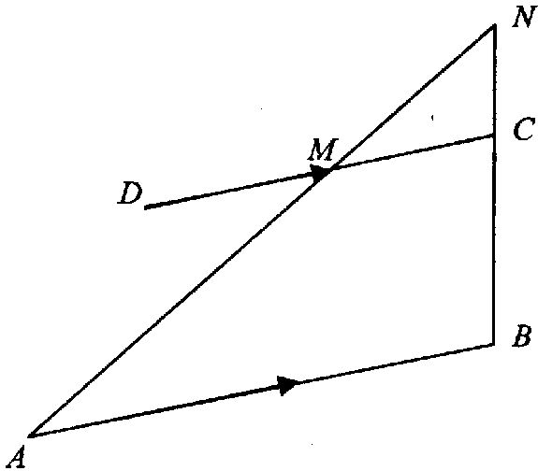
Hence determine the value of h and k and the value of $\frac{\text{areaof}Δ\text{OAQ}}{\text{areaof}Δ\text{OAR}}$. [RI/2001/P1]

- The position vectors of points A, B and C relative to an origin O are 5a + 6b, 8a and 4a – 8b respectively. Vectors a and b are non-parallel vectors. The point D on the same plane is such that $3\vec{\text{DC}}=2\vec{\text{AB}}$ and M is the midpoint of DC.
  - Express the position vector of D in terms of a and b.
  - Show that $\vec{\text{OM}}=3a−6b$.
  - Prove that O, D, M are collinear
N is a point on BC produced such that $\vec{\text{BN}}=k\vec{\text{BC}}$and AMN is a straight line.
  - Find the position vector of N in terms of a and b
  - Find the ratio of BN : BC and hence state the value of $\frac{\text{area of }Δ\text{MNC}}{\text{area of trapezium }\text{ABCM}}$.
[SCGS/2001/P1]

- The position vectors of points P, Q and R relative to an origin O are -2i + 3j, ai + bj and 6i – 5j respectively. Express $\vec{\text{PQ}}\text{ and }\vec{\text{QR}}$ in terms of a, b, i and j.
If P, Q and R are collinear, deduce an equation connecting a and b.
Given that OQ = 5 units, obtain a further equation connecting a and b and hence find the values of a and b if a > b.
With these values of a and b, find
- the position vector of M where M is the midpoint of PQ
- the ratio of $\frac{\text{PQ}}{\text{PR}}$. [Xinmin/2001/P1]

- The position vectors of the points X, Y and Z, relative to an origin are 3m, 2n and ½m – n respectively. ZO produced meets XY produced at P. Given that $\vec{\text{XY}}=λ\vec{\text{XP}}\text{ and }\vec{\text{OZ}}=μ\vec{\text{OP}}$, where λ and μ are non-zero constants,
  - express $\vec{\text{OP}}$in terms of m, n and λ
  - express $\vec{\text{OP}}$in terms of m, n and μ
  - hence evaluate λ and μ
  - find the numerical value of $\frac{\text{area of }Δ\text{OPY}}{\text{area of }Δ\text{OXY}}$.
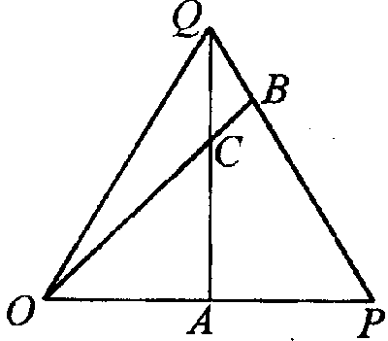
  - Find the numerical value of $\frac{\text{area of }Δ\text{OZX}}{\text{area of }Δ\text{OYP}}$. [RGS/2001/P1]

- The position vectors of P and Q relative to an origin O are p and q respectively. The midpoint of OP is A and B is the point such that PB = 3BQ. AQ intersects OB at C.
Given that $\vec{\text{OC}}=α\vec{\text{OB}}$ and $\vec{\text{AC}}=β\vec{\text{AQ}}$, express $\vec{\text{OC}}$ in terms of
  - α, p and q
  - β, p and q

Hence determine the value of α and β. [FMSS/2001/P1]

- Points A and B have position vectors a and b relative to origin O. Point C is such that $\vec{\text{BC}}=\frac{2}{3}\vec{\text{OA}}\text{.}$The line OC and AB meet at D such that $\vec{\text{OD}}=λ\vec{\text{OC}}$ and $\vec{\text{AD}}=μ\vec{\text{AB}}$. Express $\vec{\text{OD}}$ in terms of (i) λ, a and b
(ii) μ, a and b
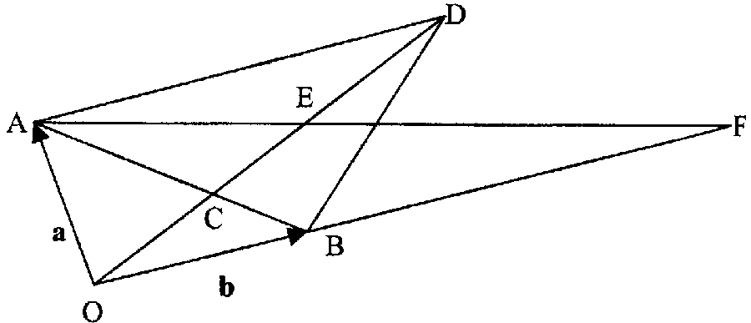
Hence evaluate λ and μ and find the ratio AD : DB. [Cedar/2001/P1]

- In the figure, the position vectors of A and B relative to an origin O are a and b respectively. Given that C is a point on AB such that AC = 2CB,
  - express $\vec{\text{OC}}$in terms of a and b
  - Given that D is a point such that $\vec{\text{AD}}=m\vec{\text{OB},}$
      - express $\vec{\text{OD}}$ in terms of m, a and b,
      - find m if O, C and D are collinear.
Hence write down the ratio OC : OD
  - If E is a point on OD such that OC = CE, write down the vector $\vec{\text{AE}}$. Also given that $\vec{\text{AF}}=k\vec{\text{AE}}$ and O, B and F are collinear, find the value of k.
[Catholic/2001/P1]

- Points A and B have position vectors a and b relative to origin O. Point C is such that $\vec{\text{BC}}=\frac{2}{3}\vec{\text{OA}}$. The lines OC and AB meet at D such that OD = λOC and AD = μAB. Express OD in terms of (i) λ, a and b
(ii) μ, a and b
hence evaluate μ and λ and find the ratio of the area of $\frac{\text{areaof}Δ\text{OAB}}{\text{areaof}Δ\text{ODB}}$. [MGS/2001/P1]

- The position vectors of points R and S relative to an origin O are r = 2i + 3j and s = λi - 3j respectively.
(i) Find the value of λ and μ if μr + 2s = 2i –18j.
(ii) Find the values of λ such that $\left|4\underline{r}+\underline{s}\right|=3\left|\underline{s}\right|$
- Find a unit vector which is parallel to r [CHIJ(TP)/2001/P1]

- (a) Relative to an origin O, the position vectors of the points P and Q are i+3j and
–5i-3j respectively. Given that R is the point such that $\vec{\text{PR}}=3\vec{\text{QR}}$, find the vector which is parallel to $\vec{\text{OR}}$and of magnitude $\frac{1}{4}$units.
(b) OABC is a parallelogram. D divides OA in the ratio OD:DA=2:1 and E is the mid-point of OC. F is the intersection of CD and BE. Given that $\vec{\text{OA}}=a$ and $\vec{\text{OC}}=c$ and that $\frac{\text{CF}}{\text{CD}}=λ$ and $\frac{\text{EF}}{\text{EB}}=μ$, express $\vec{\text{OF}}$ in terms of
(i) $λ,a$ and c
(ii) µ, a and c. Hence evaluate µ and $λ$.
- State the value of $\frac{\text{area}Δ\text{CFB}}{\text{area}Δ\text{CEF}}$. [VS/2002/P1]

13.

Answers:
- (i) -2i + 7j (ii) $\vec{\text{OM}}=(−\text{15}λ+\text{14})\underline{i}+(4−\frac{1}{2}λ)\underline{j}$ (iii) $\vec{\text{OM}}=(−9μ+7)\underline{i}+(5μ+2)\underline{j}$
(iv) $μ=\frac{1}{3},λ=\frac{2}{3}$
- (i)$\frac{2}{3}λp+\frac{1}{3}q (\text{ii})(1−μ)p+\frac{1}{2}μq;μ=\frac{1}{2},λ=\frac{3}{4}$
- $\vec{\text{BP}}=\frac{4}{3}\underline{a}−\underline{b,}$ $\vec{\text{OQ}}=\frac{2}{5}\underline{a}+\frac{3}{5}\underline{b}$ (i) $\vec{\text{OR}}=\frac{2}{5}h\underline{a}+\frac{3}{5}h\underline{b}$ (ii) $\vec{\text{OR}}=\frac{4}{3}k\underline{a}+(1−k)\underline{b}$; h = $1\frac{1}{9}$, k = $\frac{1}{3}$; $\frac{9}{\text{10}}$
- (i) 2a – 4b (ii) 3a – 6b (iv) $\vec{\text{ON}}$= 2a – 12b (v) 3 : 2; $\frac{1}{8}$
- $\vec{\text{PQ}}=(2+a)i+(b−3)j$, $\vec{\text{QR}}=(6−a)i−(5+b)j$; a + b = 1; a = 4, b = –3 (i) $\vec{\text{OM}}=i$ (ii) $\frac{3}{4}$
- (i) $\vec{\text{OP}}=\frac{3(λ−1)}{λ}m+\frac{2}{λ}n$ (ii) $\vec{\text{OP}}=\frac{1}{2μ}m−\frac{1}{μ}n$ (iii) $λ=\frac{2}{3},μ=−\frac{1}{3}$ (iv) ½ (v) 1
- (i) $\frac{α}{4}(p+3q) (\text{ii})\frac{1}{2}(1−β)p+βq$; $β=\frac{3}{5},α=\frac{4}{5}$
- (i) λ(b + $\frac{2}{3}$a) (ii) (1 – μ)a + μb; 3 : 2
- (i) $\frac{1}{3}\underline{a}+\frac{2}{3}\underline{b}$ (ii)(a) $\underline{a}+m\underline{b}$ (b) m = 2, 1 : 3 (iii) $−\frac{1}{3}\underline{a}+\frac{4}{3}\underline{b}$, k = 3
- (i) $\vec{\text{OD}}=λ(\underline{b}+\frac{2}{3}\underline{a)}$ (ii) $\vec{\text{OD}}=(1−μ)\underline{a}+μ\underline{b}$; $λ=\frac{3}{5},μ=\frac{3}{5}$; $\frac{5}{2}$
- (i) λ = 5 (ii) λ = 4 or –2 (iii) $\frac{1}{\sqrt{\text{13}}}\left(\begin{matrix}2 \\ 3\end{matrix}\right)$
- (a) $−\frac{1}{5}i−\frac{3}{\text{20}}j$ (bi) $\frac{2}{3}λa+(1−λ)c$,(ii) $μa+\frac{1}{2}(1+μ)c$; $λ=\frac{3}{8},μ=\frac{1}{4}$ (iii) 3

