
Crescent Girls’ School
Additional Mathematics

Worksheet: Vectors (1)
Name:_______________________________ ( ) Class:_______________

- Given that a = 2i – 3j, b = i + 2j and c = 3i – j, find an equation connecting m and n such that ma – nb is parallel to c, where m and n are constants. [Catholic/2001/P1]

- The position vector of a point A has a magnitude of 26 units and is in the opposite direction as 12i – 5j. Calculate the coordinates of A. [Cedar/2001/P1]

- The points P, Q and R have position vectors 2a + 4b, 3a + tb and 5a – 4b respectively where t is a constant. If PQR is a straight line, find the value of t. [Cedar/2001/P1]

- P, Q and R are points with position vectors 3a + b, λ(a – b) and a – 2b respectively relative to an origin O. Obtain expressions for $\vec{\text{PQ}}\text{ and }\vec{\text{PR}}\text{.}$ Given that Q lies on PR, find the value of λ
[CHIJ(TP)/2001/P1]

- Given that $\vec{\text{PQ}}=3i+8j\text{ and }\frac{1}{4}\vec{\text{PR}}=2i−j\text{.}$Find a unit vector in the direction $\vec{\text{QR}}$.
[FMSS/2001/P1]

- Given that $\vec{\text{OP}}=a+\text{b, }\vec{\text{OQ}}=3a−5b\text{ and }\vec{\text{OR}}=9a−\text{23}b$, show that P, Q, R are collinear.
[FMSS/2001/P1]

- Given that a = i + 2j, b = 2i – 2j and c = 6i – j are three position vectors of A, B and C relative to origin O respectively.
  - Show that ΔABC is an isosceles triangle.
- Write down the vector p, where the magnitude is √40 units and is in the same direction as the vector a + b – c [MGS/2001/P1]

  - The position vectors of A , B and C relative to an origin are 3i + 4j, i and –2i– 6j. Show that A, B and C are collinear. P is a point on BC such that AB = BP, find the position of P.
[MGS/2001/P1]

  - Find the unit vector which is in the opposite direction of the vector 3i – 4j. [VS/2001/P1]
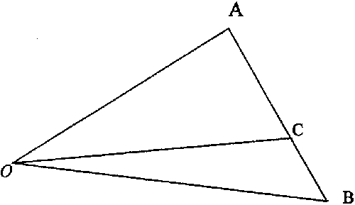
  - In the above diagram, the position vectors of A and C with respect to O are given by $\vec{\text{OA}}=\left(\begin{matrix}3 \\ 2\end{matrix}\right)\text{ and }\vec{\text{OC}}=\left(\begin{matrix}4 \\ \frac{1}{3}\end{matrix}\right)$ respectively, and AC = $\frac{4}{5}$AB. Find $\vec{\text{OB}}$as a column vector.
[VS/2001/P1]
  - The position vectors of the three points A, B and C relative to an origin O are
$\vec{\text{OA}}=\left(\begin{matrix}1 \\ k−2\end{matrix}\right),\vec{\text{OB}}=\left(\begin{matrix}k \\ 3k−4\end{matrix}\right)\text{ and }\vec{\text{OC}}=\left(\begin{matrix}k+1 \\ 2k\end{matrix}\right)$.
Find (i) the value of k if O, A and B are collinear
(ii) $\vec{\text{OD}}$, where D is the midpoint of AC. [VS/2001/P1]

  - Two vectors p and q are such that p = 3i + 2j and q = 5i + 9j. Using a vector method, find
- the unit vector in the direction of q
- the vector which is parallel to q – 3p and has a magnitude of 25 units.
[SJI/2001/P1]

  - The three points O, X and Y are such that $\vec{\text{OX}}=\left(\begin{matrix}5 \\ −2\end{matrix}\right)\text{ and }\vec{\text{OY}}=\left(\begin{matrix}\text{10} \\ −4\end{matrix}\right)$. Show that O, X and Y are collinear. [SJI/2001/P1]
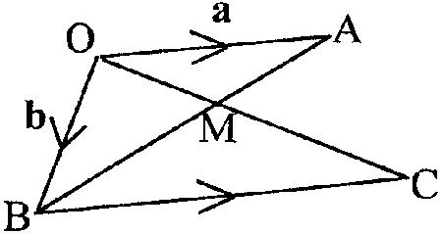
  - In the figure, the position vectors of the points A and B relative to an origin O are a and b respectively. OC and AB intersect at a point M such that $\frac{\text{AM}}{\text{MB}}=\frac{\text{OM}}{\text{MC}}=\frac{2}{3}$. Express $\vec{\text{BC}}$ in terms of a and/or b. Hence show that OA is parallel to BC. [SJI/2001/P1]

  - Vector $\vec{\text{AB}}$ is in the same direction as vector $9i−\text{12}j$ and has a magnitude of 60 units. The position vector of A relative to the origin O is – 6i + 19j. M is the midpoint of line segment AB and vector pi + qj is a unit vector in the direction of $\vec{\text{OM}}$. Find
(i) $\vec{\text{AB}}$in terms of i and j.
  - The values of p and q. [SCGS/2001/P1]

  - The position vectors of points A, B and C relative to an origin O are i – 2j, -3i + j and pi + qj respectively. Given that p is positive, $\vec{\text{OC}}$is a unit vector and $\vec{\text{AB}}$ is parallel to $\vec{\text{OC}}$, find the values of p and q. [RI/2001/P1]

  - The position vectors of points A, B and C relative to an origin O are –2i – 3j, 3i + 7j and pi + 2j respectively. Find the value of p if A, B and C are collinear. [RI/2001/P1]

  - If $\frac{1}{3}[(3−λ)i+2λj]$ is a unit vector, where λ > 0, find the value of λ. [RGS/2001/P1]

  - The three points O, P, Q are such that $\vec{\text{OP}}=\left(\begin{matrix}2 \\ 3\end{matrix}\right)\text{ and }\vec{\text{OQ}}=\left(\begin{matrix}q \\ 2q\end{matrix}\right)\text{.}$ Given that $\vec{\text{PQ}}$ is a unit vector, calculate the possible values of q. [Xinmin/2001/P1]

  - (i) The vector $\vec{\text{OA}}$ has a magnitude 10 and has the same direction as 3i - 4j. Express $\vec{\text{OA}}$ in terms of i and j.
(ii) The vector $\vec{\text{OB}}$is 13i + 16j. Obtain the unit vector in the direction of $\vec{\text{AB}}\text{.}$
[FMSS/2002/P1]

  - The position vectors of the points A and B with respect to O are a and b respectively. Given that a=6i+4j and b=2i-3j , find (i) the value of $\left|a+2b\right|\text{.}$(ii) the vector $\vec{\text{OC}}$which has the same direction as $\vec{\text{BA}}$ and has a magnitude of $5\sqrt{\text{13}}\text{.}$ [CHIJ(SN)/2002/P1]

  - The position vectors of two points P and Q relative to an origin O are p and q respectively. Given that $p=−2i+5j$ and $q=−i+j$ and that $kp+(4+k)q$is parallel to $\vec{\text{PQ}}\text{.}$ Calculate the value of k. [CHIJ(TP)/2002/P2]

  - Given that $a=pi+2j,$ $b=−i−j,$find the positive value of p if
(i) $2a+3b$is parallel to j,
(ii) $\left|a−b\right|=5,$and hence, write down the unit vector along $a−b\text{.}$ [Cedar/2002/P1]

  - The position vectors of the points A and B, relative to an origin O, are $−3i+4j$ and $ki+2kj$ respectively.
- Given that the magnitude of $\vec{\text{AB}}$is 2, calculate the values of k.
- Given that $\vec{\text{OC}}$is the unit vector in the same direction as $\vec{\text{OA},}$find the position vector of C. [SJI/2002/P1]

  - The position vectors of the points A,B and C are given by $\left(\begin{matrix}2 \\ 3\end{matrix}\right),\left(\begin{matrix}5 \\ −1\end{matrix}\right)$ and $\left(\begin{matrix}\text{11} \\ α\end{matrix}\right)$ respectively.
    - Find the unit vector in the direction of $\vec{\text{AB}}$.
    - Find the value of α if A,B and C are collinear.
    - If α=1, find by a vector method, the position vector of the point D such that ABCD is a parallelogram. [RGS/2002/P1]

  - Relative to an origin, the position vectors of the points A and B are $4i+j$and $8i+3j$respectively. Given that P is the point such that $\vec{\text{AP}}=2\vec{\text{AB}},$ find the unit vector which is the same direction as OP. [TKSS/2002/P1]

  - (a) Given that the vectors of points A, B and C are $\left(\begin{matrix}−4 \\ 3\end{matrix}\right),\left(\begin{matrix}5 \\ 2\end{matrix}\right)$ and $\left(\begin{matrix}8 \\ a−1\end{matrix}\right)$ respectively. Find
(i) the value of a if A, B and C are collinear.
(ii) the position vector of D such that $\vec{\text{AD}}=−2\vec{\text{DB}\text{.}}$

(b) Given that the vectors p=i+4j and q=-2i+5j, find the value of m and n such that
mp+nq=-13i+13j. [TKSS/2002/P2]
28. The vector $\vec{\text{OA}}$ has magnitude 85 and is in the opposite direction of $\left(\begin{matrix}8 \\ −\text{15}\end{matrix}\right)\text{.}$ Express $\vec{\text{OA}}$ as a column vector. The vector $\vec{\text{BA}}$ is $\left(\begin{matrix}−\text{35} \\ \text{63}\end{matrix}\right)\text{.}$ Obtain the unit vector in the direction of $\vec{\text{OB}}\text{.}$
[NYHG/2002/P1]

29. The position vectors of points P and Q relative to an origin O are $−i+2j$ and $\text{10}i+4j$ respectively. The point L is on OP produced such that OL=3OP and M is the midpoint of OQ. The point X is on LM such that $\vec{\text{LX}}=λ\vec{\text{LM}}\text{.}$
- Find $\vec{\text{LM},}$ in terms of i and j.
- Obtain an expression for $\vec{\text{PX},}$in terms of $i,j$and $λ$.
(iii) Given that the points P, X and Q are collinear, calculate the value of the
(a) $λ$, (b) $\frac{\text{PX}}{\text{XQ}}\text{.}$ [NYHG/2002/P2]

30. Relative to O, the position vectors of points A and B are $4i−j$ and $3j−4i$ respectively. Given that $\vec{\text{BX}}=\vec{2\text{BA}},$ find the vector in the direction of $\vec{\text{OX}}$ and has a magnitude of 26 units.
[MGS/2002/P2]

31. The position vectors relative to an origin O, of P and Q are 3a+5b and 4a+3b respectively, where a and b are non-parallel vectors. If the position vector of R is 2a+7b and if $\vec{\text{OR}}=m\vec{\text{OP}}+n\vec{\text{OQ},}$ find the value of m and of n. [ACS(I)/2002/P1]

32. The position vectors of points A and B relative to an origin O are 3a-b and 3b respectively. P is a point on OA such that OP=3PA. Q is a point on AB such that AQ=2QB

- Express the position vectors of P and Q in terms of a and/or b.
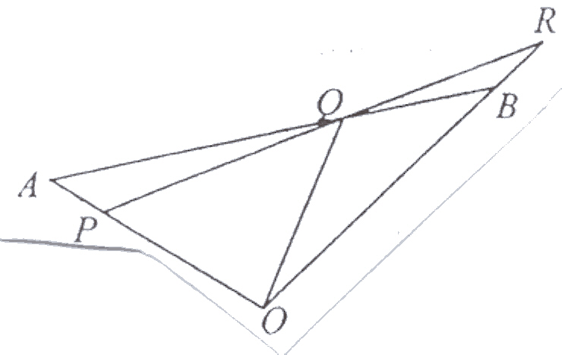
- R is a point on OB produced such that $\vec{\text{OR}}=kb$. Find the value
of k such that P, Q and R are collinear. [CHS/2002/P1]

33. (a) The position vectors, relative to the origin O, of the points A and B are $7i+3j$ and $i−5j$
respectively. Given that $\vec{\text{OC}}$is the unit vector parallel to $\vec{\text{AB}},$ find the position vector of C relative to O.

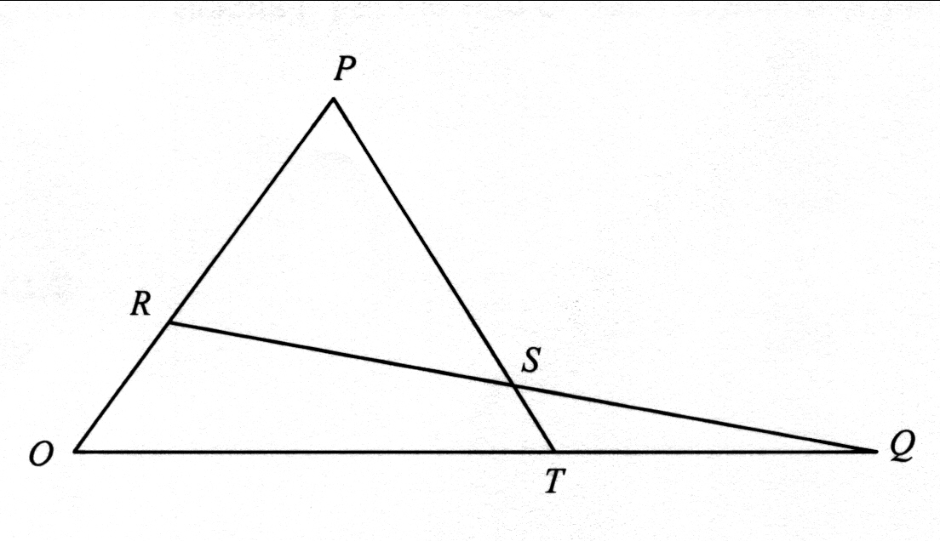
(b) Points P and Q have position vectors p and q respectively, relative to the origin O. The point R on OP is such that $\text{OR}=\frac{2}{5}\text{OP}\text{.}$ The point S on RQ is such that $\text{RS}=\frac{1}{2}\text{RQ}\text{.}$
- Express $\vec{\text{OS}}$ and $\vec{\text{PS}}$ in terms of p and q.
PS produced meets OQ at T, where OT=αOQ.
- Express $\vec{\text{PT}}$ in terms of α, p and q, and evaluate α.

[CHIJTP/2002/P2]

Answers:
- m = –n
- (-24, 10)
- t = $\frac{4}{3}$
- $$\vec{\text{PQ}}=(λ−3)a−(λ+1)b;\vec{\text{PR}}=−2a−3b;λ=1\frac{2}{5}$$
- $$\frac{1}{\text{13}}(5i−\text{12}j)$$
- –
- p = –6i + 2j
- (–1, –4)
- $$−\frac{3}{5}i+\frac{4}{5}j$$
- $$\left(\begin{matrix}4\frac{1}{4} \\ −\frac{1}{\text{12}}\end{matrix}\right)$$
- k = 4, $\left(\begin{matrix}3 \\ 5\end{matrix}\right)$
- (i) $\frac{1}{\sqrt{\text{106}}}(5i+9j)$ (ii) $−\text{20}i+\text{15}j$
- –
- $$\vec{\text{BC}}=\frac{3}{2}a$$
- (i) 36i – 48j (ii) $p=\frac{\text{12}}{\text{13}},q=−\frac{5}{\text{13}}$
- p = 0.8, q = -0.6
- p = ½
- λ = 1.2
- $$q=1\frac{1}{5}\text{ or 2}$$
- (i) 6i - 8j (ii) $\frac{1}{\text{25}}$(7i +24j)
- (i)10.2 (ii) $\sqrt{5}(4i+7j)$
- –2
- (i) 1.5 (ii) $\frac{1}{5}\left(\begin{matrix}4 \\ 3\end{matrix}\right)$
- (i) $k=3,\frac{7}{5}$ (ii) $\vec{\text{OC}}=\frac{1}{5}\left(\begin{matrix}3 \\ 4\end{matrix}\right)$
- (a) $\frac{1}{5}\left(\begin{matrix}3 \\ −4\end{matrix}\right)$ (b) α= -9 (c) $\left(\begin{matrix}8 \\ 5\end{matrix}\right)$
- $$\frac{\text{12}}{\text{13}}i+\frac{5}{\text{13}}j$$
- (a) (i) $a=2\frac{2}{3}$ (ii) $\vec{\text{OD}}=\left(\begin{matrix}\text{14} \\ 1\end{matrix}\right)$ (b) n=5; m=-3
- $$\left(\begin{matrix}−\text{40} \\ \text{75}\end{matrix}\right),\frac{1}{\text{13}}\left(\begin{matrix}−5 \\ \text{12}\end{matrix}\right)$$
- (i) 8i-4j; (ii)$\left(−2+8λ\right)i+\left(4−4λ\right)i$; (iii) (a) $\frac{4}{5}$ (b) $\frac{2}{3}$
- 24i-10j
- m=2; n=-1
- (i) $\vec{\text{OP}}=\frac{3}{4}\left(3a−b\right),\vec{\text{OQ}}=a+\frac{5}{3}b$ (ii) $3\frac{3}{5}$
- (a) $\vec{\text{OC}}=\left(\begin{matrix}−35 \\ −45\end{matrix}\right)$ (bi) $\vec{\text{OS}}=\frac{1}{5}p+\frac{1}{2}q$; $\vec{\text{PS}}=\frac{1}{2}q−\frac{4}{5}p$ (biii) $\vec{\text{PT}}=αq−p,α=\frac{5}{8}$

