
Crescent Girls’ School
Secondary 4 Express
Weekend Assignment (Term 1 Week 1)
.
ARITHMETIC

1. A map of a region is drawn on a scale of 1:40000.
- Calculate the actual length of a road in km if the length on the map is 2.5 cm.
(b) Find the actual area in m², which represents 1 cm² on the map.
Ans: (a)$1$km (b)$\text{160000}$m²

2. Evaluate
- 2.24 ÷ 0.07
(b) $\frac{1}{\text{21}}÷\left(−3\frac{1}{3}\right)×\left[\frac{1}{3}−\frac{1}{5}×\left(−2\frac{1}{2}\right)\right]$
Ans: (a)$\text{32}$ (b)$−\frac{1}{\text{84}}$

3. A man walks a distance of 3 km at an average speed of 6 km/h and then, without stopping, runs a further of 500 m in 2 minutes. Calculate
- the time, in minutes, it takes to walk,
- his running speed in km/h and
- his average speed for the whole journey in km/h.
Ans: (a)$\text{20}$mins (b)$\text{15}$km/h (c)$6\frac{9}{\text{11}}$km/h

4. Three men Peter, David and Richard invested $40 000, $80000 and $30 000 respectively in a business. At the end of each year, 25% of the profit made was placed on reserve and the remainder was divided among the partners in proportion to their investment.
- Given that in a certain year, the profit is $12 000, calculate
(i) the amount received by Peter and
(ii) the amount placed on reserve.
(b) The following year, David received $6 000. Calculate
(i) the amount received by Richard and
- the amount received by Peter.
Ans: (a)(i) $$\text{2400}$ (ii) $$\text{3000}$ (b)(i) $$\text{3000}$ (ii) $$\text{2250}$

- A company charges $530.40 for transporting goods weighing 48 kg for 36 km. If the charge is 35 cents per kg per km for the first 5 km, how much less is the charge per kg per km for every subsequent km?
Ans: $5$cents

Crescent Girls’ School
Secondary 4 Express
Weekend Assignment (Term 1 Week 2)

ALGEBRA

1) Factorise completely
(a) $3a^{3}−\text{27}a^{2}b+3a^{2}c−\text{27}\text{abc}$
- $$\text{63}−7w^{2}$$
Ans: (i)$2a−3a^{\frac{1}{2}}−2$ (ii)$\frac{3}{x−y}$

2(a) Solve the equation
$\frac{3}{p}−\frac{p}{1+p}=\frac{5}{2}$.
(b) Simplify $\frac{4k−3k^{2}}{6k^{2}+k−\text{12}}$.
- Given that $1+\text{mn}=p−3\text{qn}$, express n in terms of m, p and q.
Ans: (a)$−\frac{6}{7}$,$1$ (b)$−\frac{k}{2k+3}$ (c)$n=\frac{p−1}{m+3q}$
3. Solve the following equations.
(a) $\frac{1}{3}(x−4)+\frac{1}{4}(x−5)=\frac{1}{7}(x−9)$
- $(2x+1)(x+2)=5$
Ans: (a)$2\frac{\text{35}}{\text{37}}$ (b)$\frac{1}{2}$,$−3$
4. Given that $x=t−\frac{1}{t}$ and $y=t+\frac{1}{t}$, express the following in terms of t and simplify the results.
- $$\text{xy}$$
(b) $x^{2}+y^{2}$
(c) $x^{2}−y^{2}$
Given that $x=1\frac{1}{2}$, hence find the two possible values of y.
Ans: (a)$t^{2}−\frac{1}{t^{2}}$ (b)$2(t^{2}+\frac{1}{t^{2}})$ (c)$−4$,$y=−2\frac{1}{2}$or$2\frac{1}{2}$
5) Solve the simultaneous equations
$$\frac{2}{u}+\frac{5}{v}=\text{13}$$
$\frac{3}{v}−\frac{1}{u}=\text{10}$
Ans: $u=−1$,$v=\frac{1}{3}$

Crescent Girls’ School
Secondary 4 Express
Weekend Assignment (Term 1 Week 3)
.
COORDINATE GEOMETRY

- The equation of the line l is $3x−4y=\text{24}$and it intersects the x-axis at A and
y-axis at B. The mid-point of AB is M and O is the origin. Find
- the coordinates of A and B,
- the gradient of l,
- the length of AB,
- the coordinates of M and
- the equation of the line passing through B and parallel to OM.
Ans: (a)$A(8,$$0)$,$B(0,$$−6)$(b)$\frac{3}{4}$ (c)$\text{10}$units (d)$(4,$$−3)$ (e)$y=−\frac{3}{4}x−6$
2(a) The line $\text{mx}=\text{ny}+5$ is parallel to the x-axis. Find the value of m and state the condition for the line to be parallel to the y-axis.
(b) The points (2, -3), (3, -2) and (8, k) are collinear. Find the value of k.
Ans: (a)$m=0$,$n=0$ (b)$3$
3. The curve ${\text{px}}^{3}+8$ intersects the y-axis at A and passes through the point (2, 48).
- Write down the coordinates of A.
Calculate the value of p.
Ans: (a)$A(0,$$8)$ (b)$5$

4(a) The points (1, -5), (3, -1) and (7, k) lie on a straight line. Find the value of k.
(b) Given that the line $\frac{x}{3}+\frac{y}{2}=1$cuts the x-axis at A and y-axis at B, write down the gradient of the line and the coordinates of A and of B.
(c) (i) Given that the straight line $y=\frac{1}{2}x+k$ passes through a point A(-1, -3), calculate the value of k.
- Another straight line m parallel to$y=\frac{1}{2}x+k$ passes through the point B($\frac{1}{2}$, 0). Find the equation of the line m.
Ans: (a)$7$(b)$−\frac{2}{3}$,$A(3,$$0)$,$B(0,$$2)$(c)(i)$−2\frac{1}{2}$(ii)$y=\frac{1}{2}x−\frac{1}{4}$

Crescent Girls’ School
Secondary 4 Express
Weekend Assignment (Term 1 Week 4)

COORDINATE GEOMETRY

1(a) The points (2, -3), (3, -1) and (4, k) lie on a straight line. Find k.
(b) Given that the line $y=\text{mx}+c$has gradient -1 and passes through the point (2, 3), find the values of m and c.
Ans: (a)$1$ (b)$m=−1$,$c=5$
2. The diagram shows part of the graph $y=\frac{1}{x}−2$.
(a) A point B is on the curve such that its coordinates are (-1, b). Find the value of b.
(b) Given that the straight line $y=\frac{1}{2}x+k$ passes through B, calculate the value of k.
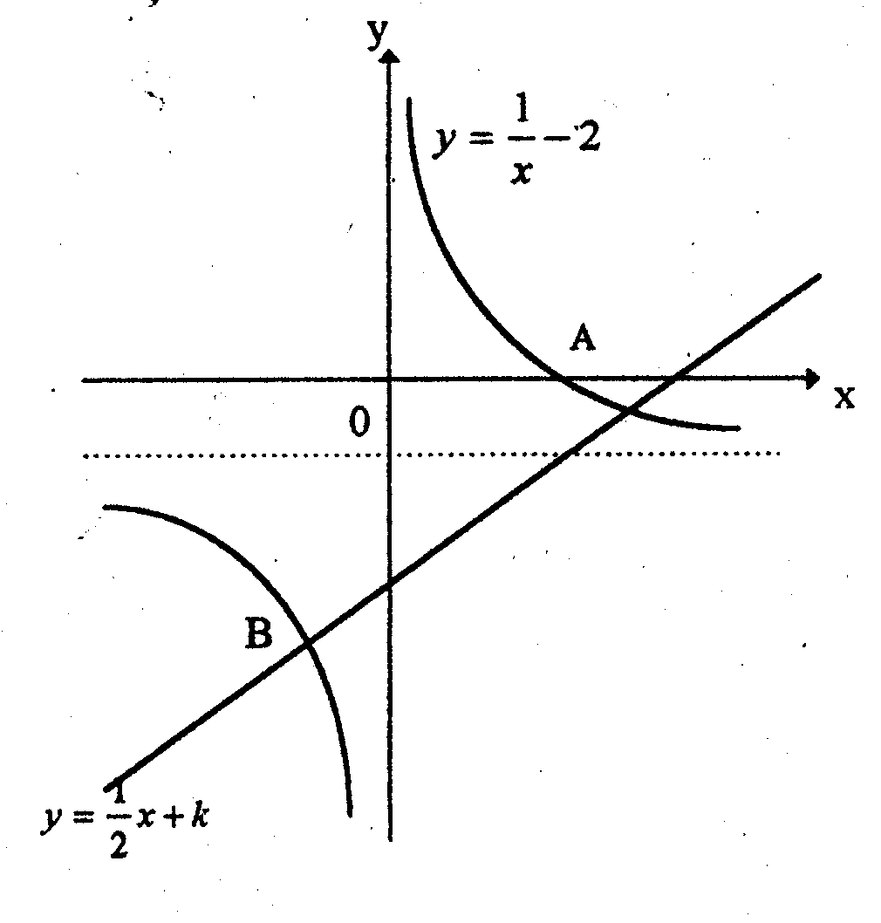
Another straight line m parallel to $y=\frac{1}{2}x+k$ passes through the point A. Find the equation of the line m.
Ans: (a)$−3$ (b)$−2\frac{1}{2}$ (c)$4y=2x−1$
3. A straight line has equation $2y+\frac{1}{2}x=6$.
(a) Write down the gradient of the line.
- Find the coordinates of the point of intersection of the line and the y-axis.
Ans: (a)$−\frac{1}{4}$ (b)$(0,$$3)$
4. Given that the equation of a line is $0\text{.}5x−2y=2$. This line intersects the x-axis at the point P and the y-axis at the point Q. The mid-point of P and Q is M. Find
(i) the gradient of the line and
- the coordinates of M.
Ans: (i)$\frac{1}{4}$ (ii)$(2,$$−\frac{1}{2})$

Crescent Girls’ School
Secondary 4 Express
Weekend Assignment (Term 1 Week 5)

- A, B, C and D are four points on the field. A is due North of D, B is due east of D and ∠DBC = 37⁰. Given that AD = 34 m, BA = 57 m and BC = 28 m, calculate
- ∠BAD,
- the bearing of B from A,
- the area of triangle BCD and
- CD (Leave your answer to 1 dec. place where applicable.)
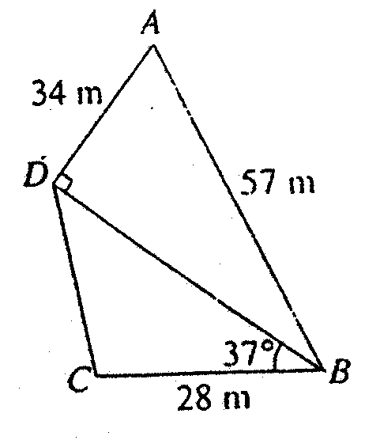

Ans: (i)$\text{53}\text{.}4^{0}$ (ii)$\text{126}\text{.}6^{0}$ (iii)$\text{385}$m² (iv)$\text{28}\text{.}8$m

- In the figure, a rectangular piece of paper ABCD is folded along EF so that C and A coincided.
If AB = 3 cm, BC = 4 cm, find the length of BF.
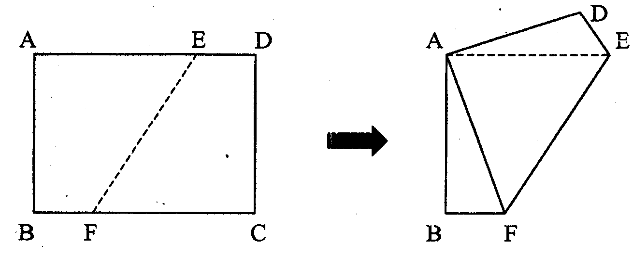
Ans: $\frac{7}{8}$cm
3(a) In the diagram AB = 20 cm, ∠BAC = 90⁰ and ∠ABC = 60⁰. Using as much information given below as necessary, calculate
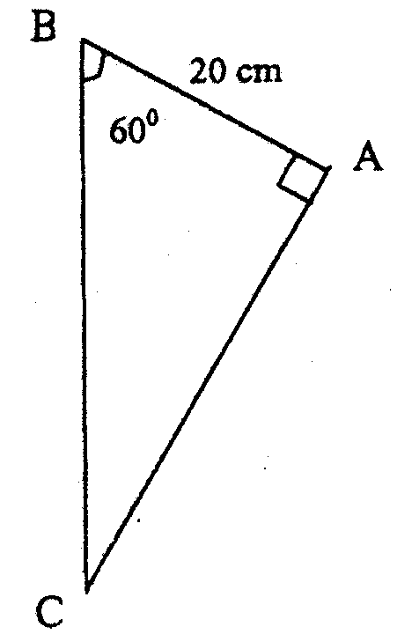
- AC and
- BC.
[sin 60⁰ = 0.866, cos 60⁰ = 0.5, tan 60⁰ = 1.73)

Ans: (a) (i)$\text{34}\text{.}6$cm (ii)$\text{40}$cm (b)$5$km

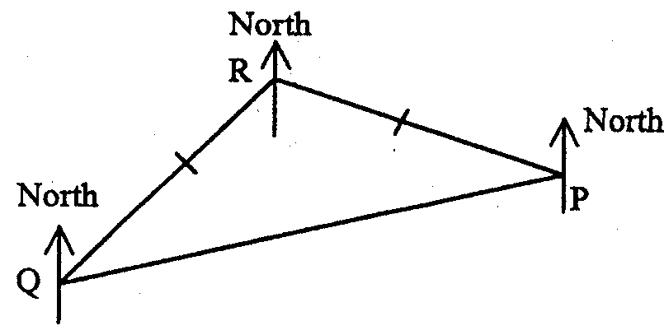
- The towns P, Q and R are such that P and Q are equidistant from R. The bearing of P from R is 110⁰ and the bearing of Q from R is 230⁰. Calculate,
(a) ∠QRP,
(b) the bearing of R from Q and
(c) the bearing of Q from P.

Ans: (a)${\text{120}}^{0}$ (b)$\text{050}$(c)${\text{260}}^{0}$

Crescent Girls’ School
Secondary 4 Express
Weekend Assignment (Term 1 Week 6)
.
- Three of the faces of a solid triangular prism, as shown in the diagram, are rectangular. The prism lies on a horizontal table and triangles ABC and DEF are vertical to the table.

Given that BE = 30 cm, AB = 10 cm, AC = 8 cm and ∠BAC = 47⁰, find
(a) BC,
(b) ∠CEA,
(c) ∠BPE where P is the mid-point of AD and
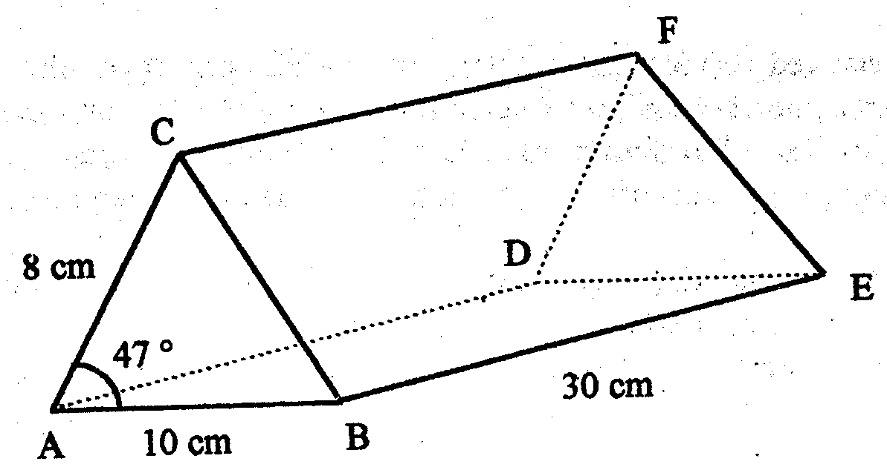(d) the area of ΔABC.

Ans: (a)$7\text{.}\text{41}$cm (b)$\text{14}\text{.}6^{0}$
(c)$\text{112}\text{.}6^{0}$ (d)$\text{29}\text{.}3$cm²

- The diagram below represents two triangular fields in a horizontal plane ABCD. BD = 250 m, ∠BAD = 37⁰, ∠ADB = 43⁰ and ∠BDC = 57⁰. A vertical pole DE stands at the corner D of the field. DE = 24 m and the angle of elevation of E from C is 50⁰. Calculate
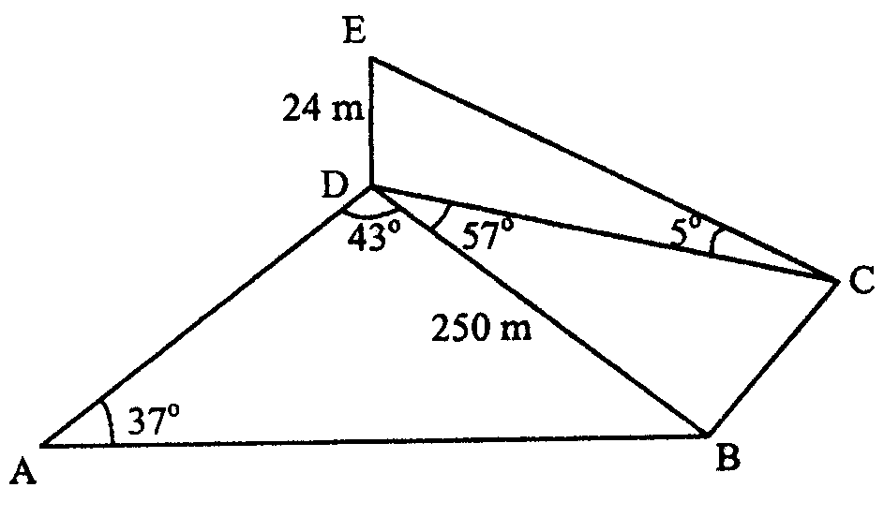
- angle of elevation of E from B,
- the length of BC and
- the length of AD.

Ans: (i)$5\text{.}5^{0}$ ( ii)$\text{251}$m (iii)$\text{409}$m

- ABCDEF is a wedge and ABCD is a rectangular plane inclined at an angle of 30⁰ to the rectangular plane ABFE. CF and DE are perpendicular to the plane ABFE. Given also that ∠CAB = 53⁰ and CF = h mm. Using as much of the information given below as is necessary, calculate,
(a) the lengths of BC and AC in terms of h,
(b) the value of sin ∠CAF and
(c) the value of AB if h =12.
[sin 53⁰ = 0.80, cos53⁰ = 0.601, tan53⁰ = 1.33, sin 30⁰ = 0.50, cos30⁰ = 0.87, tan30⁰ = 0.58]
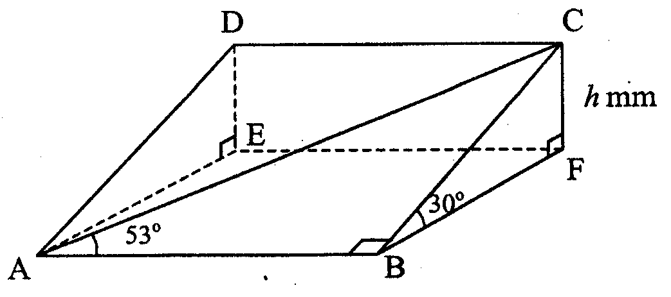
Ans: (a)$\text{BC}=2h,$$\text{AC}=2\frac{1}{2}h$ (b)$\frac{2}{5}$ (c)$\text{18}$mm

Crescent Girls’ School
Secondary 4 Express
Weekend Assignment (Term 1 Week 7)
.
GRAPHS
1. Answer the whole of this question on a sheet of graph paper.
The number of germs, n, in a colony after t hours is given by the equation $n=\text{50}(2^{t})$.
Some corresponding values of n and t are given in the table.

t | 0 | 1 | 2 | 3 | 4 | 5 | 6 | 7
n | 50 | 100 | p | 400 | 800 | 1600 | q | 6400

(a) Find the values of p and of q.
(b) Using a horizontal scale of 2 cm to represent 1 hour and a vertical scale of 2 cm to represent 1 000 germs, draw the graph of n against t.
(c) By drawing a tangent, find the gradient of the graph when $t=5\text{.}5$. State briefly what this gradient represents.
(d) Find the number of germs in the colony after 2.5 hours.
(e) The number of germs in another colony is given by the equation $n=\text{4000}−\text{500}t$.
On the same axes, draw a graph to represent the number of germs in this colony and find when the populations of germs in the two colonies are equal.

2. Two variables, x and y are connected by the equation $y=2+\frac{2}{x}$.
The table shows some corresponding values of x and y.

x | 0.25 | 0.5 | 1 | 2 | 3 | 4 | 5 | 6
y | 10 | 6 | 4 | A | 2.67 | 2.5 | b | 2.33

(a) Find the values of a and b.
(b) Using a scale of 2 cm to 1 unit on the x and y axes, plot the graph of the given equation for $0≤x≤6$and$0≤y≤\text{10}$.
(c) By drawing a tangent, find the gradient of the curve at $x=1$.
(d) By drawing a suitable straight line on the same axes, solve the equation
$\frac{2}{x}=4−x$.

Crescent Girls’ School
Secondary 4 Express
Weekend Assignment (Term 1 Week 8)
.
GRAPHS
1. Answer the whole of this question on a single sheet of graph paper.
The variables x and y are connected by the equation,
$y=\frac{\text{12}}{x}−x$.
Some of the corresponding values of x and y are given in the table below.

X | 1 | 1.5 | 2 | 3 | 4 | 5 | 6 | 8
Y | 11 | 6.5 | 4 | 1 | -1 | a | -4 | -6.5

(a) Calculate the value of a.
(b) Using a scale of 2 cm to represent 1 unit on the horizontal axis and 2 cm to represent 2 units on the vertical axis, draw the graph of $y=\frac{\text{12}}{x}−x$ for $1≤x≤8$.
(c) By drawing a tangent, find the gradient of the curve $y=\frac{\text{12}}{x}−x$ at the point $x=2$.
(d) By drawing another line on your graph, find the solution of the equations:
(i) $\frac{\text{12}}{x}−x−3=2x$
- $x^{2}+2x−\text{12}=0$.

2. The following is an incomplete table of values for the graph of $s=6−\frac{1}{2}t^{2}$.

T | -4 | -3 | -2 | -1 | 0 | 1 | 2 | 3 | 4
S | -2 | a | 4 | b | 6 | 5.5 | c | 1.5 | -2

(a) Calculate the missing values of s.
(b) Using a scale of 2 cm to represent 1 unit on each axis, draw the graph of the function for values of $−4≤t≤4$.
(c) Use your graph to find
(i) the equation of the line of symmetry,
(ii) the value of s when t = 2.2 and
(iii) the coordinates of the point where the value of s is maximum.
(d) Use your graph to estimate the solutions of the equation $t^{2}+t−\text{10}=0$.

PROBABILITY

TYS Unit 9 PAPER1 (Page 200)

Questions 4, 5, 6 and 7.

Crescent Girls’ School
Secondary 4 Express
Weekend Assignment (Term 1 Week 9)
.
INEQUALITIES
1(a) It is given that $6≤x≤8$ and $0\text{.}2≤y≤0\text{.}5$. If $z=\frac{x}{y}$, find the limits in which z must lie.
(b) Given that x and y are integers and $−8≤x≤4$and $−3≤y≤2$, find
(i) the greatest value of $x+y$
(ii) the least value of $\text{xy}$
(iii) the least value of $\frac{y}{x}$
(iv) the greatest value of$(x^{2}+y^{2})$
(v) the least value of $\frac{x}{y}$
2(a) Each 50-cent coin has a radius of 11 mm and a thickness of 2 mm, both measured correct to the nearest millimetre.
(i) Express, as a multiple of π, the smallest possible area of the circular surface of each coin.
- If ten 50-cent coins are stacked up, find the largest possible value of the height of the stack of coins.
(b) When an aircraft from Singapore was reaching New York, the temperature outside the aircraft was -58°C and the ground temperature in New York was 16°C. Both temperatures are given correct to the nearest degree.
(i) Calculate the largest possible value for the difference between these temperatures.
(ii) The aircraft was 12 000 km above the ground.
Given that the temperature changed uniformly with height, calculate, based on the result from part (i), the height of the aircraft above the ground at which the temperature was 0°C.

3. Raymond's weight is 68.9kg.
Rosamund's weight is 56.4kg.
Beatrice's weight is 51.7kg.
If all their weights have been measured correct to the nearest 1 decimal place, find
- the lower bound for the total weights of Raymond and Beatrice,
- the least possible ratio of Rosamond's weight to Beatrice's weight.

4. It is given that $−8≤x≤−3$ and $−5≤y≤4$. Find
- the smallest possible value of $\frac{x}{y^{2}}$,
- the largest possible value of $x^{2}−y^{2}$.

PROBABILITY

TYS Unit 9 PAPER1 (Page 200)

Questions 14, 17, 18 and 19.

Crescent Girls’ School
Secondary 4 Express
Weekend Assignment (Term 1 Week 10)
.
PROPERTIES OF CIRCLES
1. The figure shows a quadrilateral PQRS inscribed in a circle, centre O. PQ makes an angle of 48⁰ with the radius OP and ∠QRS = 80⁰. The tangent to the circle at P meets the tangent to the circle at S at the point T. Calculate,
(a) ∠OPS
(b) ∠PQS
(c) ∠PTS
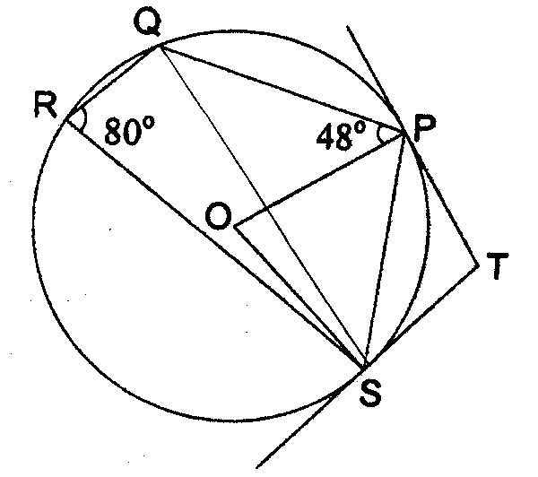
2. RT is a tangent to a circle at R. O is the centre of the circle with radius 8 cm. RP and QU are diameters of the circle. QUT is a straight line. Given that ∠PRU = 58⁰, calculate
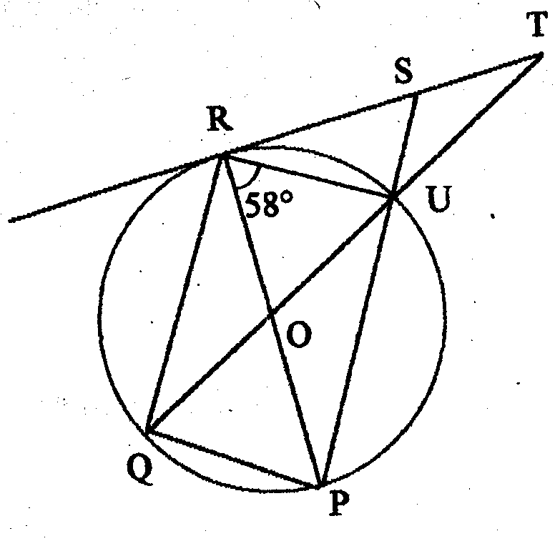
(a) ∠RQU,
(b) ∠STU,
(c) the length of RS,
(d) the length of RU.

3.
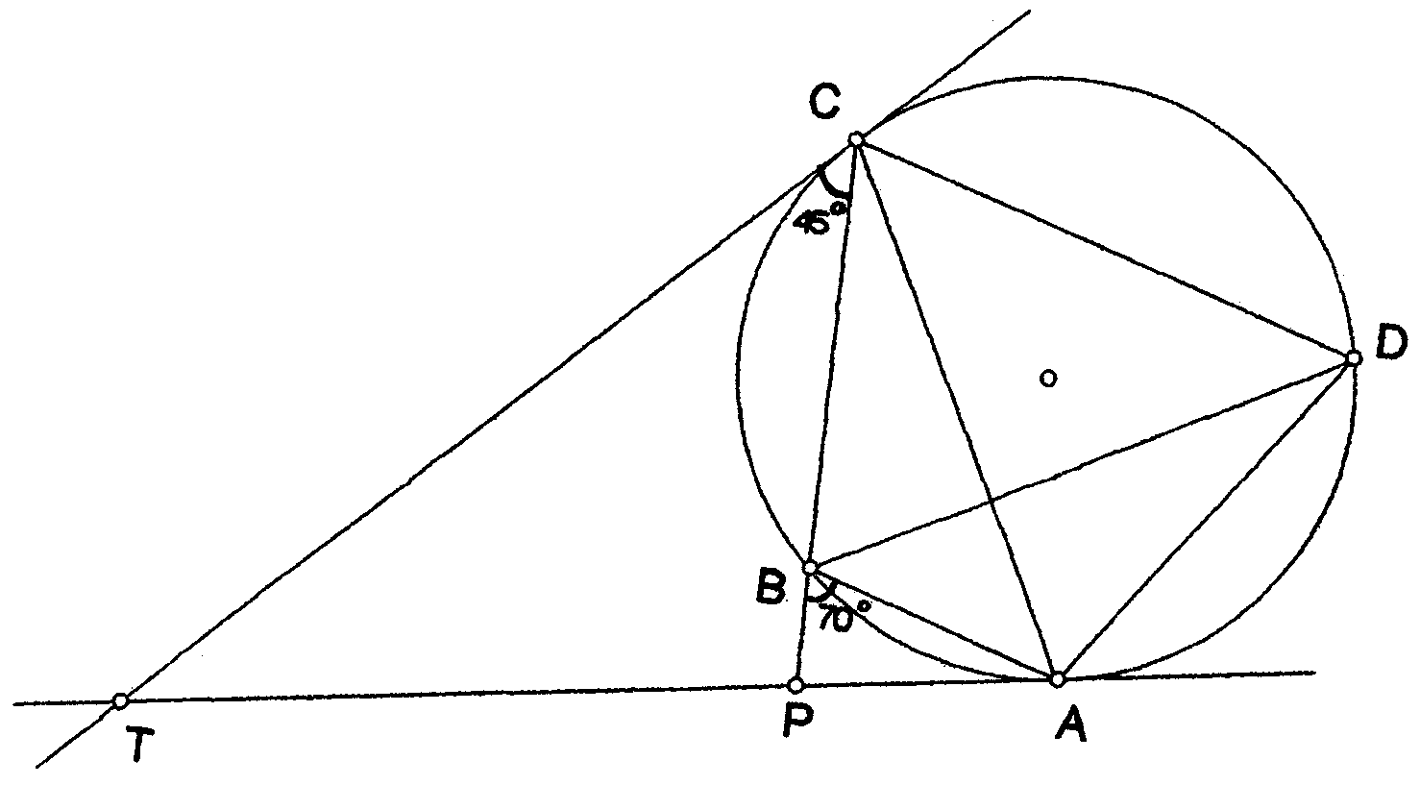

In the diagram, TA, TC are tangents to a circle. The circle passes through A, B, C and D and CB produced meets TA at P. Given that ∠ABP = 70⁰ and ∠TCP = 45⁰,
- calculate
(i) ∠ADC
(ii) ∠ACB
(iii) ∠ATC
(b) Given that TP:TA =3: 4, if the area of ΔACP is 10 cm², find the area of ΔTCA.

PROBABILITY

TYS Unit 9 PAPER 2 (Page 205)

Questions 5, 7, 9 and 10.

Crescent Girls’ School
Secondary 4 Express
Weekend Assignment (Term 2 Week 1)
.
- In a test, the pupils in a class obtained marks as shown in the table below.

Marks | 0 | 1 | 2 | 3 | 4 | 5 | 6
Frequency | 2 | 1 | 3 | 1 | 8 | x | 7

Determine,
(a) if$x=3$, the modal mark,
(b) the largest value of x if the median is 4,
(c) if$x=1$, the mean mark.

Ans: (a)$4$marks (b)$7$ (c)$3\frac{\text{20}}{\text{23}}$marks

- The given set of distribution 4, 8, 8, 8, 16, 16, 16, 25, 28, x is arranged in ascending order.
- Write down the median of the distribution above.
- What is the mode of the above distribution?
- Calculate the mean in terms of x.
It is given that the mean is equal to the median for the above distribution. Calculate the value of x.

Ans: (i)$\text{16}$ (ii)$8$or$\text{16}$or$8$and$\text{16}$ (iii)$\text{31}$

- The prices, correct to the nearest dollar, of some locally-made designer blouse is as shown in the following table:
(i) Draw a histogram to represent these data.
(ii) Calculate the mean price of a locally made designer blouse.

Price ($) | 40-49 | 50-54 | 55-59 | 60 - 64
Frequency | 4 | 5 | 10 | 12

Ans: (ii) $$\text{56}\text{.}\text{52}$

RATE OF CHANGE

TYS Unit 4.4 PAPER 1 (Page 94)

Questions 16, 18, 19 and 20.

Crescent Girls’ School
Secondary 4 Express
Weekend Assignment (Term 2 Week 2)
.
1(a) The table below shows the amount of money 90 students are willing to donate to the victims of drought in India.

Amount of money ($) | 5 | 10 | 15 | 20
Number of students | 21 | x | y | 28

(i) Show that $x+y=\text{41}$.
(ii) Given that the mean amount donated is $10.6, show that $2x+3y=\text{57}\text{.}8$.
(b) The data below shows the weights of 80 hogs to be sent to the slaughter house. Their weights are distributed as shown in the cumulative frequency below.

Weight (kg) | < 60 | <65 | <70 | <80 | <90 | <100
Number of hogs | 0 | 20 | 42 | 65 | 76 | 80

(i) Using a horizontal scale of 2 cm to represent 5 kg and a vertical scale of 2 cm to represent 10 hogs, draw a cumulative frequency curve to illustrate this distribution.
- (ii) Use your curve to estimate the median weight of the hogs.
(iii) The table below shows the same information in a different form. Find the values of a and b.

Weights in kg (x) | Number of hogs
$\text{60}≤x$<65 | 20
$\text{65}≤x$<70 | 22
$\text{70}≤x$<80 | a
$\text{80}≤x$<90 | 1l
$\text{90}≤x$<100 | b

- This information was illustrated on a histogram and the height of the column representing $\text{65}≤x$< 70 was 8.8. Calculate the height of the column representing $\text{70}≤x$< 80.

Ans: (b)(ii)$\text{69}$kg (iii)$a=\text{23},$$b=4$ (iv)$4\text{.}6$
RATE OF CHANGE

TYS Unit 4.4 PAPER 2 (Page 95)

Questions 2, 3, 4 and 5.

