
Cresent Girls School
Mathematics D

Worksheet: Loci and Construction
Name: ______________________________( ) Class:_____________
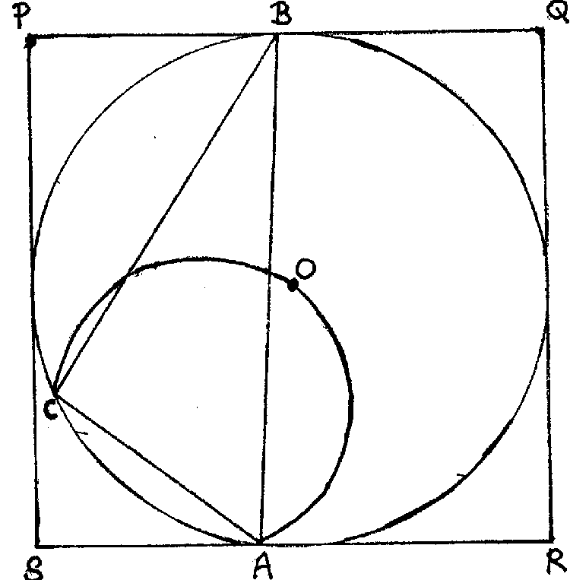
- The diagram shows a square PQRS with sides of length 8 cm. A circle with centre O is inscribed inside the square such that the sides of the square are tangents to the circle. The circle passes through the vertices of ΔABC where ∠ABC = 30º. An arc AC passes through the centre O.
- Explain why the major arc ABC is the locus of point X where ∠AXC = 30º.
- State the condition for the locus of a point Y which moves along the arc AOC
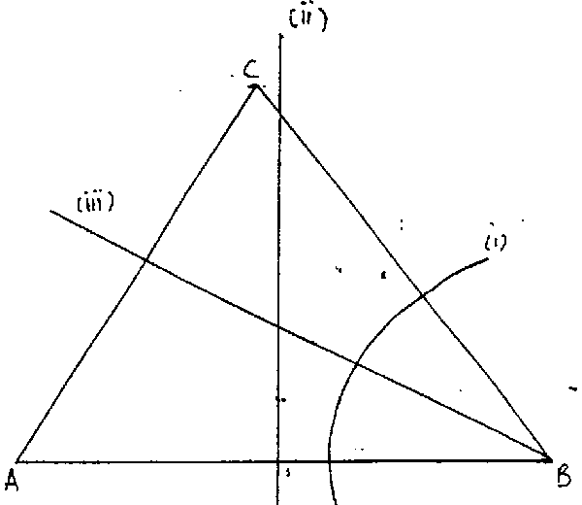
(c) Shade the region where Z lies such that Z moves within the square PQRS, ∠AZC 30º and Z is nearer to PQ than to PS. [SJI/2001/P1]

- The diagram shows ΔABC in which AB = 10 cm, BC = 9 cm and AC = 8.5 cm.
X : the locus of points which is equidistant from A and B
Y: the locus of points which is equidistant from BC and AB
Z: the locus of points which is 4 cm from B
- Indicate clearly, using X, Y and Z, the loci as shown in the diagram.
- By constructing another locus, mark clearly on the diagram with P, which is equidistant from A, B and C
- The point Q is inside ΔABC such that ∠CBQ ∠ABQ, BQ AQ and BQ ≥ 4 cm. Indicate clearly by shading the region that Q should lie. [Xinmin/2001/P1]

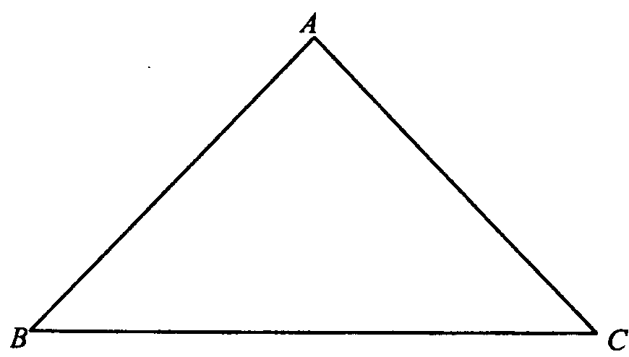
- The diagram below shows a triangle ABC. P is a variable point inside the triangle such that ∠ABP ≥ ∠CBP and MP ½AB, where M is the midpoint of AB. Construct and shade the region in which P lies. [Cedar/2001/P1]

Answer the following questions on plain paper.

- (a) Construct the triangle ABC in which AB = 10 cm, AC = 11 cm and ∠ABC = 70º. Measure and write down the length of BC.
- On the same diagram, construct
- the locus of points which are equidistant from B and C
- the locus of points which are equidistant from AB and BC
- the locus of points P such that BP = 3 cm
- the locus of points Q inside ΔABC such that the area of ΔAQC = 16½ cm²
- the locus of points R such that ∠ARC = 110º and R lies on the opposite side of AC as B
- The point X which lies inside ΔABC is such that ∠ABX > ∠CBX, X is nearer to B than to C, BX ≥ 3 cm and the area of ΔAXC ≥ 16½ cm². Indicate by shading the region of your diagram in which X must lie. [RI/2001/P2]

- Draw ΔABC such that AB = 6 cm, AC = 5 cm and ∠BAC = 90º.
- Measure and write down the size of ∠ABC
- Draw the locus of points X which is equidistant from points A and B
- Draw the locus of points Y such that Y is equidistant from the lines BA and BC.
- Construct a circle such that it passes through the point B, and AC is a tangent to the circle at A.
- Mark the point P where the circle meets the sides BC. Give a reason why ∠CAP = ∠ABC.
- The position of a point Z, which lies inside the triangle, and is such that ZB ≥ ZA,Z is nearer to the side AB than the side BC and ∠AZB ≥ 90º. Indicate clearly, by shading, the region in which point Z must lie. [SJI/2001/P2]

- (a) Construct a right-angled ΔABC in which its longest side AB = 10 cm and ∠ABC = 50º.
(b) On the same diagram,
- Construct the locus of point T such that T is 3 cm from A
- Construct the locus of point U such that U is 1 cm from AC
- Construct the locus of point V such that ∠AVB = ∠ACB
(c) Another point R, on the same side of AB as C, is such that AR ≥ 3 cm, ∠ARB ≥ 90º and R is less than or equal to 1 cm from AC. Indicate clearly, by shading, the region in which R must lie. [VS/2001/P2]

- Construct the parallelogram PQRS in which PQ = 12 cm, PS = 6.2 cm and ∠QPS = 102º.
- On the same diagram, construct
- the locus of points equidistant from P and R
- the locus of a point X so that ∠PQX = ∠RQX,
- the locus of point Y so that area of ΔPYQ = ½ area of ΔPRQ.
- M is a point such that PM = RM and that area of ΔPMQ = ½ area of ΔPRQ. Mark and label clearly the position of the point M.
- The position of point Y, which lies inside the parallelogram PQRS, is such that PY ≥ RY, ∠RQY ≥ ∠PQY and area of ΔPYQ ≥ ½ area of ΔPRQ. Indicate clearly by shading the region in which the point Y must lie. [Xinmin/2001/P2]

- Draw a parallelogram ABCD in which AB = 8 cm, AD = 5 cm and ∠BAD = 60º.
On your diagram, construct and label clearly
  - the locus of point P such that it is equidistant from AD and AB
  - the locus of point Q such that ∠BQD = 90º, and
  - the locus of point R which is on the same side of AB as D, such that the area of ΔARB is 10 cm²
A point P lies within the parallelogram and is such that
T lies nearer to AD then AB,
∠BTD 90º, and
area of ΔATB is less than or equal to 10 cm²
On your diagram, shade the region in which T must lie. [Catholic/2001/P2]

    - Construct, on a single diagram,
  - a line AB 8 cm long
  - the locus of a point P which moves such that AP = BP
  - the locus of a point Q if the area of triangle AQB = 18 cm²
  - the locus of R, which is on the same side of AB as Q, such that ∠ ARB = 55º
(b) Mark on your diagram, the point C which is equidistant from A and B and ∠ACB = 55º.
(c) On your diagram, shade accurately the region consisting of points D in which AD > DB, ∠ADB > 55º and area of triangle ADB > 18 cm². [Cedar/2001/P2]

  - Construct the triangle ABC in which BC = 10 cm, CA = 7.1 cm and AB = 8.2 cm.
(b) Construct the locus of points P, such that BP = PC. Mark with the letter P the point where this locus meets BC.
(c) Construct the locus of points Q, such that ∠BCQ = ∠QCA. Mark with the letter Q the point where this locus meets AB.
- Measure and write down the length of BQ.
- Construct the locus of points R, such that AR = 4.1 cm. Mark with the letter R the point where this locus meets AC.
- The point S, inside ΔABC, is such that BS ≥ SC, ∠ACS ∠BCS and AS 4.1cm. Indicate clearly, by shading the region in which S must lie. [BMSS/2001/P2]

- (a) Draw ΔPQR in which base PQ = 11 cm, ∠PQR = 60º and QR = 7 cm.
(b) On your diagram, draw the locus of points which are
  - equidistant from P and Q
  - equidistant from P and R
Hence draw the locus of A such that ∠PAR = 60º
    - Draw and label the locus of points on the same side of PQ as R which are 2 cm from PQ.
    - Mark and label the point B such that the area of ΔPBQ = 11 cm² and ∠PBR = 60º.
    - A point C in ΔPQR is such that CP > CQ, area of ΔPCQ > 11 cm² and ∠PCR > 60º. On your diagram, shade the region in which C must lie. [RGS/2001/P2]

      - Construct ΔABC in which AB = 7.5 cm, BC = 6 cm and ∠ABC = 115º. Measure and write down the length of AC.
(a) Construct the locus of
- the point P such that it is always equidistant from the points B and C
- the point Q such that it is always equidistant from the lines AB and BC
- the point R such that it is always on the same side of AB as C and ∠ARB = 90º
(b) The point S inside ΔABC is such that
- it is on the same side of AB as C
- it is nearer to the line BC than the line AB
- SC ≥ SB
- ∠ASB is always less than or equal to 90º
Indicate by shading the region in which S must lie. [MGS/2001/P1]

