
Crescent Girls’ School
Mathematics D

Worksheet: Trigonometry (1)
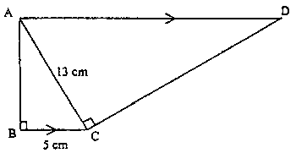
Name:_______________________________ ( ) Class:_______________
- In the diagram, AD is parallel to BC, ∠ABC = ∠ACD = 90º, BC = 5 cm, AC = 13 cm. Calculate (a) AB
(b) AD
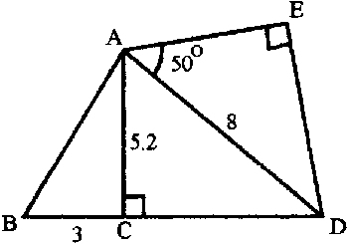
(c) cos ∠BCD [MGS/2001/P1]

- In the diagram, BCD is a straight line, BC = 3 cm, AD = 8 cm, AC = 5.2 cm, ∠ACD = ∠AED = 90º and ∠DAE = 50º. Calculate (a) CD
  - AE
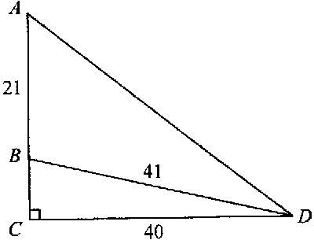
  - ∠ADC
  - ∠ABC [BMSS/2001/P2]

- In the right angled triangle ACD, B is a point on the side AC. Given that AB = 21 cm, CD = 40 cm and BD = 41 cm, calculate (a) BC
    - tan ∠ABD
- sin ∠ADB [Catholic/2001/P1]
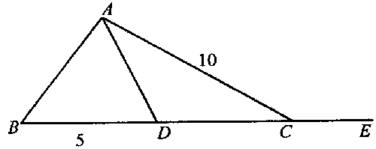

- In the diagram, BDCE is a straight line, BD = 5 cm and AC = 10 cm. Given that the area of ΔABD = 15 cm², calculate (a) sin ∠ACD
(b) tan ∠ACE [Cedar/2001/P1]
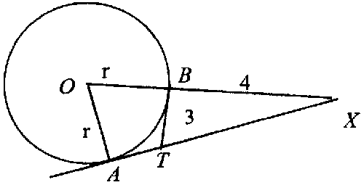
- TA and TB are tangents to a circle centre O and AT produced meets OB produced at X. XB = 4 cm, TB = 3 cm and OA = r cm.
- Write down the length of TA
- Calculate the length of TX
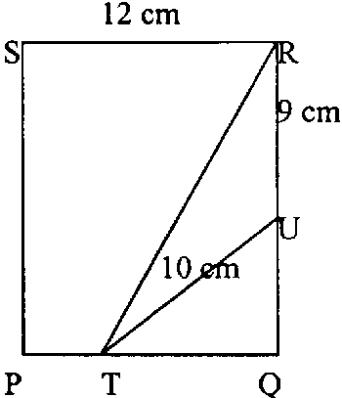
- Find the numerical value of $\frac{\text{OA}}{\text{AX}}$.
- Calculate the value of r. [Cedar/2001/P1]

- The figure is a rectangle PQRS with SR = 12 cm. U and T are points on RQ and PQ respectively. RU = 9 cm and TU = 10 cm. Given that sin ∠TUQ = 0.8, calculate the value of
- the length PT
- cos ∠PTR as a fraction in its lowest terms [SCGS/2001/P1]

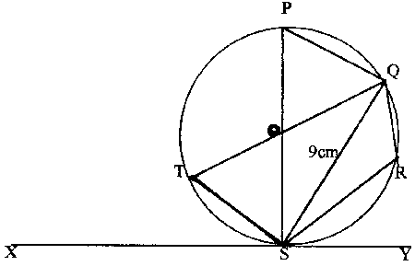
- The diagram shows a circle with centre O, where P, Q, R, S and T lie on its circumference. The lines TQ and PS pass through O. The radius of the circle is 5 cm, QS = 9 cm and XSY is a tangent to the curve at S. Using the information given below where necessary, calculate
    - cos ∠TSY
    - ∠TOS
    - ∠QRS
    - ∠SPQ [SJI/2001/P1]
[cos 20º = 0.9; sin 20º = 0.3; tan 20º = 0.4]
[cos 56º = 0.6; sin 56º = 0.8; tan 56º = 1.5]

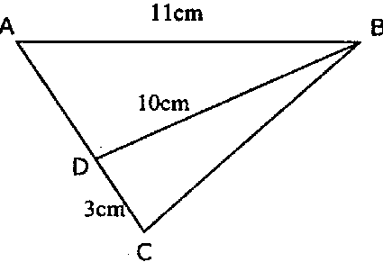
- Using as much information given below as necessary, calculate
    - sin ∠BAD
    - BC²
    - The area of ΔBCD [VS/2001/P1]
[sin ∠ADB = 0.88, cos ∠ADB = –0.47, tan ∠ADB = –1.88]
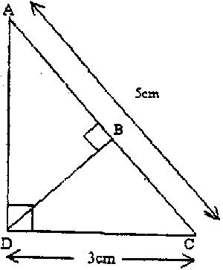
- In the diagram, AC = 5 cm,, CD = 3 cm, ∠ADC = 90º and ∠ABD = 90º, calculate
    - tan ∠CAD
    - BD
    - AB. [Xinmin/2001/P1]

Answers:
- (a) 12 cm (b) 33.8 cm (c)$−\frac{\text{12}}{\text{13}}$
- (a) 6.08 cm (b) 5.14 cm (c) 40.5º (d) 60.0º
- (a) 9 (b) –4$\frac{4}{9}$ (c) $\frac{\text{84}}{\text{205}}$
- (a) $\frac{3}{5}$ (b) $−\frac{3}{4}$
- ( No answers given )
- (i) 4 cm (ii) $−\frac{8}{\text{17}}$
- (a) –0.9 (b) 40º (c) 110º (d) 70º
- (a) 0.8 (b) 80.8 (c) 13.2 cm²
- (a) $\frac{3}{4}$ (b) 2.4 cm (c) 3.2

