
Crescent Girls’ School
Mathematics D

Worksheet: Trigonometry (2) – Angles of Elevation and Depression, Bearings, 3-D Problems
Name:_______________________________ ( ) Class:_______________

- You were given an old map which was supposed to give clue to the entrance of an ancient tomb. The tomb was known to be found within a triangle formed by three points, A, B and C. It was indicated that B is due east of A and C is north of the line AB. It was also revealed that AB = 60 km, BC = 80km and AC = 70km. The bearing of the entrance, E from A and B were 020º and 300º respectively. Calculate (i) ∠CAB
(ii) the bearing of C from A
- ∠EAB
- the distance AE [RGS/2001/P2]
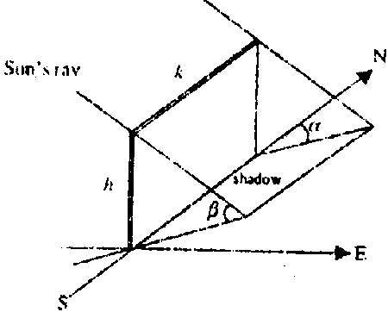
- A vertical wall k metres long and h metres high is built on a north-south line on a horizontal ground as shown in the figure. If the angle of elevation of the sun is β and its bearing is α, express the area of the shadow of the wall on the ground in terms of k, h, β and α.
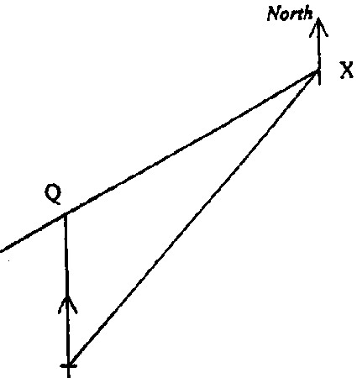
[RGS/2001/P2]

- X is a port 250 km and a bearing of 040º from port P. At 14 00, a ship sails at a constant speed at a bearing of 240º from a port X. The ship will pass another port Q, which is exactly due north of port P at 17 15.
(a) Copy the given diagram and include the given information of bearing and distance.
Find (b) the speed of the ship
- the shortest distance of the ship from port P
- the time, to the nearest minute, at which it is at the shortest distance from P. Give your answer in the 24-hour clock notation
- There is a hot air balloon hovering directly above port P at a height of 2400m above. Find the angle of elevation of the balloon when the ship is at point P.
[MGS/2001/P2]

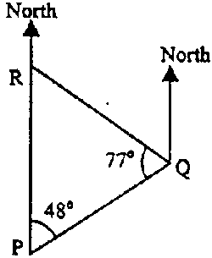
- The points P, Q and R are on level ground and ∠PQR = 77º. R is due north of P and the bearing of Q from P is 048º. Find
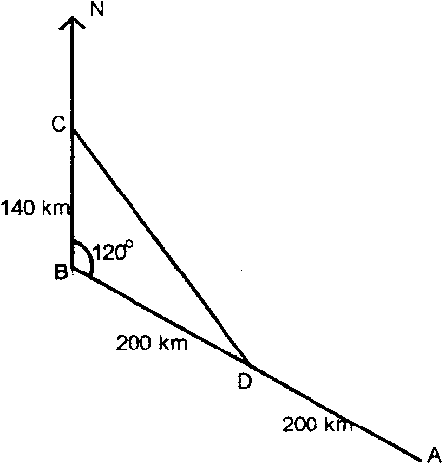
- the bearing of Q from R
- the bearing of R from Q [MGS/2001/P1]

- The diagram shows that airport A is 400 km from airport B on a bearing of 120º. An aircraft leaves at A at 21 59 h to fly to B. Its speed over the ground is 600km/h.
    - How far is airport B north of airport A?
    - Calculate the time at which the aircraft is expected to arrive at B.
    - When the aircraft is at D, halfway between A and B, it is diverted to airport C because of fog at airport B. Airport C is 140 km due north of B
  - Calculate the distance from D to C
  - Calculate the bearing of C from D
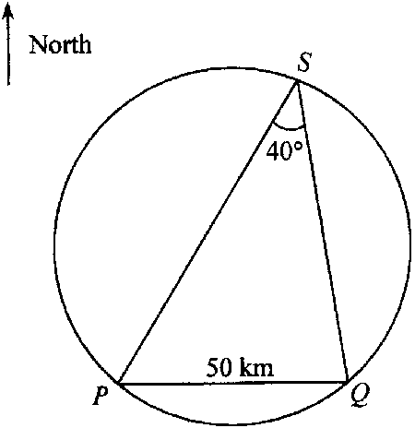
  - The point on the aircraft’s path nearest to B is X. Calculate the distance of X from B. [BMSS/2001/P2]

- The diagram shows two small islands P and Q. Island Q is 50 kilometres due east of island P. A submarine S moves in a circular path such that ∠PSQ is always 40º, as shown.
    - Find the bearing of S from P when S is due north of Q
    - Find the bearing of S from Q, when S is equidistant from P and Q
    - Using as much information given below as is necessary, find the distance of S from Q when S is 50 kilometres from P
[sin 40º = 0.643; cos 40º = 0.766; tan 40º = 0.839] [Catholic/2001/P1]

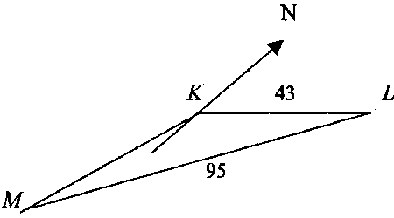
- In the figure, K, L and M are three points on level ground where KL = 43 m, and LM = 95 m. The bearing of L from K is 067º and the bearing of M from K is 200º. Calculate
    - ∠KML, leaving your answer to the nearest degree
    - the bearing of M from L, leaving your answer to the nearest degree
    - the area of ΔKLM, correct to two decimal places
A vertical tower LY, 70 m high, stands at L
(d) calculate the angle of elevation of T from M. [Catholic/2001/P1]

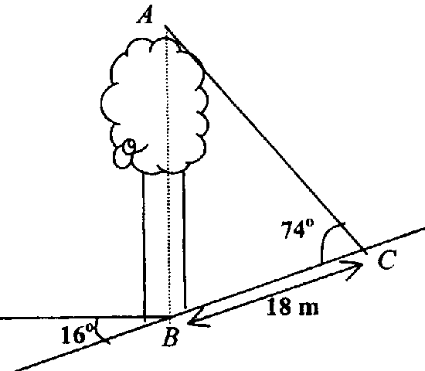
- A tree AB is growing vertically on a hillside that is inclined at an angle of 16º to the horizontal. When the Sun is at a certain position, the tree casts a shadow 18 m long up on the slope. Given that ∠ACB = 74º, calculate (i) ∠ABC
  - the angle of elevation of the sun from C
  - the height of the tree, correct to the nearest metre.
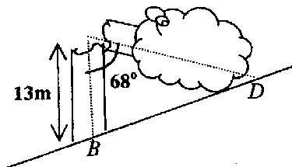
During a thunderstorm, the tree cracked and fell as if hinged. The tip of the tree hit the slope at D. Using the answer in (iii), find the distance BD. Give your answer correct to 1 decimal place.
[Cedar/2001/P2]

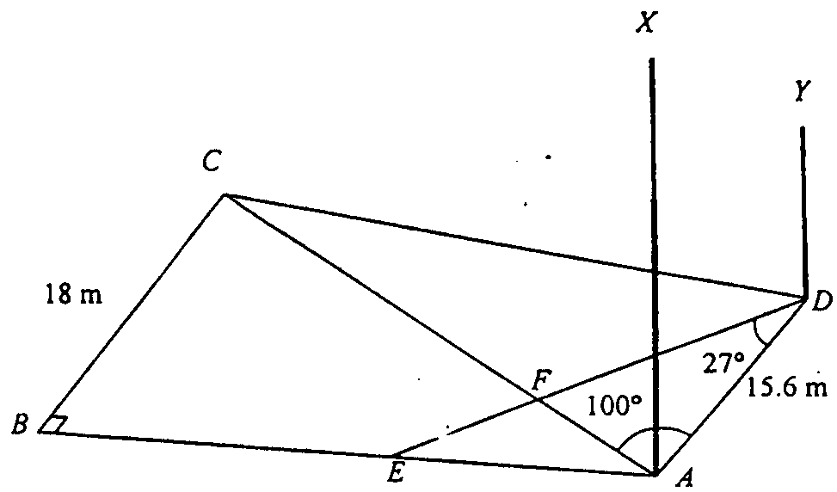
- ABCD is a quadrilateral field on a horizontal plane such that BC = 18 m, AD = 15.6 m, AC = 26 m, ∠ABC = 90º and ∠CAD = 100º. E is a point on AB such that ∠ADE = 27º. AC intersects DE at F. Calculate (i) ∠ BAC
  - CD
  - CF
  - Area of triangle ABCD
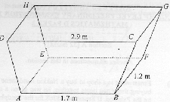
AX and DY are vertical poles at A and D respectively. Given that DY = 25 m and the angle of depression from X to D is 74º, calculate the angle of elevation from Y to X.[RI/2001/P2]

- The diagram shows a metal container ABCDHGFE. Both the base ABFE and the top DCGH are horizontal and rectangular. Each of the vertical sides ABCD and EFGH is a trapezium. The two sloping ends AEHD and BFGC are rectangular and are equally inclined to the horizontal. Given that AB = 1.7 m, BF = 1.2 m, CD = 2.9 m and the perpendicular height of DCGH above the base is 1.3 m, calculate (a) the angle between CD and FG
(b) the length of AC
- the angle between planes ADHE and BDHF
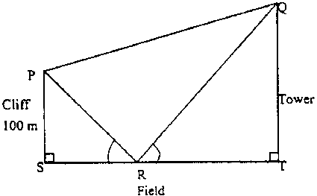
[RI/2001/P2]

- A surveyor is standing at P, the top of the cliff which is 100m high. At the foot of the cliff is a field. Across the field is an upright tower. The surveyor measures the angle of elevation of the top of the tower, Q from P to be 20º. He also looks down onto the field and sees the shadow of the top of the tower at R. The angle of depression of R is 50º. Given that ∠PRS = ∠QRT, calculate the height of the tower. [SCGS/2001/P2]

- Solutions to this question by accurate drawing will not be accepted.
Miss Tan, a teacher-in-charge of athletics proposed the following route for her girls to run:
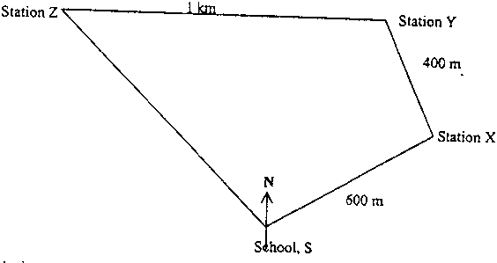
“Starting at the school S, we will head at a bearing of 057.8º for 600m to reach station X. From X, we will run for 400 m at a bearing of 340º to station Y. After that, we will head fur west for 1 km to station Z. Finally, we will run at a bearing of 137º and then we will be back at school.” The route could now be represented by the following diagram:

Calculate (i) the distance of Station Y from school
(ii) ∠YSZ
(iii) the shortest distance of the school to the route joining stations Y and Z.
[SCGS/2001/P2]
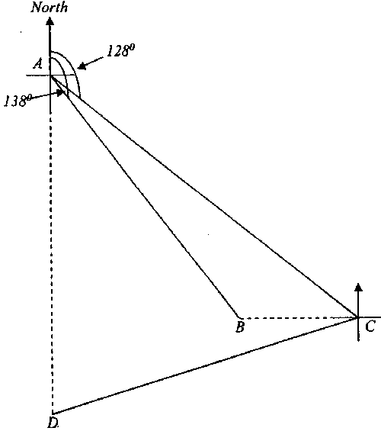
- A lighthouse stands at point A. B is a buoy 650 m from A in the direction 138º. A boat sailed from point A in the direction 128º until it reached a point C, which is due east of B.
- Find its nearest distance from B during this course
- Show that ∠ABC = 132º
- Calculate the distance AC
At C, the angle of elevation of the lighthouse is 5º
- Find the height of the lighthouse
The boat then changed direction and sailed towards a point D, which is due south of the lighthouse. At this point, the angle of elevation of the lighthouse is 3º.
- Find the distance DA
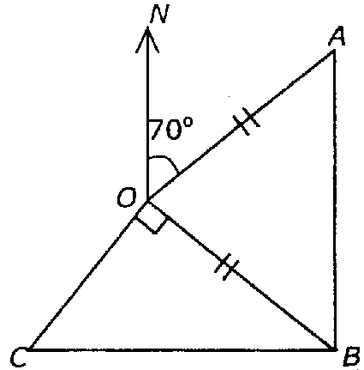
- Calculate how far C is east of the lighthouse. [SJI/2001/P2]

- O, A, B and C are points on level ground. A has a bearing of 070º from O. B is due south of A and C is due west of B. OA = OB = 120 m and ∠COB is a right angle. Calculate
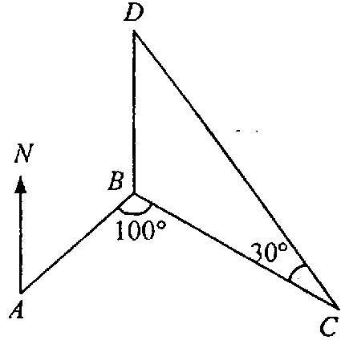
(a) the bearing of O from (i) A (ii) B
(b) the shortest distance from O to BC [VS/2001/P1]

- A ship sails from port A at 0800 on a bearing of 040º towards port B. It sails at an average speed of 10 km/h, reaching port B at 1024. From port B, it sails to port C which is 40 km away. After resting for ½ hour, the ship sets sail again to port D which is due north of port B. The figure shows the route taken by the ship.
Given that ∠ABC = 100º and ∠BCD = 30º, calculate
    - the distance of AB and of AC
    - the distance of BD
    - the bearing of C from A, to the nearest degree
    - the shortest distance between B and the ship as it sails from C to D
    - If the ship uses the same speed throughout the whole journey, find the time it reaches port D, correct to the nearest minute. [VS/2001/P2]
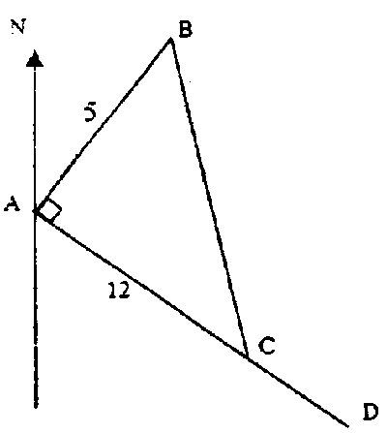

- In the diagram, ACD is a straight line, the bearing of B from A is 039º, ∠BAC = 90º, AB = 5 m and AC = 12m. Find
    - the bearing of A from B
    - cos ∠BCD
Given that a man is walking along the path BC is looking at the top of a tower built at point A.
    - find the distance of the man from A if its angle of elevation is the greatest.
[Xinmin/2001/P1]
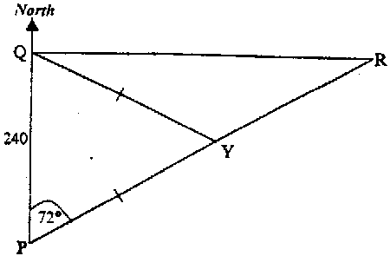

- Port Q is 240 km due north of port P. A ship leaves P and sails in the direction 072º at a steady speed of 12 km/h unitl it arrives at port R which is due east of Q.
    - Calculate the distance between P and R
    - Calculate the distance between port Q and the ship as it sails from P to R.
    - Another ship taking the same route sails from P unitl it reaches a point Y which is equidistant from P and Q. Calculate the distance PY.
    - Given that the second ship leaves the port P 8 hours later than the first ship and sails at a steady speed of 14 km/h. Which ship, the first or the second one, reach port R first? Explain your answer. [Xinmin/2001/P1]

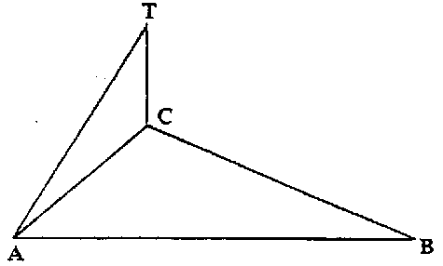
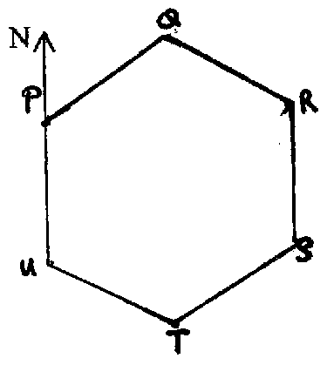
- Three point A, B and C are on horizontal ground . B is 500 m due east of A, C is on a bearing 050º and 335º from a and B respectively. A vertical tower TC stands at C. The angle of elevation of T from A is 38º. Find the height of the tower. [Xinmin/2001/P1]

- The diagram shows a regular hexagon PQRSTU with P directly north of U. Calculate
- the bearing of Q from P
- the bearing of P from T [SJI/2001/P1]

Answers:
- (i) 75.5º (ii) 014.5º (iii) 70º (iv) 30.5 km
- $$\frac{\text{hk}\text{sin}α}{\text{tan}β}$$
- (a) 57.1 km/h (b) 85.5 km (c) 1807 (d) 1.4º
- (i)125º (ii) 305º
- (a) 200 km (b) 22 39 (c)(i) 296 km (ii) 324.2º (iii) 82.0 km
- (a) 040º (b) 340º (c) 76.6
- (a) 19º (b) 219º (c) 949.44m² (d) 36.4º
- (i) 74º (ii) 58º (iii) 33 m; 19.3 m
- (i) 43.8º (ii) 32.6m (iii) 17.1 m (iv) 369m²
- (a) 65.2º (b) 2.64 m (c) 35.7º
- 188 m
- (i) 0.777 km (ii) 70.3º (iii) 0.690km
- (i) 113 m (iii) 785 m (iv) 68.6 m (v) 1310m (vi) 618 m
- (a)(i) 250º (ii) 290º (b) 40.8 m
- (a) AB = 24 km, AC = 50.1 km (b) 40 km (c) 092º (d) 20 km (v) 2150
- (a) 219º (b) $−\frac{\text{12}}{\text{13}}$ (c)$4\frac{8}{\text{13}}$
- (a) 777 km (b) 228 km (c) 388 km (d) 2nd ship
- 367m
- (i) 060º (ii) 330º

