Crescent Girls School

Secondary 3 Mathematics D

Past Years Examination Questions
(1997 – 2001)

Topic: Trigonometry

1. A, B, C and D are four points on the field. A is due North of D, B is due east of D and ∠DBC = 37⁰. Given that AD = 34 m, BA = 57 m and BC = 28 m, calculate
- ∠BAD,
- the bearing of B from A,
- the area of triangle BCD and
- CD (Leave your answer to 1 dec. place where applicable.)
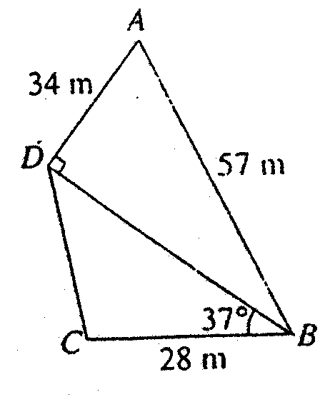
(2000 Mid SB Q5a)

2. In the figure, a rectangular piece of paper ABCD is folded along EF so that C and A coincided.
If AB = 3 cm, BC = 4 cm, find the length of BF.
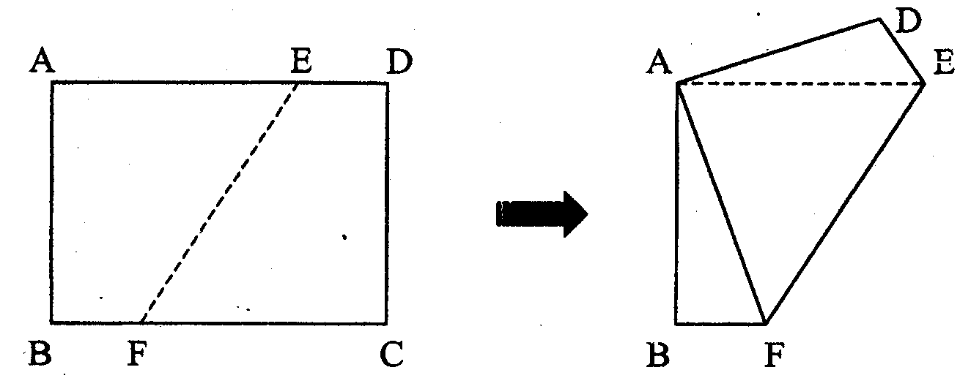
(2000 Final SA Q6)

3(a) In the diagram AB = 20 cm, ∠BAC = 90⁰ and ∠ABC = 60⁰. Using as much information given below as necessary, calculate
- AC and
- BC.
[sin 60⁰ = 0.866, cos 60⁰ = 0.5, tan 60⁰ = 1.73)
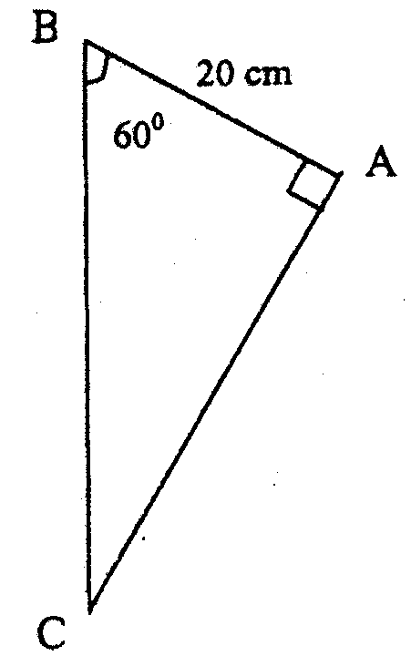

- A ship leaves Island A and sails 3 km due South to Port C. It then sails 4 km due East to Island B. Find the distance between Island A and Island B.
(2000 Mid SA Q16)

4. ABCDEF is a wedge and ABCD is a rectangular plane inclined at an angle of 30⁰ to the rectangular plane ABFE. CF and DE are perpendicular to the plane ABFE. Given also that ∠CAB = 53⁰ and CF = h mm. Using as much of the information given below as is necessary, calculate,
(a) the lengths of BC and AC in terms of h,
(b) the value of sin ∠CAF and
(c) the value of AB if h =12.
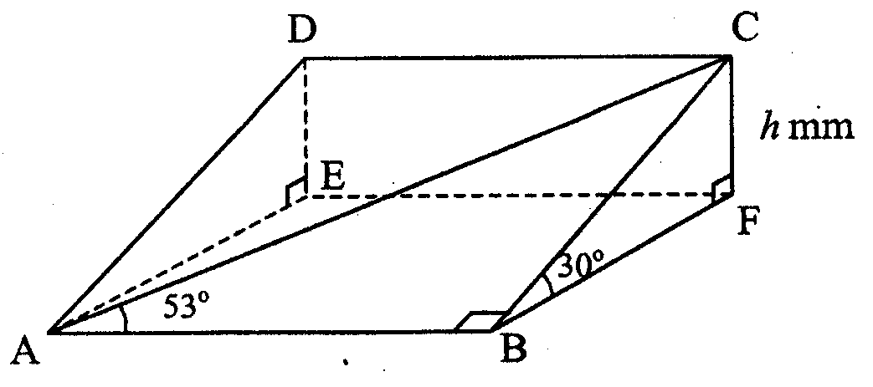
[sin 53⁰ = 0.80, cos53⁰ = 0.601, tan53⁰ = 1.33, sin 30⁰ = 0.50, cos30⁰ = 0.87, tan30⁰ = 0.58]
(2000 Final SA Q12)

5. The towns P, Q and R are such that P and Q are equidistant from R. The bearing of P from R is 110⁰ and the bearing of Q from R is 230⁰. Calculate,
(a) ∠QRP,
(b) the bearing of R from Q and
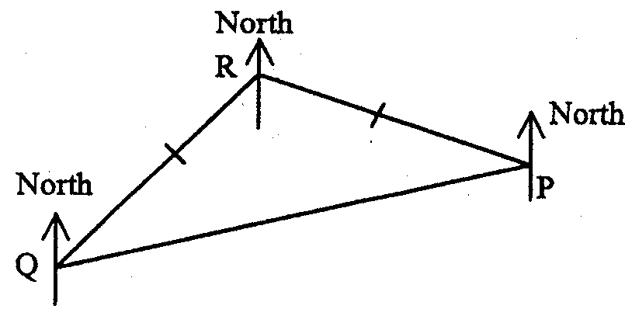
(c) the bearing of Q from P.
(2000 Final SA Q13)

6. A, B, C and D are four points on level ground with C due east of B. It is given that AB = 26 m, AC = 28 m and BC = 30 m.
(a) Find ∠ACB and ∠ABC.
(b) If the area of ΔBCD is 160 m², find the length of CD.
(c) A man walks due east from B until he reaches a point P which is of equal distance from A and B. Calculate the length of BP.
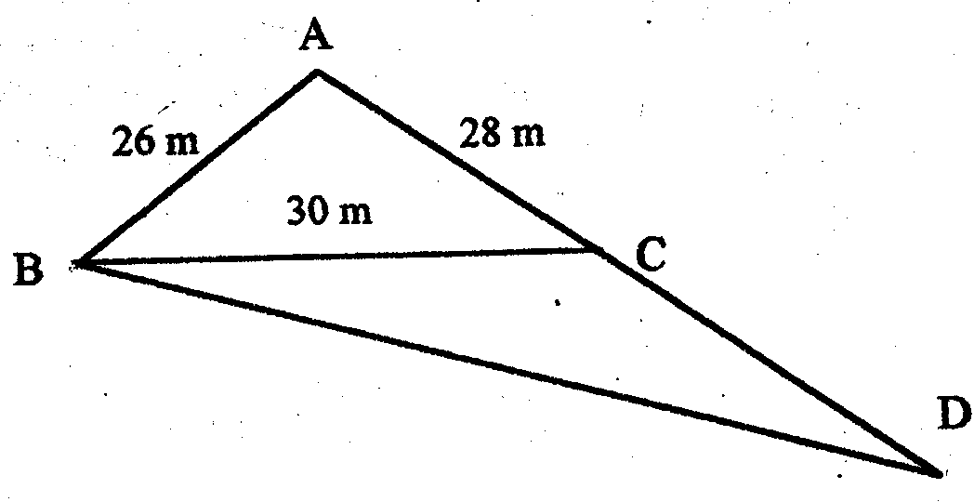
(d) Find the bearing of P from A.
(1997 Final SB Q2)
26
B

7. The area of triangle ABC is 5.5 cm². Given that ∠ABC is more than 90⁰ and
AB = 5 cm,
(a) calculate the perpendicular distance C to AB produced.
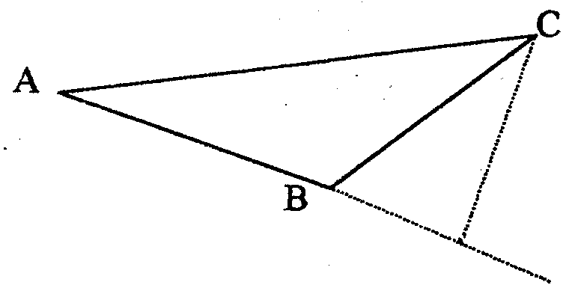
(b) Given further that AC = 8.8 cm, calculate the perpendicular distance from B to AC.
(1998 Final SA Q9)

8. Three of the faces of a solid triangular prism, as shown in the diagram, are rectangular. The prism lies on a horizontal table and triangles ABC and DEF are vertical to the table.

Given that BE = 30 cm, AB = 10 cm, AC = 8 cm and ∠BAC = 47⁰, find
(a) BC,
(b) ∠CEA,
(c) ∠BPE where P is the mid-point of AD and
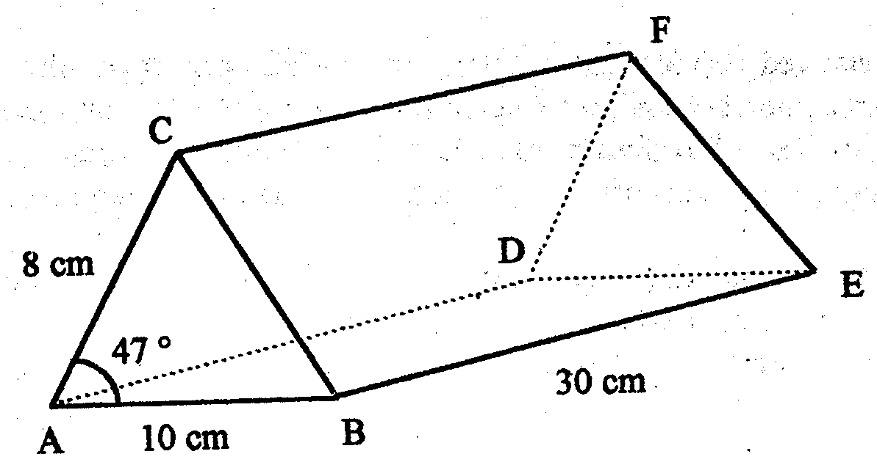
(d) the area of ΔABC.
(1997 Final SB Q4)

9. In the diagram, A, B and C represent 3 points on a map. Calculate
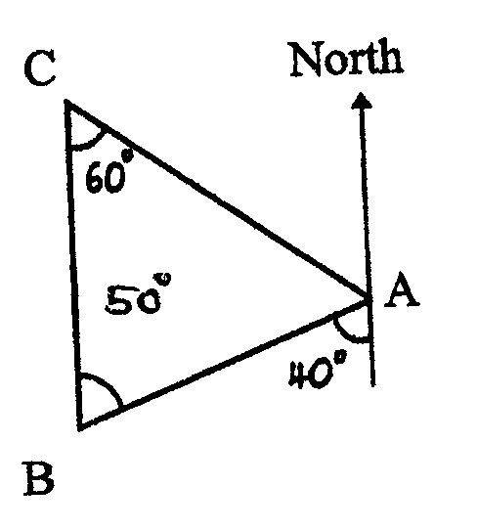
- the bearing of B from A and
- the bearing of A from C.
(1997 Final SA Q5)

- In the diagram, $∠\text{ABC}$=$∠\text{ACD}$= 90⁰, $∠\text{CAD}$= 40⁰ and AB = 4 cm. Given
sin 40⁰ = 0.643, cos 40⁰ = 0.766, tan 40⁰ = 0.839, find
(a) AC,
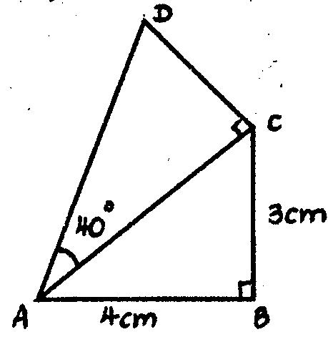
(b) cos $∠\text{BCA}$and
(c) CD.
(1997 Final SA Q14)

11. In the diagram, PTR is a straight line, ∠QPT = 20⁰, ∠PTQ = 150⁰, QT = 8 km and TR = 5 km. Calculate
(a) the length of PT,
(b) the length of QR and
(c) the area of ΔPQR.

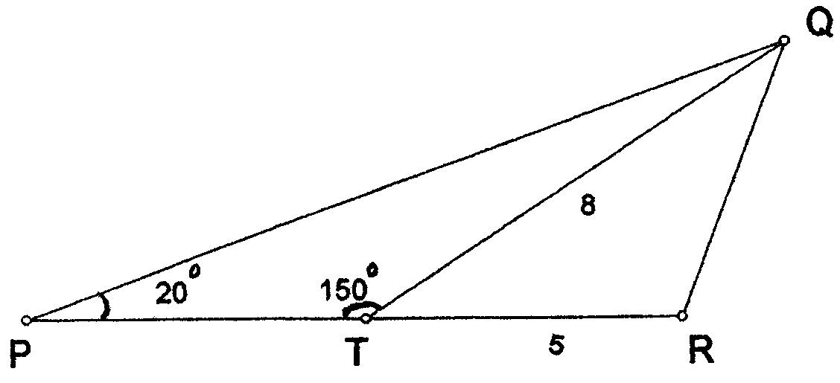
A map of this area is drawn to a scale of 1 cm to 3 km. Calculate the area of
ΔPQR in cm² on the map.
(1998 Final SB Q1)

12. A map jogs 6 km from A to B, then walks another 2 km from B to C on a bearing of 065⁰. Given that ∠ABC = 145⁰,
- calculate the bearing of B from A.
- How far is B east of A?
C
B

A
(1999 Final SA Q15)
13. In the diagram, A is 3 km due north of B. AC = 5 km and the bearing of A from C is 120⁰. Given also cos 120⁰ = $−\frac{1}{2}$ and cos 30⁰ = $\frac{\sqrt{3}}{2}$, calculate
(a) the bearing of C from A,
(b) the distance BC and
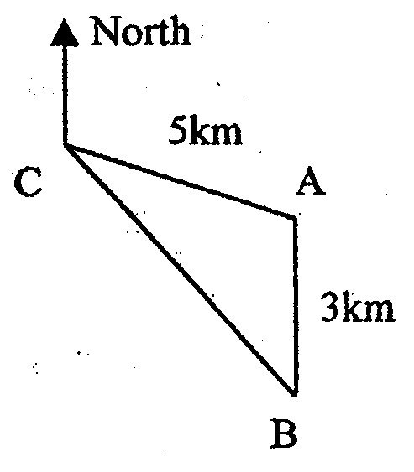
(c) the distance that B is due east of C.
(1998 Final SA Q11)

14. The diagram below represents two triangular fields in a horizontal plane ABCD. BD = 250 m, ∠BAD = 37⁰, ∠ADB = 43⁰ and ∠BDC = 57⁰. A vertical pole DE stands at the corner D of the field. DE = 24 m and the angle of elevation of E from C is 50⁰. Calculate
(i) angle of elevation of E from B,
(ii) the length of BC and
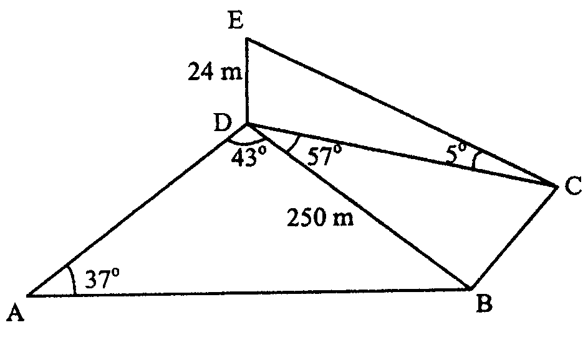
- the length of AD.
(2000 Final SB Q1b)

15. In the diagram below, the given ΔABC is right angled at B. The point D lies on BC produced.
- Calculate the length of BC.
- Write down, as a fraction, values of
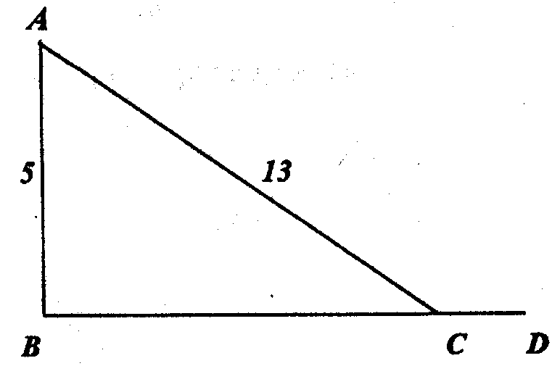
- sin ∠BAC and
- cos ∠ACD.
(1999 Final SA Q11)

16. ABC is a triangle in which AB = 3 cm, BC = 5 cm, AC = x cm and $A\hat{B}C={\text{96}}^{0}$. The side AB is produced to D. Given that $\text{cos}{\text{96}}^{0}=−0\text{.}1$,
- write down the values of cos$C\hat{B}D$and
(b) calculate the value of $x^{2}$. (2001 Mid SA Q12)

- The diagram shows the positions of points P, Q and R. State the bearing of
(a) Q from P,
55⁰
46⁰
Q
66⁰
P
N
R
- R from P and
- Q from R.

(2001 Mid SA Q13)

- A man, who is 1.94 m tall, stands on horizontal ground 40 m from a tree.
The angle of elevation of the top of the tree from the man’s eyes is ${\text{33}}^{0}$.
Use as much of the information below as is necessary to calculate an estimate of the height of the tree.
Round off your answer to one decimal place.
[$\text{sin}{\text{33}}^{0}=0\text{.}\text{545}$, $\text{cos}{\text{33}}^{0}=0\text{.}\text{839}$, $\text{tan}{\text{33}}^{0}=0\text{.}\text{649}$] (2001 Mid SA Q14)

19(a) Given that 0⁰<$\hat{A}$< 180⁰, find$\hat{A}$, correct to the nearest 1 degree, in each case.
(i) $\text{sin \{}\hat{A}=0\text{.}\text{576}$
(ii) $\text{tan \{}\hat{A}=−0\text{.}\text{258}$
(b) In the diagram, RST is a straight line.$P\hat{S}T={\text{90}}^{0}$, $Q\hat{P}S={\text{63}}^{0}$, $P\hat{S}Q={\text{72}}^{0}$, $\text{PS}=9$cm and ST = 12 cm. Calculate
(i) $P\hat{T}S$,
(ii) PR,
(iii) QS and
S
P
T
Q
R
12
72⁰
63⁰
9
(iv) the area of$Δ\text{PQS}$.

(2001 Mid SB Q3)

20. A, B and C are three points on horizontal ground. B is due south of A and C is due east of A. AT is a vertical pole standing at A. Given that the angle of elevation of T from C is $\text{38}\text{.}5^{0}$, the bearing of C from B is $\text{032}\text{.}6^{0}$and TC = 14.6 m, calculate
- AT,
- AB and
- the angle of depression of B from T.

Given also that P is the point on BC such that the angle of elevation of T from P is maximum, calculate
- AP and
- the angle of elevation of T from P.

T
B
N
38.5⁰
C
A
14.6m

(2001 Mid SB Q5)

21. An oil tanker sails from a port P to port Q, 20 km away and on a bearing of ${\text{110}}^{0}$from P. After reaching Q, it sets sail to R, 15 km away and on a bearing of ${\text{150}}^{0}$from Q. It then proceeds to sail to S, a port 20 km away and on a bearing of ${\text{050}}^{0}$from R. Draw a sketch to indicate the relative positions of the ports P, Q, R and S. Calculate
- how far south of P is S,
- how far east of P is S and
- the bearing of S from P.
- If the boat sails directly from P to S at a constant speed of 12 km/h, calculate the time taken, giving your answers correct to the nearest minute. (2001 Mid SB Q4)

22. Points A, B, C and D lie on level ground. The point D is due north of A. $D\hat{A}C={\text{150}}^{0}$, $C\hat{A}B={\text{90}}^{0}$ and $A\hat{B}C={\text{75}}^{0}$. Find the bearing of
- B from A and
150º
75º
A
North
C
B
D
- C from B.

(2001 Final SA Q12)

23. The diagram shows the points P, Q, R and S on level ground where PQ = 250 m, $Q\hat{P}R={\text{36}}^{0}$, $P\hat{S}R={\text{47}}^{0}$and $S\hat{P}R={\text{70}}^{0}$.
P
70º
47º
36º
250m
S
R
Q
285m

- Calculate:
(i) the length of QR
(ii) the area of $Δ\text{PQR}$and
(iii) the shortest distance from P to SR.
(b) A vertical mast stands at the point P and the angle of elevation of the top of the pole from both Q and S are measured. Given that the smaller of these two angles is${\text{10}}^{0}$, find the height of the mast. (2001 Final SB Q2)

