Crescent Girls School

Secondary 3 Mathematics D

Past Years Examination Questions
(1997 – 2001)

Topic: Coordinate Geometry

- The equation of the line l is $3x−4y=\text{24}$and it intersects the x-axis at A and
y-axis at B. The mid-point of AB is M and O is the origin. Find
- the coordinates of A and B,
- the gradient of l,
- the length of AB,
- the coordinates of M and
- the equation of the line passing through B and parallel to OM. (2000 Mid SB Q2)

2(a) The line $\text{mx}=\text{ny}+5$ is parallel to the x-axis. Find the value of m and state the condition for the line to be parallel to the y-axis.
(b) The points (2, -3), (3, -2) and (8, k) are collinear. Find the value of k.
(2000 Mid SA Q14)

3. The curve ${\text{px}}^{3}+8$ intersects the y-axis at A and passes through the point (2, 48).
- Write down the coordinates of A.
- Calculate the value of p. (2000 Mid SA Q15)

4(a) The points (1, -5), (3, -1) and (7, k) lie on a straight line. Find the value of k.
(b) Given that the line $\frac{x}{3}+\frac{y}{2}=1$cuts the x-axis at A and y-axis at B, write down the gradient of the line and the coordinates of A and of B.
(c)(i) Given that the straight line $y=\frac{1}{2}x+k$ passes through a point A(-1, -3), calculate the value of k.
(ii) Another straight line m parallel to$y=\frac{1}{2}x+k$ passes through the point B($\frac{1}{2}$, 0). Find the equation of the line m. (1997 Mid SB Q1)

5(a) The points (2, -3), (3, -1) and (4, k) lie on a straight line. Find k.
(b) Given that the line $y=\text{mx}+c$has gradient -1 and passes through the point (2, 3), find the values of m and c. (1997 Final SA Q3)

6. The diagram shows part of the graph $y=\frac{1}{x}−2$.
(a) A point B is on the curve such that its coordinates are (-1, b). Find the value of b.
(b) Given that the straight line $y=\frac{1}{2}x+k$ passes through B, calculate the value of k.
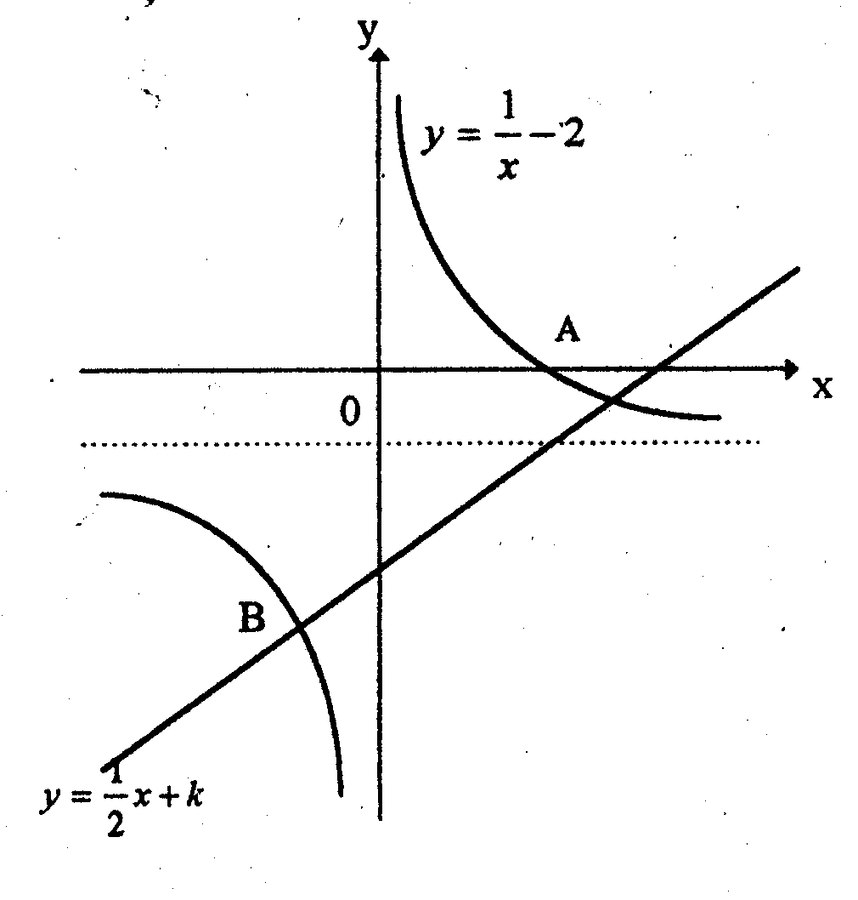
- Another straight line m parallel to $y=\frac{1}{2}x+k$ passes through the point A. Find the equation of the line m.
(1997 Mid SA Q14)

7. A straight line has equation $2y+\frac{1}{2}x=6$.
(a) Write down the gradient of the line.
(b) Find the coordinates of the point of intersection of the line and the y-axis.

(1998 Final SA Q10)

8. Given that the equation of a line is $0\text{.}5x−2y=2$. This line intersects the x-axis at the point P and the y-axis at the point Q. The mid-point of P and Q is M. Find
(i) the gradient of the line and
- the coordinates of M. (1999 Final SA Q12)

9. A straight line passes through the point (-1, 5) and has a gradient of 3.
(a) Find the equation of the straight line.
(b) Given that the line also passes through the point (2g, $3+g$). Find the value of g.
(1999 Mid SA Q12)

10. In the diagram, B is the point (0, 9) and C is the point (0, 6). The sloping line through B and the horizontal line through C meet at the point A.
(a) Write down the equation of the line AC.
(b) Given that the gradient of the line AB is 1.5, find the equation of the line AB.
(c) Calculate the co-ordinates of the point A.
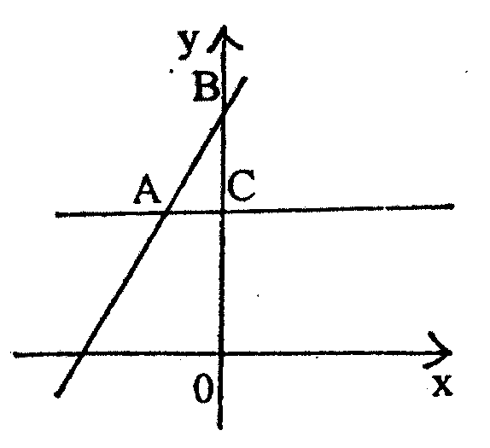
(d) Calculate the area of the triangle ABO.
(1999 Mid SB Q3)

11. Find the equation of the straight line that is parallel to $3y−x=9$ and passes through the x-axis at $x=3$. (2000 Final SA Q10)

12. Three of the vertices of a parallelogram ABCD are A(3, 0), B(7, 3), C(1, 7). Find the mid-point of AC and, hence, or otherwise, find the coordinates of the fourth vertex, D. (2001 Mid SA Q9)

13. In the diagram, the equation of the line AC is $2x+5y=\text{15}$. Find
- the equation of BD,
- the coordinates of B,
- the area of $Δ\text{BCD}$and
- the coordinates of E if line $y=0$ is the line of symmetry for quadrilateral BDEC.

B
y
x
C
2x + 5y = 15
1
D
-2
A

(2001 Mid SB Q2)

- Given the line $\frac{x}{3}+\frac{y}{2}=1$, find
- its gradient
- the coordinates of the point at which it cuts the x-axis. (2001 Mid SA Q10)

15. A straight line has equation $2x+y=6$. Find
(i) the points which the line intersect with the x-axis and y-axis.
- the coordinates of a point on the line which is equidistant from the x-axis and
y-axis. (2001 Final SA Q6)

16. P(-4, 1), Q(1, 11) and R(3, 10) are vertices of a parallelogram PQRS. Find
- the equation of PS and
- the coordinates of S. (2001 Final SA Q7)

