Coordinate Geometry

Contents
  - Pre-requisite Knowledge
  - Calculate the distance between two given points
  - Calculate the mid-point of two given points
  - Calculate the gradient of a straight line
  - Find the equation of a straight line
  - Find the equations of Parallel lines
  - Find the equation of perpendicular lines
  - Perpendicular bisector
  - Intersection of a straight line and a curve
  - More challenging questions
  - Summary

1.1 Pre-requisite Knowledge
- How to draw and label x-axis and y-axis
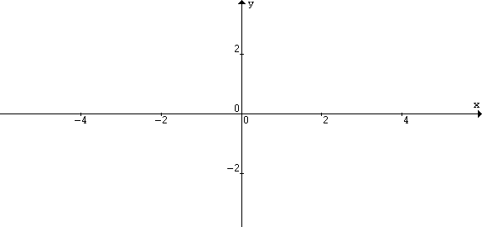
- How to plot coordinates
x-axis
y-axis
(2,2)
(-4,-2)

1.2 Calculate the distance between two given points
a) Finding the distance between point A and point B (horizontal line segment)
y
y

A(2,3)
B(4,3)
A(-3,5)
B(2,5)

x
x

Distance between points A and B = 4-2 Distance between points A and B = 2 – (-3)
= 2 units = 5 units
y
y
x

x
B(x₂,y₂)
A(x₁,y₁)
A(-5,-1)
B(-1,-1)

Distance between points A and B = -1 - (-5) Therefore, in general, for a horizontal line segment,
= 4 units Distance between points A and B = x₁-x₂
where $x_{1}>x_{2}$

b) Finding the distance between point A and point B (vertical line segment)
y
x
A(2,7)
B(2,1)
y
x
A(3,4)
B(3,-2)

Distance between points A- and B = 7 -1 Distance between points A and B = 4 – (-2)
= 6 units = 6 units
y
x
y
x
A(x₁,y₁)
B(x₂,y₂)

A(-2,-2)

B(-2,-5)

Distance between points A and B = -2 – (-5) Therefore, in general,
= 3 units for a horizontal line segment,
Distance between points A and B = $y_{1}−y_{2}$
where $y_{1}>y_{2}$

c) Finding the distance between point A and point B (general line segment)

Let us find the distance between A(5,4) and B(1,1).
y  x  B(1,1)  A(5,4)  C(5,1) | Construct a right angle triangle ABC with AB as the hypothenuse.
y  x  B(1,1)  A(5,4)  C(5,1) | Applying Pythagorus’ Theorem  AB² =

Let us find the distance between A(x₁,y₁) and B(x₂,y₂)..
y  x  A(x₁,y₁)  B(x₂,y₂)  C(x₁,y₂) | Construct a right angle triangle ABC with AB as the hypothenuse.
y  x  A(x₁,y₁)  B(x₂,y₂)  C(x₁,y₂) | Applying Pythagorus’ Theorem  AB² =

In general,
Distance between any two points
and
is

Practice 1
1. The points A(-3, -2), B(2, -7) and C(-2, 5) are the vertices of a triangle. Show that $Δ\text{ABC}$ is an isosceles triangle.

- Three points have coordinates A (2,5), B (-1,1) and C (2,1). Calculate the length of BC and CA, and the area of the triangle ABC. Also, calculate the length of AB and of CF where F is on AB and CF is perpendicular to AB.

1.3 Calculate the mid-point of two given points

The coordinates of the midpoint of A(x₁,y₁) and B(x₂,y₂) are
$\left(\frac{x_{1}+x_{2}}{2},\frac{y_{1}+y_{2}}{2}\right)$

Practice 2
- M(5, 7) is the mid-point of the line segment joining A(3, 4) to B. Find the coordinates of B

2. P(1, -2), Q(6, -1), R(9, 3) and S are the vertices of a parallelogram. Find
- the midpoint of the diagonal PR,
- the coordinates of S.

Homework
Practice 5A Pg 92
Q2(b, d), 4, 6, 9, 11, 12, 14

1.4 Calculate the gradient of a straight line

Gradient refers to the “steepness” of the slope of the line.

m = $\frac{\text{change in y-coordinate}}{\text{change in x-coordinate}}$

=

y
x
A(x₁, y₁)
B(x₂, y₂)
C(x₂, y₁)

The gradient of a line passing through the points A(x₁,y₁) and B(x₂,y₂) is
$m=\frac{y_{2}−y_{1}}{x_{2}−x_{1}}$ or $m=\frac{y_{1}−y_{2}}{x_{1}−x_{2}}$, provided that $x_{1}≠x_{2}$
In coordinates geometry, we use “m” to denote gradient.

Practice 3
1. The coordinates of P and Q are given. Find the gradient of the line PQ where possible. Show a sketch of each line.
a) P(3, 2), Q(6, -1) b) P(2, 3), Q(2, 7)
c) P(3, -2), Q(6, -2)

Collinearity of points.

A set of points are collinear if they all lie on the same straight line.

1. Given that the distinct points A(1, 6), B(5, k) and C(-k, 4) are collinear, find the value of t.

Homework
Practice 5B Pg 96
Q 3(a, d, e, h), 4(b, c, d, f), 5(a, h, k, r)
1.5 Find the equation of a straight line

If a linear equation is in the form y = mx + c , then m is the gradient of the line and c is the y-intercept.

Equations of non-vertical straight lines are in the form y = mx + c,
where m is the gradient of the line and c is the y-intercept.
Equations of vertical lines are of the form x = k.
Equations of horizontal lines are of the form y = h, where k and h are constants.

Consider the straight line l passing through the points A(3, 4) and B(5, 8) as shown below.
y
x
P(x, y)
B(5, 8)

Gradient of line, m =

Let P(x,y) be any point on the line l.
A(3, 4)
Gradient of AP =

The equation of a straight line passing through (x₁,y₁) and (x₂,y₂) is
$\frac{y−y_{1}}{x−x_{1}}=m$ where $m=\frac{y_{2}−y_{1}}{x_{2}−x_{1}}$

Case 1: Given the gradient and a point on the line

Find the equation of the line passing through (-3, 2) and with gradient 3.

With gradient m and a point (x₁,y₁) on the straight line, the equation of the line is
$(y−y_{1})=m\left(x−x_{1}\right)$

Case 2: Given 2 points on the line

Find the equation of the line passing through the points A(3, 1) and B(4, -2).

Case 3: Given the gradient and the y-intercept

Find the equation of the line with gradient m and y-intercept c.

Practice 4
- Find the equation of the line passing through A(2, 4) and B(6, 4).

- Find the equation of the line passing through A(3, 1) and B(3, 7).

  - The line y = 3x + 6 passes through the point (t,3). Find the value of t. If the line meets the y-axis at point P and the x-axis at Q, find the coordinates of P and Q.

Non-Parallel Lines

If the gradients of the two lines $l_{1}:y=m_{1}x+c$and $l_{2}:y=m_{2}x+d$are not equal (i.e they are not parallel, then the two lines intersect at a point. The point of intersection may be found by solving the equations of the two lines simultaneously.

Example:
A straight line intercepts the x-axis at $\frac{1}{2}$ and the y-axis at 2. another line passes through (2, 1) and (-3, -14). Find the point of interception of the two straight lines.

Homework
Practice 5C pg 100
Q 1(g, h), 2(c, e, f), 5(d, e, f), 7(c, h), 11, 12
  - Finding equations of parallel lines
Equations of parallel lines
For the lines $l_{1}:y={\text{mx}}_{1}+c_{1}$
And $l_{2}:y={\text{mx}}_{2}+c_{2}$

$l_{1}$ and $l_{2}$are parallel $⇔θ_{1}=θ_{2}$
$⇔m_{1}=m_{2}$

Practice 7

1. Find the equation of the line which passes through the point (4, -1) and is parallel to the line joining (-2, 3) and (1, 2). Also if (k, -3) lies on the line, find k.

2. Find the equation of the line parallel to $x+2y+6=0$ and passing through the point where $2x−y+5=0$ intersects $x+y+4=0$.

$y=m_{1}x+c_{1}$ and $y=m_{2}x+c_{2}$are parallel $⇔m_{1}=m_{2}$

Homework
Exercise 7.5 A maths text Pg 157
Q2, 4, 6, 8, 10, 12
  - Find the equations of perpendicular lines
Two non-vertical lines with gradients m₁ and m₂ are perpendicular $⇔m_{1}m_{2}=−1\text{.}$

Example

1. Find the gradient of the line perpendicular to $3x−2y−3=0$.

2. Find the equation of the line perpendicular to $y=2x+3$ and passing through the point (3, -1). Find also their point of intersection.

3. Three points have coordinates A(3,6), B(2,-1) and C(6,7). The point F is the foot of the perpendicular from A to BC. Find the coordinates of F. Hence or otherwise, find the perpendicular distance from A to the line BC.

Homework
Exercise 7.6 A maths text Pg 162
Q1, 4, 8, 12, 16

  - Perpendicular bisector
A
M
y
x
O
B
P
Let M be the midpoint of the line AB as shown in the diagram. The straight line through M and perpendicular to AB is called the perpendicular bisector of AB. Any point on the perpendicular bisector is equidistant from A and B.

Example

1. Two points have coordinates A(-1, -2) and B(3, 6). Find the equation of the perpendicular bisector of AB.

2. Two points have coordinates A(1, 3) and B(5, -1).
a) Find the equation of the perpendicular bisector of AB. Hence or otherwise, Find the value of t given that the point C(8, t) lies on the perpendicular bisector.
b) Find the coordinates of the point D such that AB is the perpendicular bisector of CD.

3. Show that the equation of the perpendicular bisector of the points (t, t+1) and
(3t, t+3) is $y+\text{tx}=2t^{2}+t+2\text{.}$ If this perpendicular bisector passes through the point (5,2), calculate the values of t.

Homework
Exercise 7.7 A maths text Pg 165
Q2, 4, 6

  - Intersection of a straight line and a curve

Recall that two non-parallel lines intersect at one point. But a straight line and a curve may intersect at more than one point. The coordinates of the point of intersection can be obtained by solving the equations of the line and curve simultaneously.

Example
1. The line $y−x=1$intersects the curve $\text{xy}=6−2y$at P and Q. Calculate the midpoints of PQ.

2. The line $3x+y=8$intersects the curve $3x^{2}+y^{2}=\text{28}$at A and B. Calculate
- the length of AB,
- the equation of the perpendicular bisector of AB.

- A straight line of gradient 3 is drawn through the point (2,-2) on the curve $y=3x^{2}−7x\text{.}$Find the coordinates of the point at which the line meets the curve again.

Homework
Exercise 7.8 A maths text Pg 166
Q2, 4, 6, 8

  - More challenging questions

1. Given the points A(a, a+1), B(-6,-3) and C(5,-1), find the possible values of a if the length of AB is twice the length of AC.

2. Given that the four points A(1,2), B(2,-5), C(7,0) and D($α,β$) are the vertices of the rhombus ABCD, calculate
- the values of $α$ and $β$,
- the length of AC,
- the length of BD,
- the area of the rhombus.

- Find the equation of the line with gradient m which passes through the point (2,3). If m<0 such that the line meets the positive x-axis at A and the y-axis at B, find
  - the coordinates of A and B in terms of m,
  - the values of m for which the area is enclosed by this line and the axes is 16 square units.

4. The diagram, which is not drawn to scale, shows a trapezium ABCD in which BC is parallel to AD and CD is perpendicular to both BC and AD. The coordinates of A, B and C are (0,2), (3,13) and (12,16) respectively. Find
- the equation of AD and of CD
- the coordinates of D.
The line AB produced meets the line DC produced at E. Find
- the coordinates of E,
- the ratio AE:BE,
- the ratio of the area of the triangle BEC to the area of the trapezium ABCD.
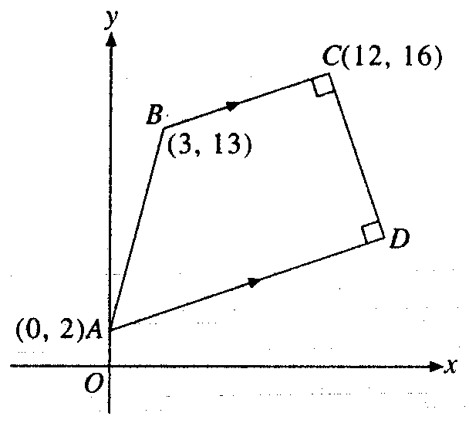

  - The diagram, which is not drawn to scale, shows a right-angled triangle ABC in which $B\hat{A}C=\text{90}°$. The coordinates of A and B are (3,5) and (-1,-3) respectively. Given that the gradient of BC is $\frac{1}{2}$and D is the foot of the perpendicular from A to BC, find
  - the equation of BC and of AC,
  - the coordinates of C,
  - the coordinates of D,
  - the length of the perpendicular AD.
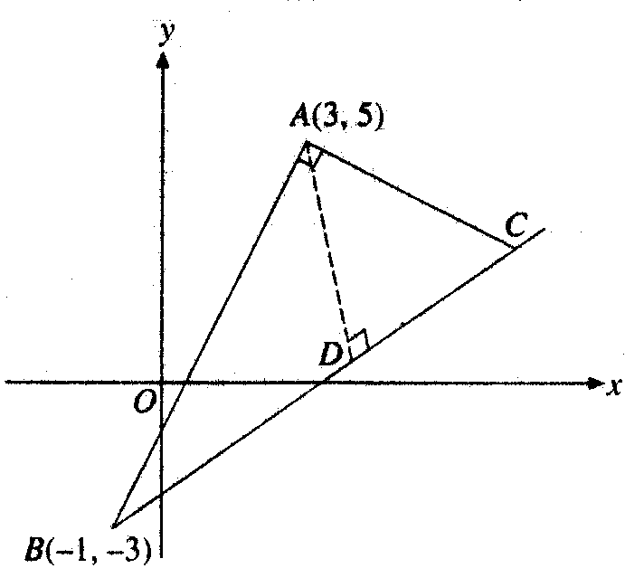

Homework
Misc Exercise 7 A maths text Pg 171
Q2, 8, 12, 18, 22, 28
Summary

1. Formulae concerning two points
For the points A(x₁,y₁) and B(x₂,y₂),
a) the distance AB =$\sqrt{{\left(x_{1}−x_{2}\right)}^{2}+{\left(y_{1}−y_{2}\right)}^{2}}$,
b) the midpoint of AB is$\left(\frac{x_{1}+x_{2}}{2},\frac{y_{1}+y_{2}}{2}\right)$.

2. Parallelogram
ABCD is a parallelogram $⇔$diagonals AC and BD have a common midpoint. Note that rhombuses, rectangles and squares are special parallelogram.

3. Equations of straight lines
- For a line of gradient m, passing through A(x₁,y₁) and B(x₂,y₂),
  - gradient of the line, $m=\frac{y_{2}−y_{1}}{x_{2}−x_{1}}$
  - the equation of the line is $(y−y_{1})=m\left(x−x_{1}\right)$.

- The equation of a line may be written in the form y = mx + c
where m = gradient and c = y-intercept
Straight lines of different gradients are shown as follows:
y
x
m>0
c
O
y
x
m<0
c
y
x
m=0
c
O
y
x
M is undefiined
O
y=c
x=k
O
k

- Equations of parallel lines

The lines$y=m_{1}x+c_{1}$ and $y=m_{2}x+c_{2}$are parallel $⇔m_{1}=m_{2}$

5. Equations of perpendicular lines
- The lines $y=m_{1}x+c_{1}$ and $y=m_{2}x+c_{2}$are perpendicular$⇔m_{1}m_{2}=−1\text{.}$
- The line passes through the point $\left(x_{1},y_{1}\right)$, perpendicular to the line $y=\text{mx}+c,$has gradient $m^{'}=−\frac{1}{m}$and the equation of the line is $y−y_{1}=−\frac{1}{m}\left(x−x_{1}\right)$.

6. Perpendicular bisector
A
M
y
x
O
B
P
The line that passes through the midpoint of A and B and perpendicular to AB is known as the perpendicular bisector of AB. For any point P on the line, PA=PB.

7. Foot of perpendicular and perpendicular distance
a) The point F is the foot of the perpendicular from the point A to the line $l$
y
$$l$$
$$l_{1}$$
b) The distance AF is the perpendicular distance from the point A to the line $l\text{.}$
A
F
- The distance AF is the perpendicular distance between the pair of parallel lines $l$ and $l_{1}$.
x
O

8. Points of intersection
The coordinates of the point(s) of intersection of a line and a non-parallel line or curve can be obtained by solving their equations simultaneously.

