Crescent Girls School

Secondary 3 Mathematics D

Past Years Examination Questions
(1997 – 2001)

Topic: Circle Properties

1. The figure shows a quadrilateral PQRS inscribed in a circle, centre O. PQ makes an angle of 48⁰ with the radius OP and ∠QRS = 80⁰. The tangent to the circle at P meets the tangent to the circle at S at the point T. Calculate,
(a) ∠OPS
(b) ∠PQS
(c) ∠PTS
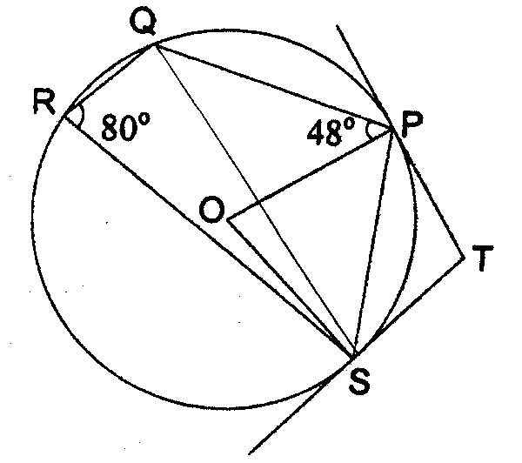 (2000 Final SA Q16)

2. RT is a tangent to a circle at R. O is the centre of the circle with radius 8 cm.
RP and QU are diameters of the circle.
QUT is a straight line. Given that ∠PRU = 58⁰, calculate
(a) ∠RQU,
(b) ∠STU,
(c) the length of RS,
(d) the length of RU.
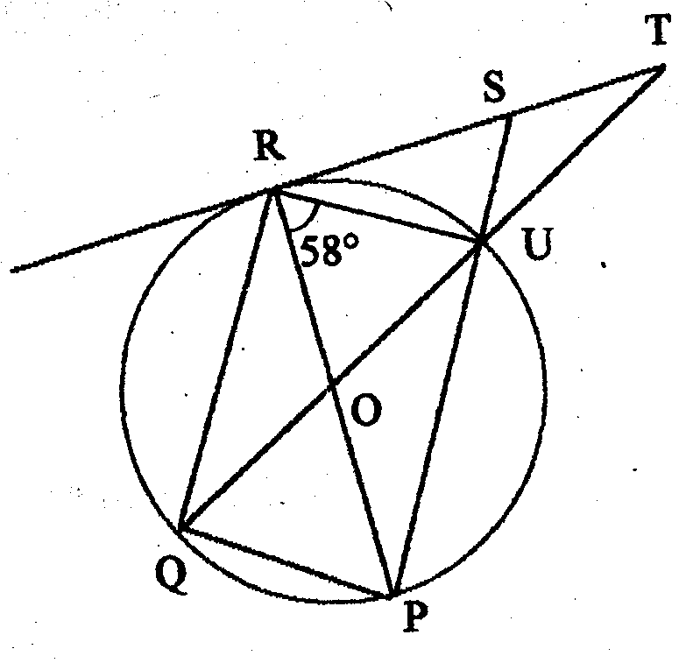 (1997 Final SB Q3)
3.
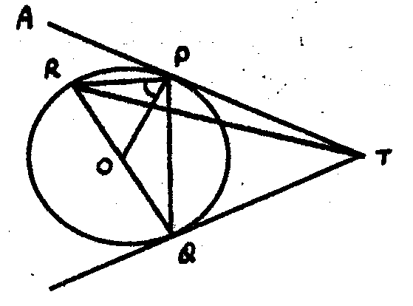

RQ is the diameter of a circle with centre O. TPA and TQ are tangents to the circle. Given that $∠\text{RPO}={\text{68}}^{0}$, calculate
- $$∠\text{PQT}$$
- $$∠\text{PTQ}$$
- $∠\text{APR}$ (1997 Final SA Q9)

4.
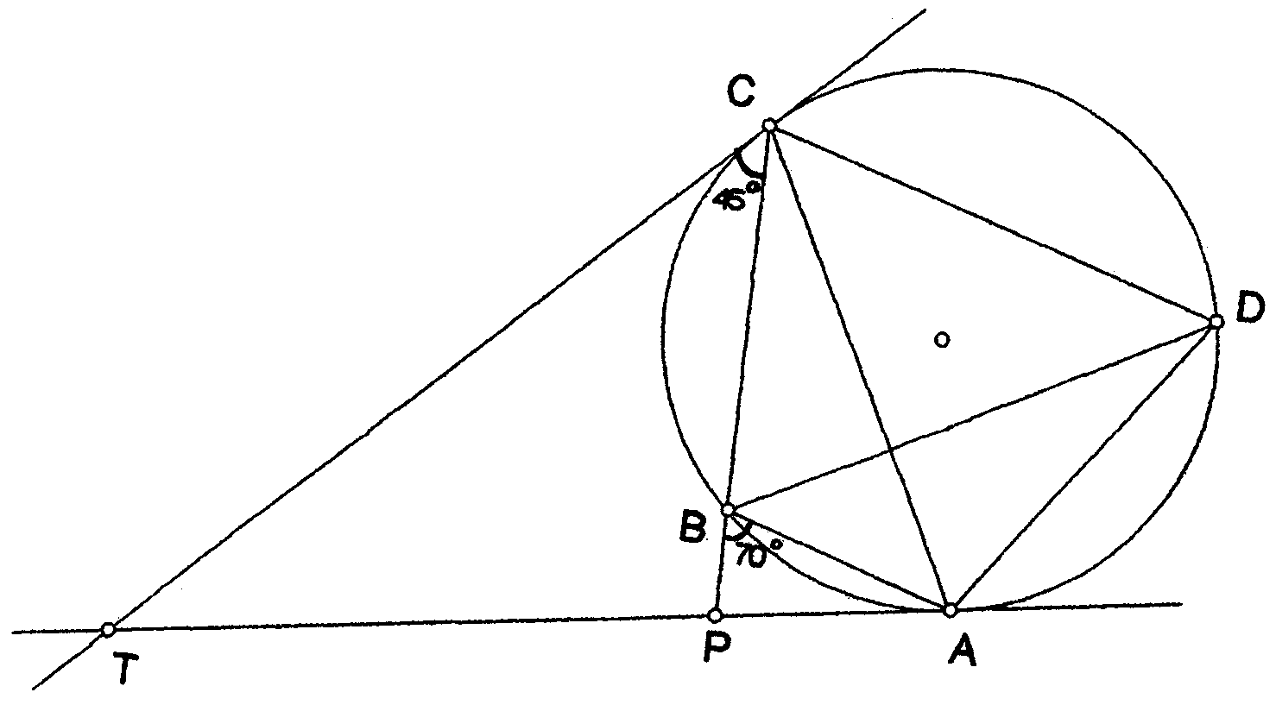

In the diagram, TA, TC are tangents to a circle. The circle passes through A, B, C
and D and CB produced meets TA at P. Given that ∠ABP = 70⁰ and ∠TCP = 45⁰,
- calculate
(i) ∠ADC
(ii) ∠ACB
(iii) ∠ATC
(b) Given that TP:TA =3: 4, if the area of ΔACP is 10 cm², find the area of ΔTCA.
(1998 Final SB Q2)

5. In the diagram, AB is a diameter of the circle, centre O. The chords AQ and PB meet at R when produced. Given that ∠BRQ = 22⁰ and ∠PAB = 42⁰, calculate
(a) ∠ABP,
(b) ∠BPQ and
(c) ∠AOP.
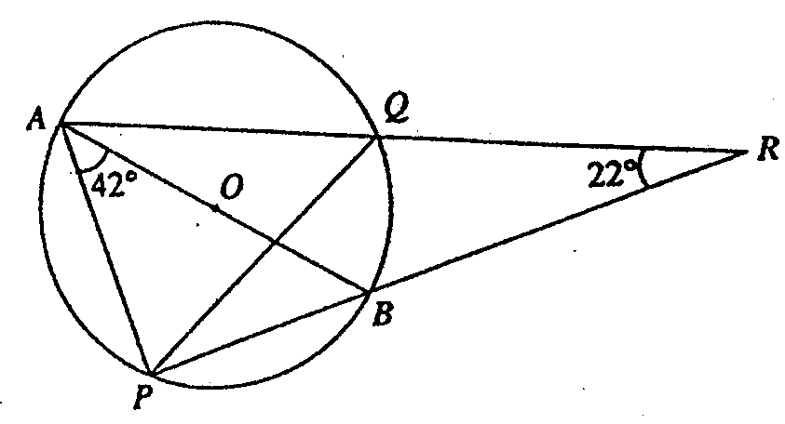 (1998 Final SA Q6)

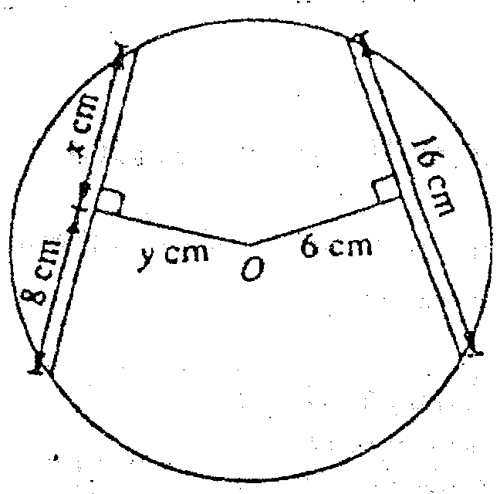
6(a) In the figure given, O is the centre of the circle.
(i) Write down the values of x and y.
(ii) Find the length of the longest chord.

(b) In the diagram, AOC is the diameter of the circle with centre O. RST is the tangent at S. Given that ∠ASO = 38⁰ and ∠BAC = 26⁰, calculate
- ∠CST,
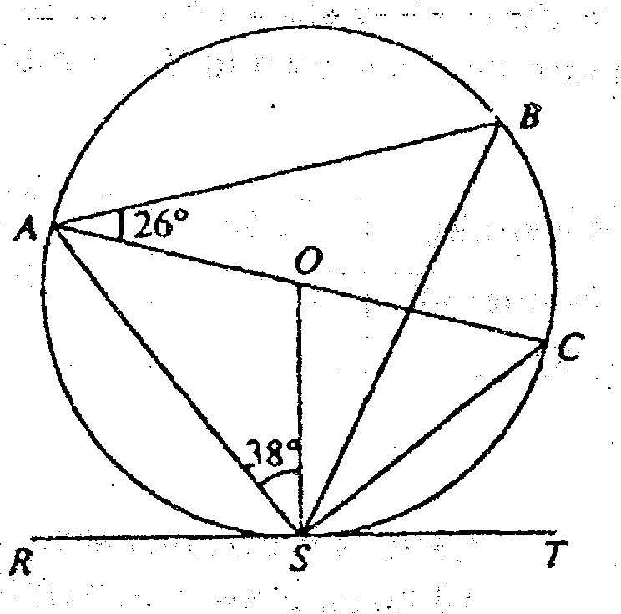
(ii) ∠ABS,
- (iii) ∠BSO and
(iv) ∠BCS.

(1999 Final SB Q3)

7(a) The points A, B, C and D lie on a circle where XY is a tangent to the circle at D. ∠CDY = 54⁰, ∠CXY = 30⁰ and AB = AD and XAC is a straight line. Calculate,
(i) ∠CAD
(ii) ∠ADX
(iii) ∠ABC
(iv) ∠BAD
(v) ∠BCD
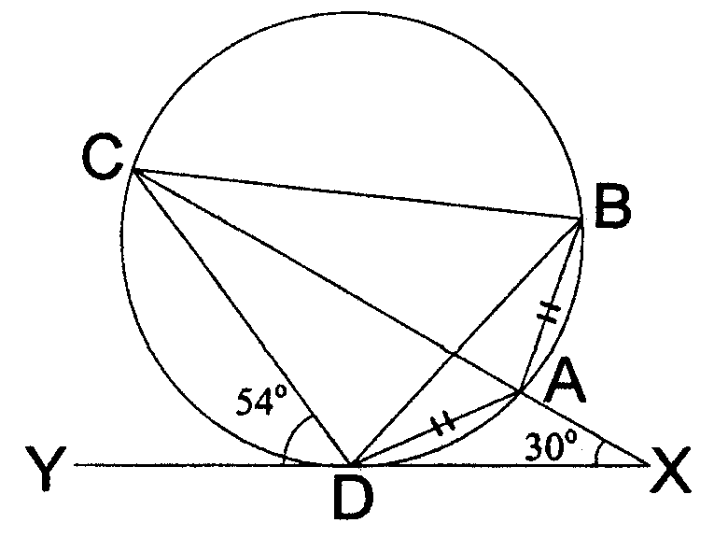

(b) In the figure below, AQRB is a semicircle and PQR is a straight line. If
∠QBR = 59⁰ and ∠QPA =15⁰, find the value of x.

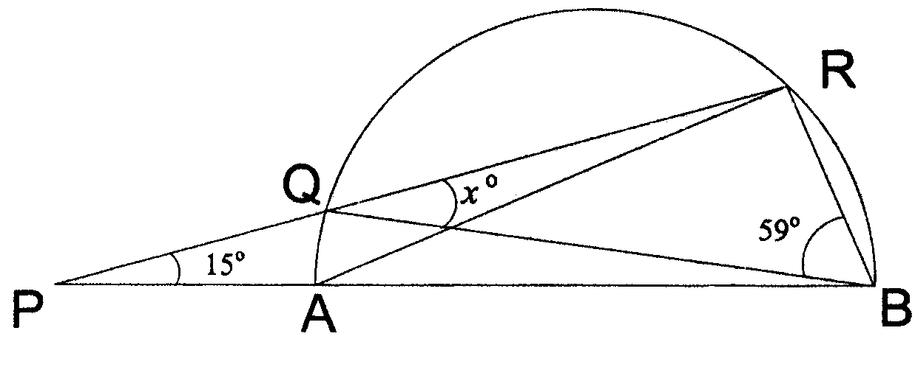
(2000 Final SB Q2)

8(a) In Figure 1, O is the centre of the circle, PAQ is a tangent and AC is a diameter. If ∠ACB = x and ∠ACD = 3x, express the following angles in terms of x:
(i) ∠ODA
(ii) ∠PAD
(iii) ∠OBA
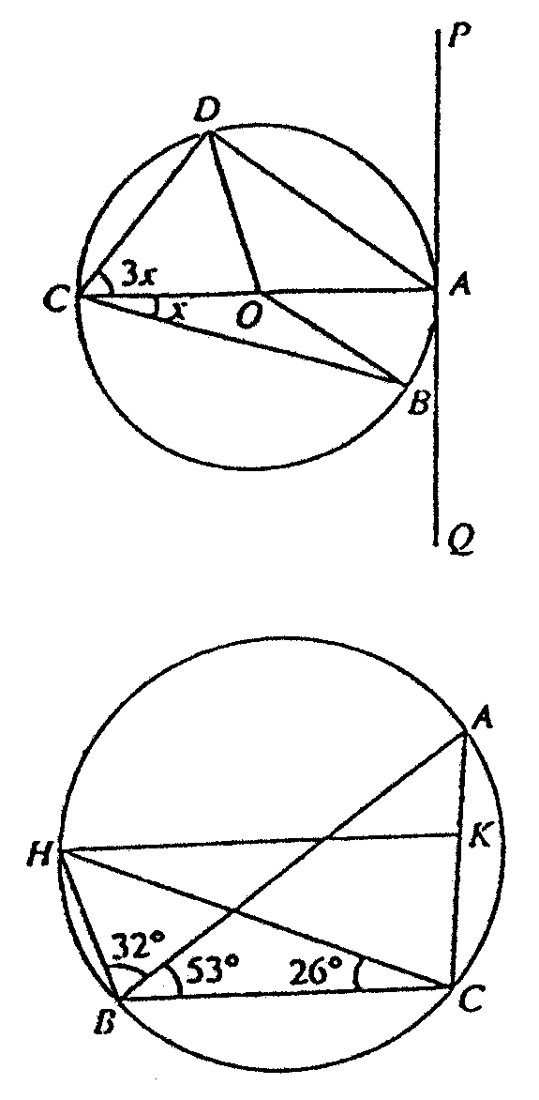
Figure 1

Figure 2

(b) In Figure 2, HK is parallel to BC, ∠HBA = 32⁰, ∠ABC = 53⁰ and ∠BCH = 26⁰. Calculate
(i) ∠HKA
(ii) ∠BAK (1999 Mid SB Q4)

9. In the figure, PA and PB are tangents to the circle at A and B respectively. Given
that O is the centre of the circle, OA = 2.8 cm and AP = 4.4 cm, find
(a) PB stating the reason for your answer
(b) PQ
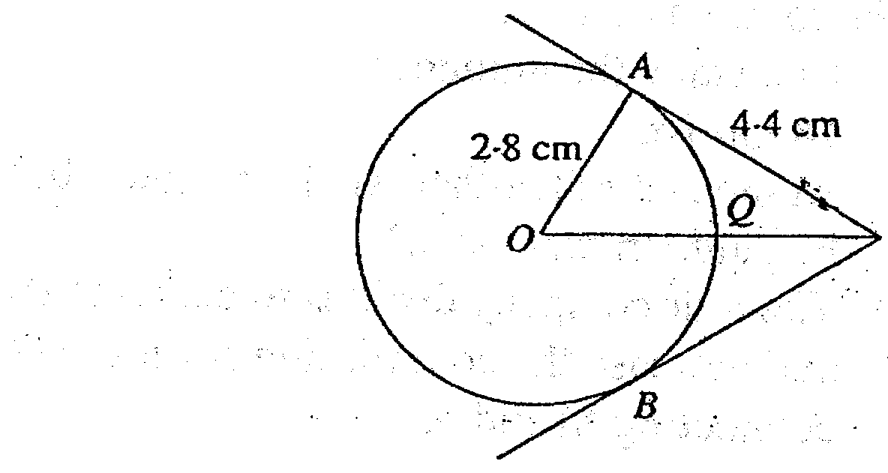
(c) angle APB
P

(1999 Mid SA Q14)

10. In the figure given, find the values of x and y.
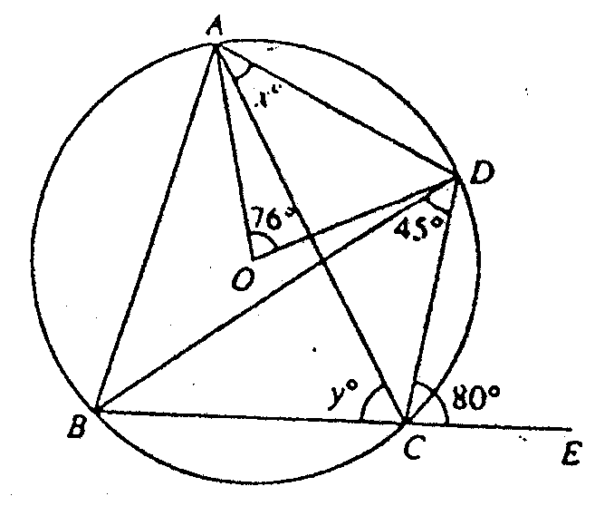
(1999 Final SA Q14)

11(a) In the figure, AOD is a straight line and O is the centre of the circle. Given that $A\hat{O}B={\text{130}}^{0}$, OB = 4 cm and BE = CE, calculate
(i) $O\hat{C}B$
A
C
D
E
4
O
B
130⁰
(ii) DE
(iii) AB

- In the diagram, AOC is a diameter of the circle, centre O. RST is the tangent at S. Given that $A\hat{S}O={\text{38}}^{0}$and$B\hat{A}C={\text{26}}^{0}$, calculate
- $$C\hat{S}T$$
(ii) $A\hat{B}S$
38⁰
R
S
26⁰
T
C
O
B
A
(iii) $B\hat{S}O$
(iv) $B\hat{C}S$

(2001 Final SB Q3)

